The rainbow crow, also known as the ‘Many Coloured Crow’, is a Lenape tribe legend, symbolising the value of selflessness and sacrifice. A long time ago, a crow bravely rescued forest animals from the snowstorm that promised to bury them. Wise Owl chose Rainbow Crow for this arduous journey. His voice was enchanting and his feathers were of all colours glistening in the sun's rays. With his voice, Rainbow Crow summoned the Creator out to solve this freezing dilemma. A blazing, glowing fire burned on a stick given to Crow. This fire stick was to be flown to Earth quickly before the stick burned up. This journey caused Rainbow's feathers to catch on fire and turn black and the smoke strangled his beautiful singing voice. Rainbow Crow did save the animals of the earth and warmed them with the fire but sacrificed much. The Creator and animals never forgot and honour crow - the hoarse voice prevents man from putting him into a cage to sing and men won't eat crow because the creator made his flesh taste of smoke. He would always be free.
Although the crow’s beautiful singing voice has been strangled by the smoke, its once colourful feathers scorched by the fire, he remains a symbol of selflessness, as its shiny black feathers shimmer under the sun, reminding the people of its sacrifices.
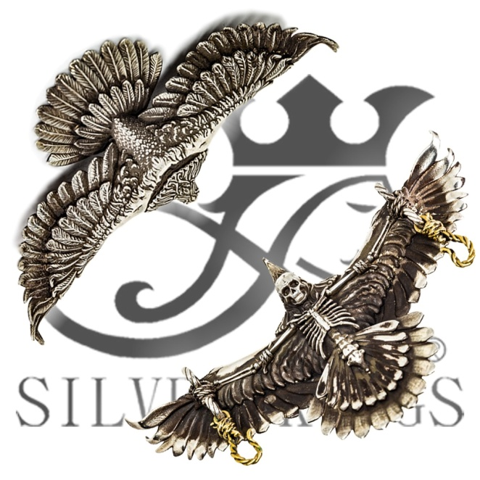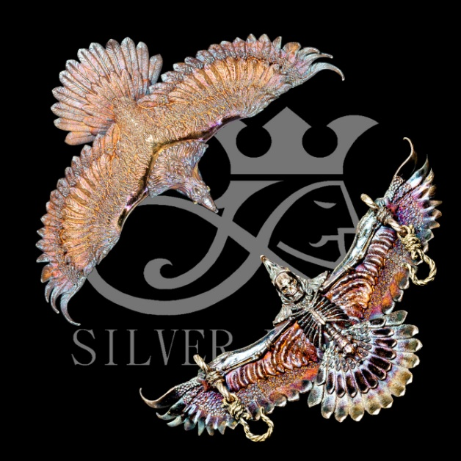
~Rainbow Crow Necklace : Size 95mm 70gram Oxidation high finishing
~Rainbow Crow Ring
~Rainbow Crow Pendant

Designed by : LEO LO (S.A.N.D LIMITED)
HONG KONG company
Email: silverkingshk@yahoo.com.hk

