SNAKE Pattern (Stingray Leather) many different dyeing color as below:
PANTHER pattern (Stingray Leather) bangle
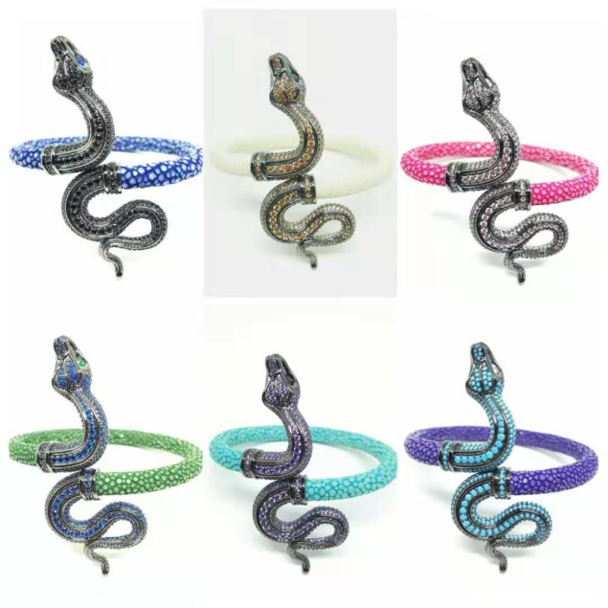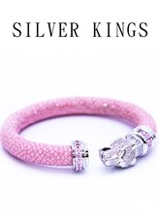
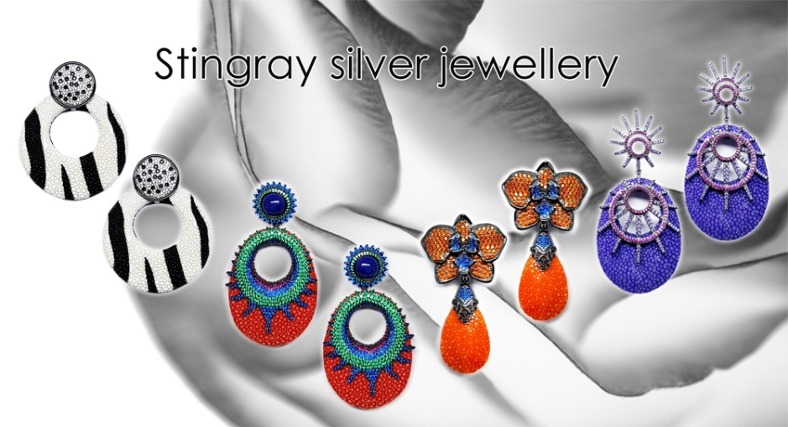
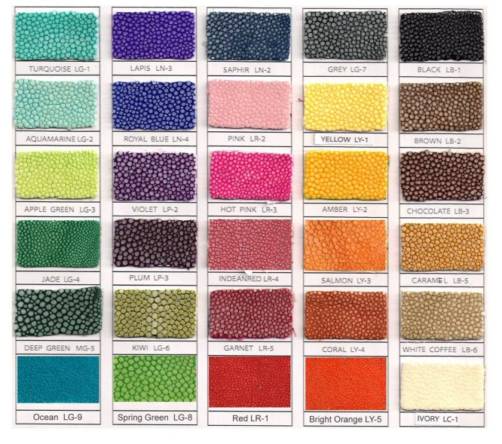
Designed by Leo Lo (S.A.N.D LIMITED)
Sterling Silver or Brass we can manufacturer.
Email: silverkingshk@yahoo.com.hk

