Invitation mailer

Don’t miss out on the chance to visit South African manufacturers on exhibit at the Pure London show 2023

Show dates: 12-14 February 2023

Venue: London Olympia

Show times: 09h30 – 18h00 Sunday & Monday, Tuesday 09h30 – 16h00

Booth Numbers: C91, C93, C103, C104, D90, D91, D92, D93, D102, D103, E90, E92, E102.

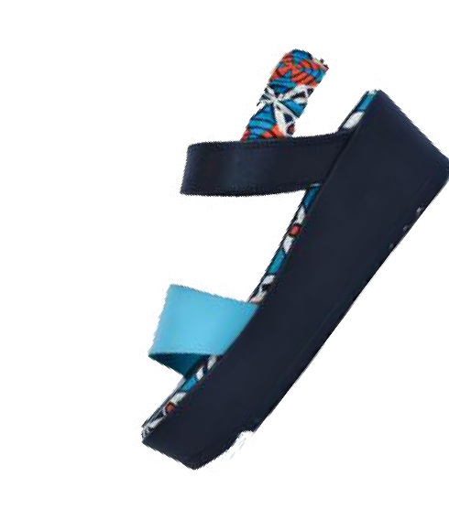
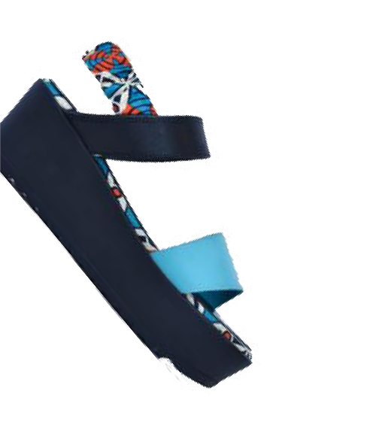
I N C R E D I B L E
CAPABILITIES
OF AN OVER
1Y E A5R OLD I N 0D USTRY

M A N U F A C T U R I N G F O R S O M E O F T H E W O R L D ' S M O S T R E N O W N E D B R A N D S

Copyright © SAFLEC, All rights reserved.
Our mailing address is:
info2@saflec.co.za

