**Subject: I Sports Wall – Improving the wellbeing of primary school pupils through curriculum based exercise and learning.**

**Primary schools use a new innovative development to deliver PE and tackle Covid-19 ‘catch-up’ learning through fun and exercise. The system is quick to set-up and saves time and effort when running a PE lesson or curriculum based activity. Can be financed through the Sports Premium fund.**

<https://www.youtube.com/watch?v=cr4dPFcLJdg>

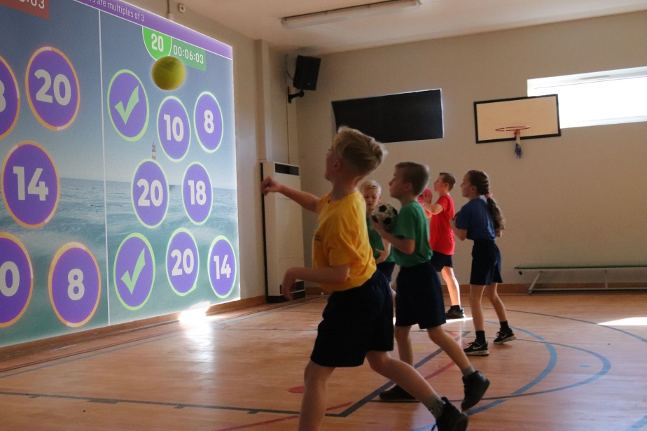

A large number of North East primary schools have taken an innovative and creative approach to engage learners after they return to school from a significant period of absence. **ISportsWall** combines physical exercise with educational knowledge to create a classroom environment whilst participating in sporting activities. This easy to use system makes PE both fun and educational and helps motivate children to exercise.

Head teacher from Kader Primary, Mrs Alison Mitchinson stated, ‘The technology was amazing. Our hall space has been developed to create an enhanced learning environment. I am really keen to see how our children enjoy and progress through its continued use’.

|  |
| --- |
| **ISportsWall** is an innovative new development that converts a large 4m to 6m wall within a school hall into an interactive & exciting learning space for pupils to use whilst maintaining a safe distance.  **ISportsWall** includes over 70 educational modules covering Maths, English, Science, Phonics, History, Geography and Physical education. The system also includes modules that allow the teacher to create their own questions and answers to fit within teaching sequences.  Overall **ISportsWall** makes better utilisation of halls by creating an additional safe presentation space, maintaining distance between pupils. This can be used by year groups within their support bubble. It also includes a powerful lighting / sound system that can be used for after school events etc.  **Advantages of using ISportsWall**   * Helps deliver the sports premium objectives * Can help maintain safe distancing between pupils * Makes learning English, maths, science, history, phonics and geography fun. * Pupils can work together within their support bubble * Makes PE fun and easy to teach. * Stimulates pupils both physically and mentally. * Better utilisation of school halls/gyms. * Helps periodic retrieval of learning that strengthens connections to the memory. * Stimulates physical effort through competitive fun based exercise. * Improves fundamental movement skills which helps reduce obesity in later life. * Can be used as a reward based activity for good behaviour. * Can support children with challenging behaviour by stimulating them to learn. * Can be used as a fun activity at break times or in after school clubs. * Balls are treated with an antibacterial additive.   Mrs Joanne Smith from Breckon Hill Primary immediately recognised the potential of ISportsWall to engage all pupils as they returned from the extended period away from school. ‘The children have lost so many valuable experiences. For us we have a sports' week in school which is a really big event and although this cannot be replaced, ISportsWall will enable children to have lots of opportunity to exercise safely whilst learning’.    ISportsWall at Park End primary school  **Future developments for ISW**  The ISW interplay system will be a technology game changer in regards to interactive curriculum based exercise and learning, allowing primary schools to compete with each other at every level, classroom to classroom, school to school, nationally and internationally. The extensive library of both educational and fun content encourages all pupils to participate, whatever their ability, improving the wellbeing of primary school pupils through increased engagement, activity and learning. The online platform will provide the medium to integrate pupils, whilst maintaining safe practices, reducing the need to travel and saving costs.  **Total installed price Approximate £12,000 ex vat, also ISW can be financed through the Sports Premium fund and the costs spread over three years. Financed through funding4Education. The cost is dependent on installation requirements, electrical, physical, location etc.** |

**Further information on ISW contact:-**

Pravin Jethwa [p.jethwa@amazing-int.com](mailto:p.jethwa@amazing-int.com)

01642 226690

07801757656

Amazing interactives will be showcasing the I Sports Wall system as a feature at the Autism conference in Manchester on the 24th and 25th of May, ISW system is a new innovative development from Amazing Interactives ltd and a creative approach to engage, motivate and inspire learners. I Sports Wall system combines physical exercise with educational knowledge to create a classroom environment whilst participating in sporting activities. ISW system stimulates physical and mental development and language skills as the learners participate in a series of collaborative and engaging content which in turn helps to increase group collaboration and promotes problem-solving skills

This easy to use system makes learning fun and educational and helps motivate children to exercise, and creates an inclusive learning environment, encouraging active participation and removing barriers to learning. Over 80 software packages are included within the ISW system as well as build your own custom quiz builder, the possibilities are endless and only limited to your imagination.