PARK WITH EASE: NEW IMPROVEMENTS TO YOUR NEC EXPERIENCE

We’re pleased to share that the NEC is investing £1.5 million to improve your event parking experience.

From September, a new hybrid ANPR-enabled barrier system will be in place to help streamline the parking process. While it means there will be a few changes to how you park, we’re here to help make the transition smooth and simple.

Contractors will continue to enjoy free parking during build and break down times but will now need to validate their parking before returning to the car park.

Need-to-knows  - Free parking is available during build and break down.  - To enjoy this benefit, you’ll need to validate your free parking at any pay-on-foot machine in the venue by entering your vehicle registration and scanning the QR code on your Voyage Control delivery pass. However, please be aware that overstays beyond 2:00 AM will incur additional charges.  - No Voyage Control pass? Simply collect a QR code from the lorry park team, venue security or our organiser team and validate at a pay-on-foot machine in the venue.  - Unfortunately, if you don’t validate your free parking before returning to the car park, your vehicle won’t be recognised at the exit barrier, and a £25 fee will apply (card payment only).  Planning to be on site during open days? Book online and in advance to save £5 on the standard day rate.  - If you want to park at the venue during open days, we recommend pre-booking your parking via the NEC’s online portal for the best rates and a smoother experience, with no need to validate.  - It only takes a moment, and you can do it any time up until midnight the day before your visit to our event – just follow the handy How-to Guide below.  - If you haven’t pre-booked, you can still pay on the day at any pay-on-foot machine in the venue or the on-the-day online portal. Please note that if you’re planning to use the on-the-day online portal, you can only do so once you’ve parked up in the car park or once you’re in the venue. | KEY BENEFITS  Effortless access  Your vehicle’s number plate is recognised automatically, helping you move in and out quickly during busy periods.  Increased security  The system logs each entry and exit for peace of mind while you're parked at the venue.  Reliable and accurate  Your entry and exit times are recorded automatically to help ensure accurate and transparent tracking of your parking time.
HOW-TO GUIDE
Pre-book your parking at the NEC
Please ensure you book in advance to get the best rates for your parking. To do this, visit: https://parking.thenec.co.uk/

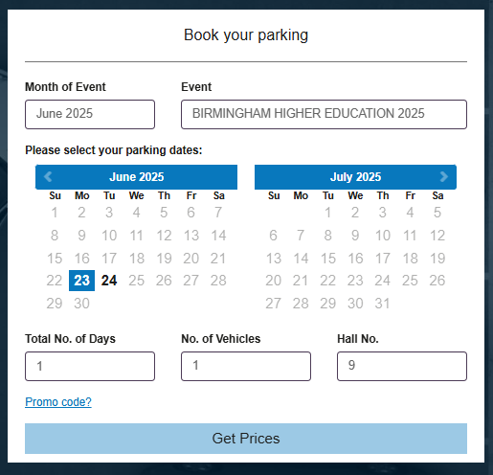
- Select the month and then our event from the dropdown list.
- Select the date(s) you need parking for and whether you require single or multiple days.
- If you select more than one consecutive day, overnight parking will be offered. If your vehicle will remain onsite beyond 2:00 AM, select ‘Overnight Parking’ to avoid overstay charges.
- Select our Hall Number.
- Click ‘Get Prices’.
- Select your parking product or upgrade if this interests you (please note overnight parking is not available on upgrades).
- Enter your details and vehicle registration number.
- Press ‘Book Now’.
Your booking is now complete. An email confirmation will be sent to you.

If you need to make any changes ahead of our event, simply use the 'Manage my Booking' link in your confirmation email - amendments can be made right up until midnight the day before your arrival.

Full parking terms and conditions can be found here.

