PARK WITH EASE: NEW IMPROVEMENTS TO YOUR NEC EXPERIENCE
We’re pleased to share that the NEC is investing £1.5 million to improve your event parking experience. From September, a new hybrid ANPR-enabled barrier system will be in place to help streamline the parking process. While it means there will be a few changes to how you park, we’re here to help make the transition smooth and simple.
And there’s more good news, by booking in advance with your unique Exhibitor promo code, you'll continue to enjoy free parking during build, break down and our event open days, without the need to validate in venue.
The smart way to visit? Book online and in advance  - We recommend pre-booking your event parking via the NEC online portal for the quickest and easiest experience.  - It only takes a moment, and you can do it any time up until midnight the day before your visit to our event – just follow the handy How-to Guide below. (If you do not pre-book your parking using the promo code, you will have to pay during the open period of the event.)  Need-to-knows  - For the best possible experience, pre-book online using the promo code that we’ll provide in advance. Please note, physical passes are no longer being issued.  - Once you've booked your Exhibitor parking for all event open days, your vehicle will automatically enjoy free parking from 72 hours before the event begins until 48 hours after it ends. However, please be aware that overstays beyond 2:00 AM each day may incur additional charges, unless overnight parking is selected when making the booking.  - Didn’t pre-book? During build and break, you can still validate your free parking at any pay-on-foot machine in the venue by entering your vehicle registration and scanning the QR code on your Voyage Control delivery pass.  - No Voyage Control pass? Simply collect a QR code from the lorry park team, venue security or our organiser team and validate at a pay-on-foot machine in the venue.  - Unfortunately, if you don’t pre-book or validate your free parking before returning to the car park, your vehicle won’t be recognised at the exit barrier, and a £25 fee will apply (card payment only). | KEY BENEFITS  Effortless access  Your vehicle’s number plate is recognised automatically, helping you move in and out quickly during busy periods.  Increased security  The system logs each entry and exit for peace of mind while you're parked at the venue.  Reliable and accurate  Your entry and exit times are recorded automatically to help ensure accurate and transparent tracking of your parking time.

HOW-TO GUIDE
Pre-book your exhibitor parking at the NEC
Please ensure you book in advance to activate your free parking. To do this, visit: https://parking.thenec.co.uk/NECBirminghamexhBooking
Please ensure you use the above URL for Exhibitors as opposed to the Visitor URL
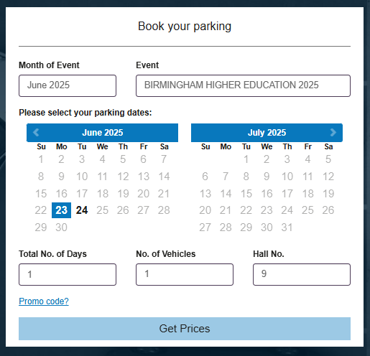
- Select the month and then our event from the dropdown list.
- Select the date(s) you need parking for and whether you require single or multiple days.
- If you select more than one consecutive day, overnight parking will be offered. If your vehicle will remain onsite beyond 2:00 AM, select ‘Overnight Parking’ to avoid overstay charges.
- Select our Hall Number.
- Click ‘Promo code?’.
- Enter your unique promo code that we have provided.
- Click ‘Get Prices’.
- Select your free Exhibitor parking product.
- Enter your details and vehicle registration number.
- Press ‘Book Now’.

Your booking is now complete. An email confirmation will be sent to you.
If you need to make any changes ahead of our event, simply use the 'Manage my Booking' link in your confirmation email - amendments can be made right up until midnight the day before your arrival.
Please note that Exhibitor Advantage upgrades are still available. If you wish to book Exhibitor Advantage, please search without using your promo code. For clarity, upgrades do not include build and break parking, so validation will still be required on those days. In addition, upgrades do not include overnight parking).
Promo codes are unique and single use only. Use of promo codes is traceable to individual bookings.
Full parking terms and conditions can be found here.

