SPACE ONLY CONTRACTORS STAND CHECK SHEET
& RIGGING SUBMISSION DECLARATION

EVENT NAME
VENUE
EXHIBITING COMPANY NAME
STAND NUMBER
STAND FOOTPRINT DIMENSIONS &
MAX BUILD HEIGHT
PRINCIPLE CONTRACTOR DETAILS
ONSITE CONTACT NAME
ONSITE CONTACT NUMBER
ARRIVAL & COMPLETION TIME & DATE
The following documents MUST be submitted by the 20thOctober 2023 , in order to comply with HSE legislation and CDM Regs. Please tick to confirm. Please ensure that this sheet is returned as soon as possible, together with all relevant documents, to phil.fellows@dimeevents.com

Full stand plans and visuals, showing all dimensions and elevations
None generic Risk Assessment
Method Statement
Public Liability Insurance, which must be in date at the time of the event,
and cover ALL days and MUST be a minimum of £5m
Confirm that you have checked that your stand will fit in the footprint and
that the height is acceptable

Please also confirm the following structural stipulations

You will supply a back wall to your stand, up to a minimum of 2.5m
You would prefer to purchase a shell back wall
You will dress down the back wall of your stand if higher, to 2.5 m in a neutral colour. Please note that corporate branding is not permitted on
walls which overlook the next exhibitor.
Any storeroom doors will be fitted with a CLEAR vision panel – Frosted
panels are NOT permitted
I will be rigging above the stand (If yes, please complete the Rigging Declaration Section further on) | Yes ☐  No ☐

CDM REGS 2015 CHECK LIST

I will provide an event project safety file | YES NO
I can confirm that all personnel have viewed
the Site Induction and will comply
I will provide suitable welfare for all staff on my Space site. This will include access to hot food and hot/boiling water and a suitable rest
area
I confirm that my space only site will become a separate construction under the auspices of the CDM Regulations 2015 and that I will have sole responsibility for the safe implementation
and completion of the project within that area

RIGGING REQUIREMENTS & DECLARATION

if you intend to rig above your stand, please complete the following section. ANY and ALL rigging MUST be approved by the organisers in the first instance. if you are rigging bespoke items, plans and structural calcs must be submitted with the rest of the stand plans. These will require sign off from our Structural Engineers for which there may be an additional charge. Your method statement and risk assessment must cover all rigged items.
If you are in doubt as to what type of rigging you have, please refer to the rigging classifications from the e-guide, below.
I WILL BE RIGGING:
A STANDARD BANNER
☐
A MODULAR STRUCTURE OR TRUSS
☐
CUSTOM BUILT/BESPOKE STRUCTURE
☐

I CONFIRM THAT THE ORDER HAS BEEN PLACED WITH THE VENUE
RIGGERS AS DETAILED IN THE EXHIBITOR MANUAL
I CONFIRM THAT THE RIG HAS BEEN APPROVED BY THE ORGANISERS
I HAVE ENSURED THAT MY RAMS RELFECT THE RIGGING CONCERNED
I AM AWARE OF THE POSSIBLE CHARGES FOR THE SIGN OFF OF A
COMPLEX RIG (TO BE ADVISED BY THE ORGANISERS)
I HAVE ATTACHED PLANS AND VISUALS AND FULL DESCRIPTION OF
THE RIG

SIGNED:

PRINT NAME:

CLIENT/PRINCIPLE CONTRACTOR (Delete as necessary) DATE:

GENERAL RIGGING INFORMATION
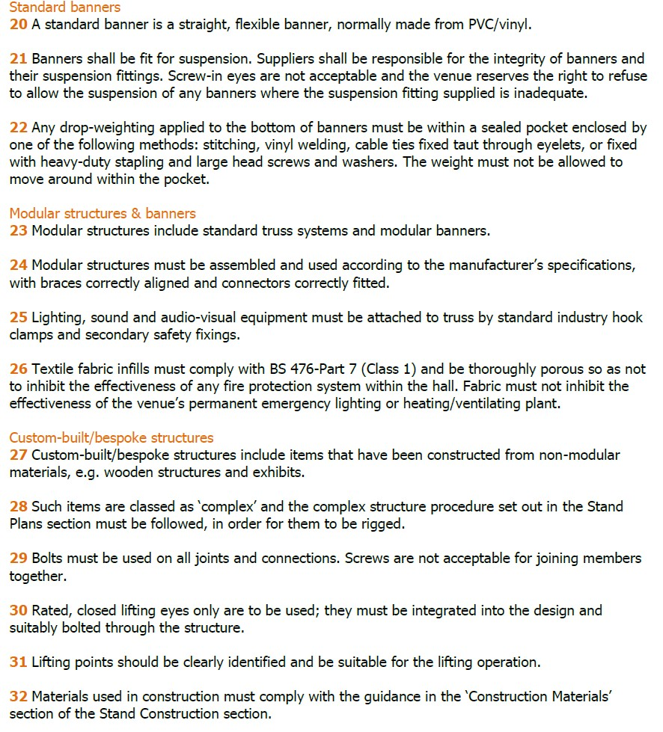
More guidance on rigging is available in the e-guide., which can be viewed at the link below https://www.aev.org.uk/e-guide

