**BOOTH TYPES**

The majority of booths come at 10x10ft, 20x10ft and 20x20ft - this may differ. The below represent the different types which come, depending on the location within the hall. The drapes for each booth type may differ on quantities and heights of 8ft and 3ft; you can confirm this with your account manager.

• **In-line Booth:** Generally arranged in a straight line with neighboring exhibitors

on their immediate right and left leaving only one side exposed to the aisle.

Individual booths may be combined to form a larger in-line booth space.

• **Corner Booth:** In-line booth exposed on two sides with an immediate neighbor

on one side (all guidelines for in-line booths apply).

• **Perimeter Wall Booth:** In-line Booth backs to an outside wall of the exhibit

facility rather than to another exhibit. Please note: The height restriction is 8’.

• **Peninsula Booth:** Backs up to another booths, the booths share a common back wall drape 8ft (2.5m) high.

**• Island Booth:** Exhibit space enclosed by aisles on all four sides of the booth space. No pipe/drape or furniture, space only. Island booths must provide suitable flooring for the entire area of their booth.

Hanging Signs and Ceiling Rigging

• Hanging Signs: See booth space for details.

• Lighting/Truss Hanging truss or suspending lights from facility ceiling requires approval.

**10x10 booth visuals -** THESE ARE ONLY EXAMPLES, please confirm orientation and size with your Account Manager if unsure.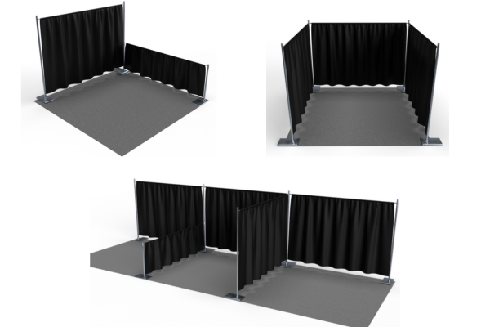

**WHAT TO AVOID AND BE AWARE OF**

**RULES**

• Pop-Up Tents are prohibited.

• Front of booth - no items over 4ft (1.22m) in height can be within 5ft (1.52m) of aisle as it blocks sight line.

• Back of booth - The maximum height of 8ft (2.44m) is allowed only in the rear half of the booth space.

• Exhibits must be constructed with enough space to allow for utility service at the rear of the booth (back drape, rails, power drop).

• Any structure facing the neighboring booth must be free of any branding/logos.

• Umbrellas are prohibited.

**Storage**

Exhibitors must not store items behind back drapes due to fire regulations. Limited literature or product storage within the booth is allowed, provided it doesn't obstruct access, pose safety issues, or appear unsightly.

**Electrical**

Every exhibit facility has different electrical requirements. However, minimum guidelines are suggested:

• All 110-volt wiring should be grounded three-wire.

• Wiring that touches the floor should be “SO” cord (minimum 14-gauge/three-wire) flat cord, which is insulated to qualify for “extra hard usage.”

• Cord wiring above floor level can be “SJ” which is rated for “hard usage.”

• Using zip cords, two-wire cords, latex cords, plastic cords, lamp cords, open clip sockets, and two-wire clamp-on fixtures is not recommended and is often prohibited. Cube taps should be prohibited.

• Power strips (multi-plug connectors) should be UL approved, with built-in over-load surge protectors.

**Flammable and Toxic Materials**

Use fire-retardant materials certified as flame retardant for display construction or decorating. Provide samples for testing and certificate of use incase of inspection. Avoid using materials that cannot be treated to meet these requirements.Exhibitors should be aware of local regulations regarding fire/safety and environment which must be adhered to. Exhibitors should dispose of any waste products they generate during the exhibition in accordance with guidelines established by the Environmental Protection Agency and the facility.

**Sound/Music**

Sound and noise should not exceed 85 decibels when measured from the aisle immediately in front of a booth. Exhibitors should be aware that music played in their booths, whether live or recorded, may be subject to laws governing the use of copyrighted compositions. ASCAP, BMI, and SESAC are three authorized licensing organizations that collect copyright fees on behalf of composers and publishers of music.

If you require any further information on anything you can not see here such as Vehicles On Displays, Demonstrations, Structural Integrity, Lighting etc please contact your account manager.