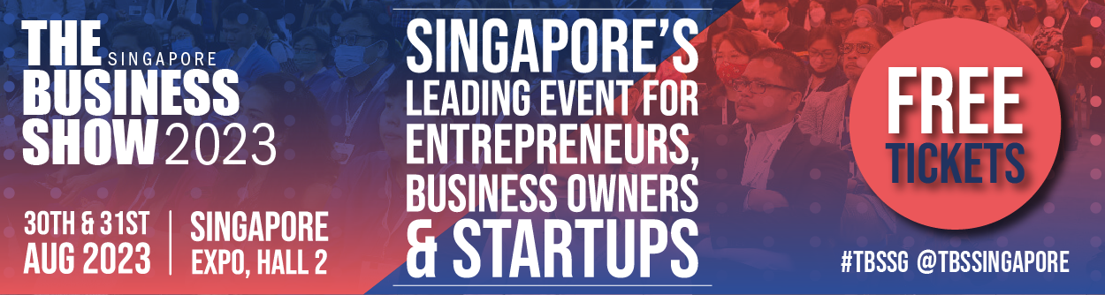

The Business Show Singapore returns this August!
___________________________________________________________________________

This year's leading business event for entrepreneurs, business owners and startups takes place at the Singapore Expo in Hall 2 on the 30th and 31st of August 2023. A hub for entrepreneurs, business owners, and startups to learn about business adaptation, innovation, and survival in the business world by finding and purchasing the products and services your business needs to succeed.
Featuring over 300 exhibitors and 250 seminars from industry leaders, the show is set to be the biggest and best yet. Here's your chance to grab some FREE PASSES before the show. Follow us on social media for updates and announcements.

