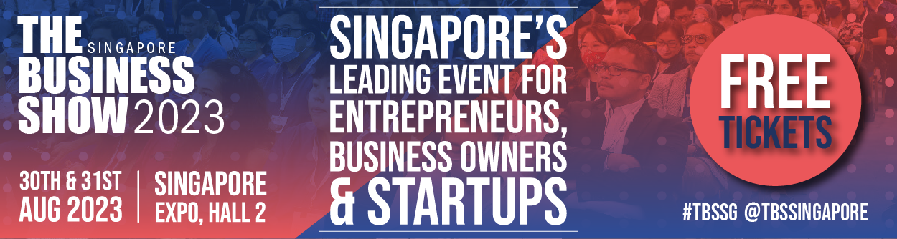

The Business Show Singapore returns this August!
___________________________________________________________________________

The Business Show Singapore returns to the Singapore Expo, Hall 2 on the 30th & 31st August 2023. With 25 years of success, the event provides a complete line-up full of inspiration, ideas, and advice, as well as two days of inspirational networking between thousands of entrepreneurs and business leaders.
A hub for aspiring entrepreneurs, business owners, and startups to learn about adaption, innovation, and survival in the business world by finding and purchasing the products and services that will help your business succeed. This event aims to educate and encourage SMEs and startups to grow and develop, as it offers an opportunity for entrepreneurs, key decision makers and business leaders to explore new business possibilities.
The Singapore government supports startups and provides resources and opportunities that shape Singapore into a business-friendly environment that attracts entrepreneurs to invest and start their own businesses. The time is right for Singapore to boost its economy as international travel opens up.
A one-stop shop of industry experts will offer in-depth knowledge and insights into the latest trends, and all of the newest products and services that will help your business grow. A full range of keynotes will ensure that you cover all aspects of your business. Don't miss the chance to hear from the experts - Google, Shopify, Docusign, among others. Additionally, you will benefit from interactive workshops, 1-2-1 advice sessions, and unlimited opportunities to connect with like-minded business owners. The benefits are endless!
Let's get started! Secure your FREE PASS and discover the resources and services that could help your business! Check out our social media accounts for the latest updates.

