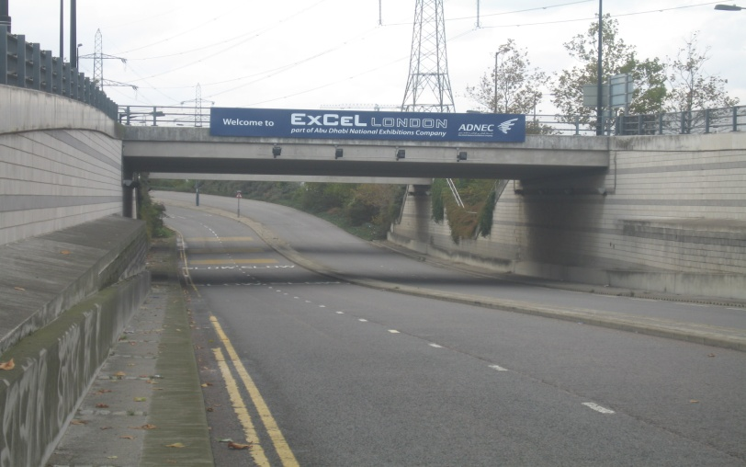
All Build & Break vehicles must gain access to the site via the East Entrance, On Sandstone Lane. The post
Code is E16 1SL. When approaching the east end of the site you will pass under the
Bridge pictured above.

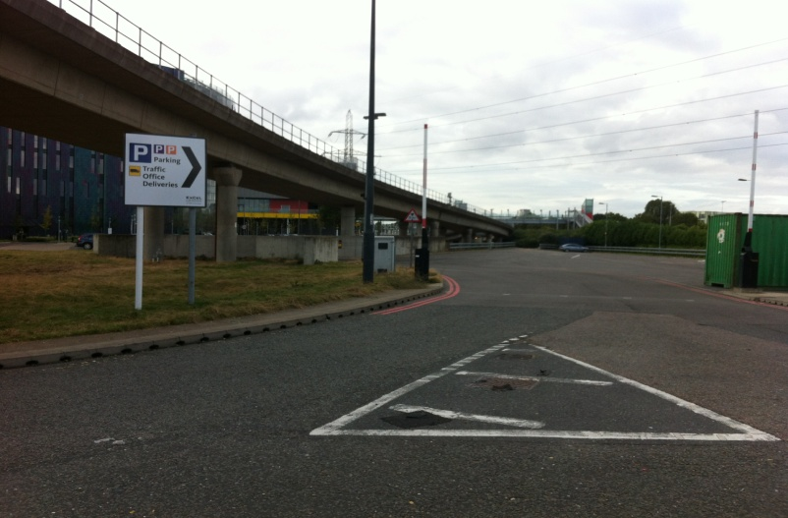

Please take the last right turn on the roundabout and enter the site via the Service
Road.
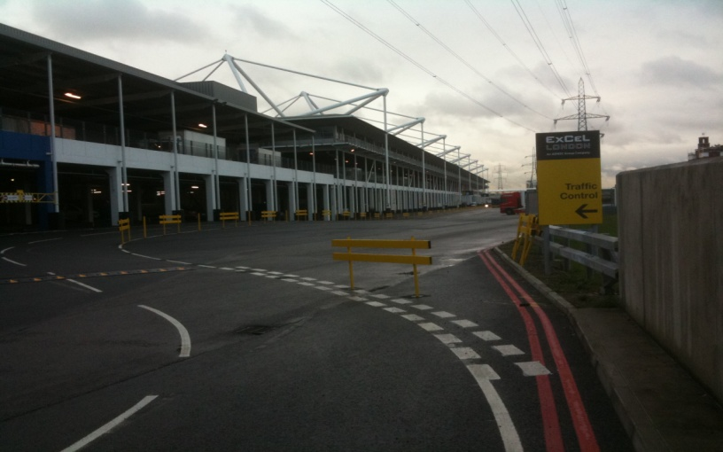

Please enter the Traffic Marshalling Yard left of the yellow sign shown above.

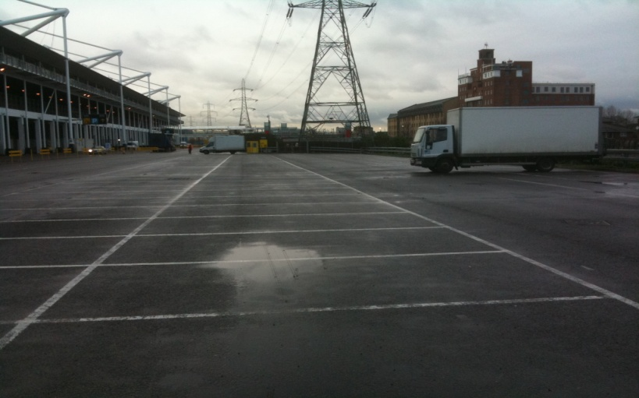

Please park in the allocated bays. DO NOT PARK ON THE SERVICE ROAD.

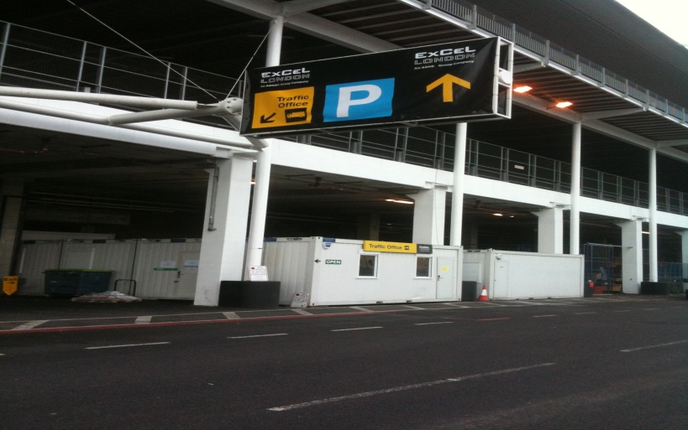

Once you have parked up, and while the vehicle is stationary please switch off your engines.
Please make your way by foot to the Traffic Office.
Please be aware of your surroundings i.e. moving traffic etc.
Enter the traffic office using the Entrance Door Only and
Please be aware that in busy periods queues may be likely.

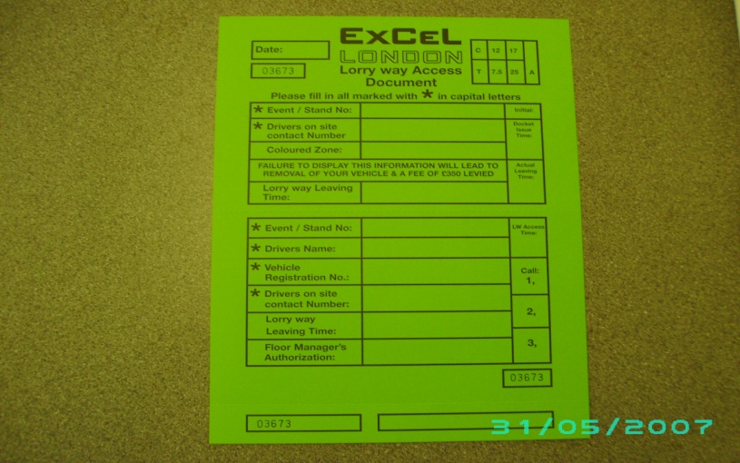

You will be asked to complete a Lorry Access Document and must have the following
Information available to gain access to the lorry way
- Event / Stand Name
- Vehicle Drivers Name & On Site Contact Number
- Vehicle Registration.
Once the vehicle driver goes back outside they must speak to the Traffic marshal who will give instruction as to which lane the driver needs to queue in.

The vehicle driver will be allocated a queuing lane and coloured zone on the lorry way.
Which will ensure a parking space closest to the stand / area required in halls?
Please ensure you have the LAD and make your way back to your vehicle, and while the vehicle is stationary please switch off your engines.

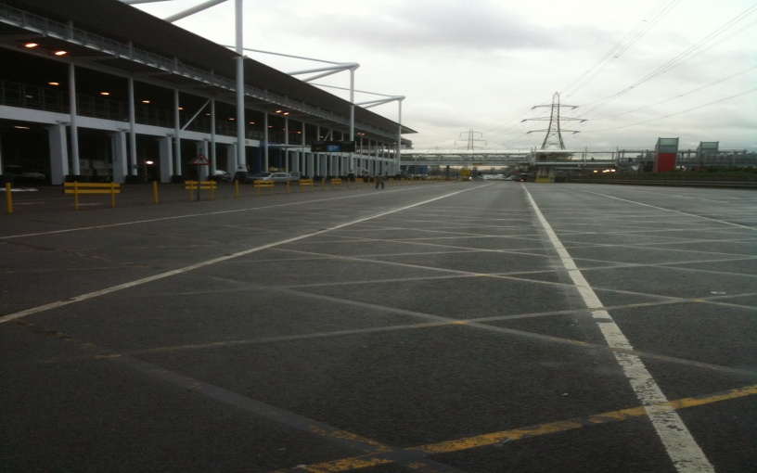

When space becomes available a Traffic Marshal will ask you to move your vehicle
Onto the North / South or East lorry ways.
DO NOT MOVE YOUR VEHICLE UNTIL ASKED.

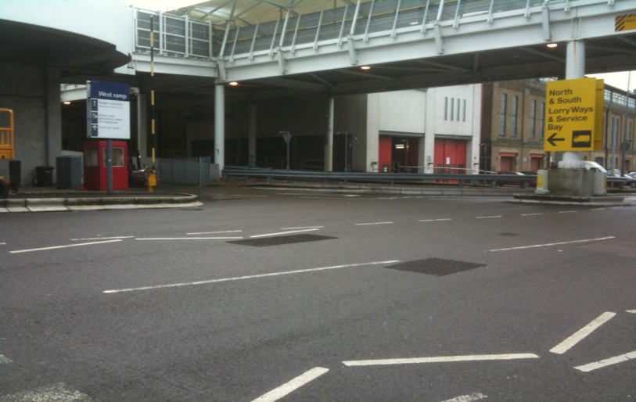

Once your vehicle has been given permission by a Traffic Marshal to access the North or South Lorry Ways
Please make an immediate left turn to the West Ramp. Your LAD will be
Checked and the barrier rose to allow access. East traffic will be sent back along the service road to the various areas at the East end of the building.

Please follow the signs for the North & South Lorry Ways

A Traffic Marshal will stop your vehicle at the lorry Way Control Point, Where the time of access will be recorded on the LAD. This LAD will be torn in half. THE DRIVERS HALF MUST BE DISPLAYED IN THE VEHICLE.
WINDSCREEN.

A Traffic Marshal will guide your vehicle into an available parking space within your
Allocated coloured zone (i.e. above – orange), and while the vehicle is stationary please switch off your engines.

Vehicles requiring the Capital suite or Capital halls (East traffic) will be sent back along the service road to the various areas at the East end of the building, Entrance below is sign posted for deliveries.

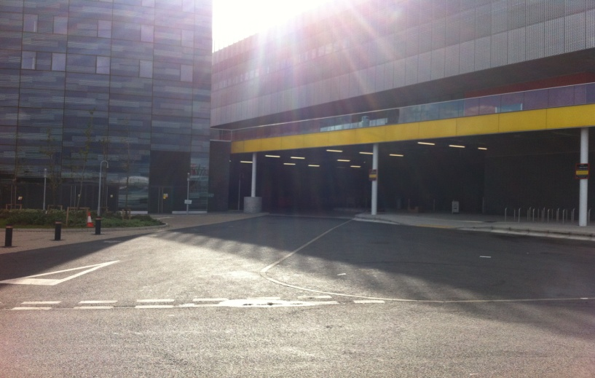

Capital Hall and Capital Suites delivery area, two ways traffic in this area.

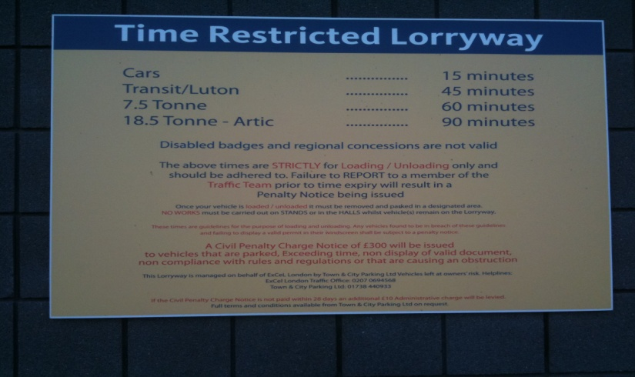

Once your vehicle is parked it is advisable to take a few minutes to
Read the Lorry Way Rules & Regulation Notices placed on Walls.
Unloading times are as follows:
Cars: 10 – 15mins
Transit Sized Vehicles: 30 – 45mins
7.5 Tonnes: 50 – 60mins
Articulated vehicles – 90mins
Authorisation to stay passed your allocated unload time must only come from a
Traffic Supervisor positioned on the Lorry Way.
FAILURE TO MOVE VEHICLES WHEN REQUESTED WILL RESULT IN THE
VEHICLE BEING TICKETED WITH A FEE LEVIED OF £300.00
PLEASE NOTE: THE LORRY WAY IS NOT A CAR PARK
On exit a Traffic Marshal will stop your vehicle and request your LAD.
Please take care when exiting onto the service road using give way Signs.

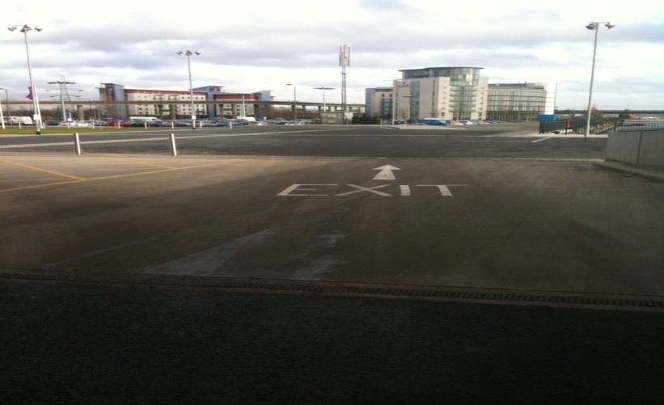

Parking for vehicles transit size and upwards is available onsite
Transit size vehicles below 3.5 tons: Build & Break Days – Free of Charge
Open Days – £20.00 per day Last Open Day (After 14.00) – Free of Charge
Vehicles 3.5 tons and above: Build & Break Days – Free Of Charge
Open Days - £35.00 per day Last Open Day (After 14.00) – Free of Charge
All cars should be parked in normal car parks and is chargeable
For Further Information on Traffic Marshalling please telephone 02070694568

