Booth Panel Specification

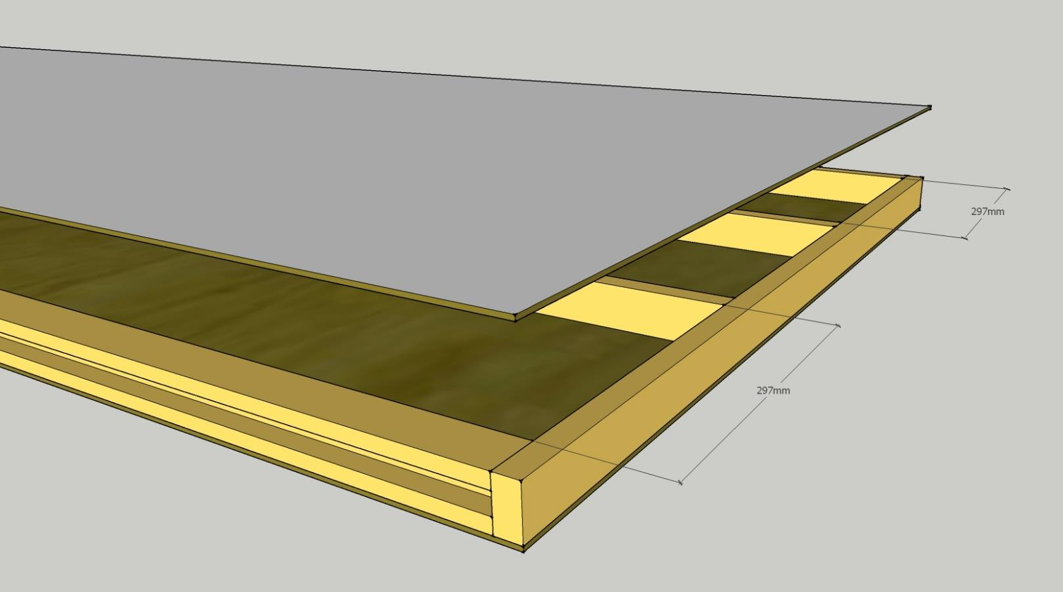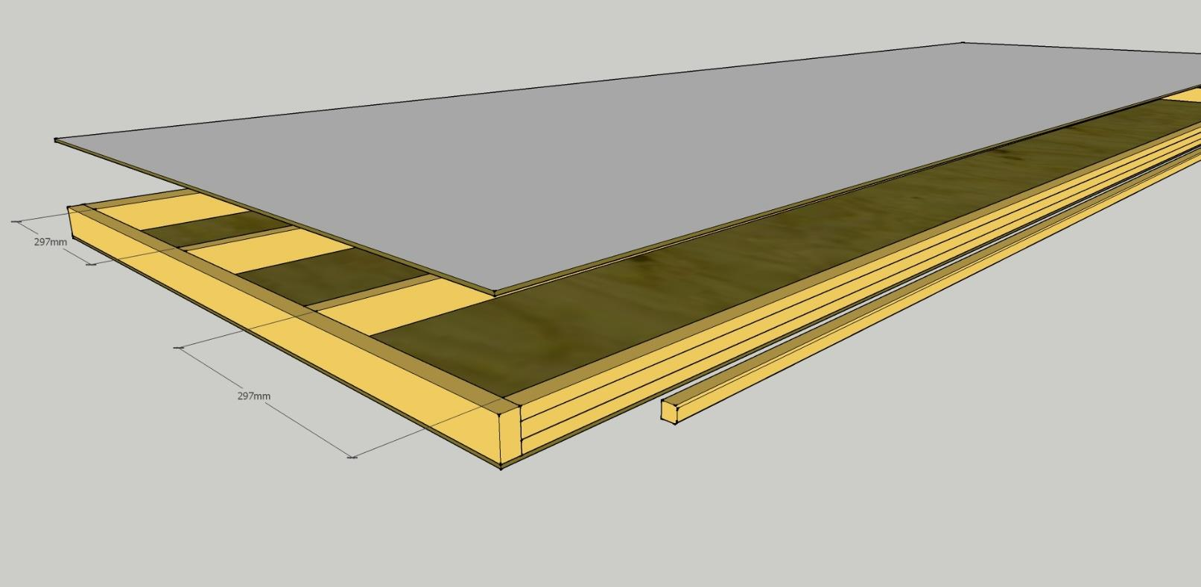
PANEL COMPONENTS OVERVIEW
Grooved external uprights – 3006mm soft wood timbers on the long sides of the Panels. The 1mm groove is for positioning of tongue
Internal uprights and cross members
-two 3006 mm pieces for reinforcing inside of the panel
-two 1000mm pieces on the top and the bottom of the panel
Tongue – 2700mm x 17mm x 17mm wide with 2 chamfered edges with 5 evenly spaced predrilled countersunk 4.5 mm diameter holes used to join the panels together
.Fire retardant ply – two sheets at 3050mm x 1000mm x 3.6mm

