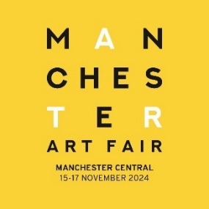

<insert artist name> To Exhibit At Manchester Art Fair This November 15-17
- The Largest & Most Significant Art Fair In The North -

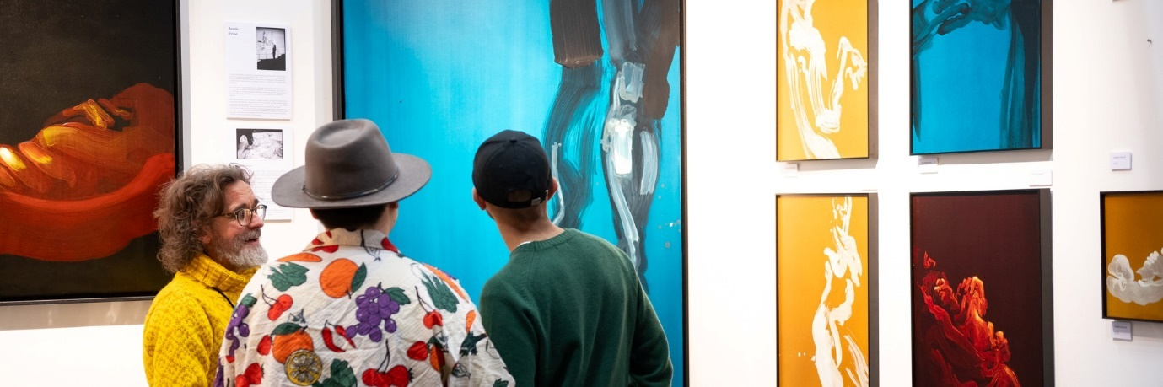

<insert location> based <insert artist name>, is to exhibit at this year's Manchester Art Fair (November 15-17), having been chosen to follow a rigorous selection process.

<Insert artist first name> will join over 170 UK and international individual artists, galleries and artist-led spaces showing the works of some of the world’s most exciting up-and-coming and celebrated artists including Andy Warhol, David Hockney, Damien Hirst, Tracey Emin, Salvador Dali, Francis Bacon, Grayson Perry, and Banksy.
Exhibiting for the first time / returning for its <xx> year, <insert artist name> will showcase <insert detail of the works to be shown>.

<Option for artist to insert par on the business’s back story.> ie artist name can be found on Stand <insert number>.

Speaking ahead of the acclaimed art fair, <insert name> <insert title> at <insert artist name>, said: "Insert quote."

Managing Director of Manchester Art Fair, Sophie Helm, added: "The quality and number of applications received for this year’s Fair was extremely high, making for an exceptionally difficult selection process. We are delighted to welcome <insert artist name> to Manchester Art Fair 2024 as we return with our most inclusive and impactful edition to date. We look forward to welcoming visitors to the Fair this November.”
The North’s largest and most significant art fair, Manchester Art Fair has welcomed over 110,000 visitors since its inception in 2008, amassing over £7m in art sales.
Showing a uniquely diverse mix of acclaimed galleries and independent artists, with a rich programme of artist talks, panel discussions, performances, and installations, it blurs the boundaries between the traditional and the contemporary, creating a friendly and unpretentious Northern art-buying experience.
Sitting alongside Manchester Art Fair is The Manchester Contemporary, a collegiate platform for young galleries, artist-led spaces, charitable organisations, and partner institutions providing a critically engaged environment for artistic exploration and development.
Tickets are available now at manchesterartfair.co.uk and priced at £12 for a weekend ticket or £25 for the preview night. Tickets include access to a rich programme of artist talks, panel discussions, performances and installations.
Ends

For supporting images please see:
<insert link>

For further information on Manchester Art Fair please contact:
Julie Wilson or Phoebe Melmoth at The Strong Agency on
Jules@thestrongagency.co.uk 07873 231 615 / Phoebe@thestrongagency.co.uk 07510 558 163

For further information on <insert artist name> please contact
<insert details> on <insert details>

