OPTIONAL EXTRA LOCATION PLAN |  |  | MANCHESTER ART FAIR  THE MANCHESTER CONTEMPORARY
Show: |  | Manchester Art Fair 2026
Venue: |  | Manchester Central
Dates: |  | 19-22 November 2026
Company:
Stand No.
Please complete and email back to Tracy Lee: operations@easelprojects.com by return.
Shelf position and height must be indicated | As standard, sockets are installed at a height 30cm clear from the floor on bottom left hand side of panel |Individual spot lights will be added to existing lighting batton 0.5m from front of stand | Long arm spots can be positioned where requested on grid.
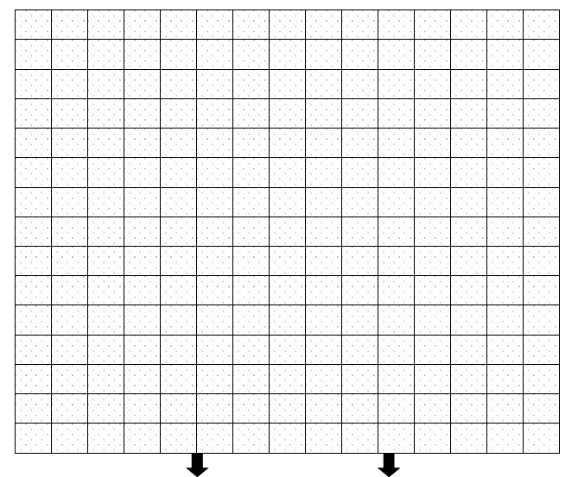
FRONT OF STAND
It is important that the sketch gives details of the open front(s) of the stand, and also the orientation of the stand in relation to others.
VERY IMPORTANT - Please Read The Following Notes:
A | All items (subject to availability) provided in accordance with suppliers' terms and conditions (a copy of which is available on request), and should be insured during the show period against all risks for 3 times the rental value.
B | This diagram will be used to place all orders on your stand. Ensure you complete the diagram clearly and show all heights and dimensions for the placement of all items you have ordered. Where no drawing is received, the items may be positioned at our discretion, and re-fixing could involve additional costs.
C | Only one four-way trailing outlet allowed per socket load of 500w may be used. Flexible cord (round  cable) should not exceed two metres.

