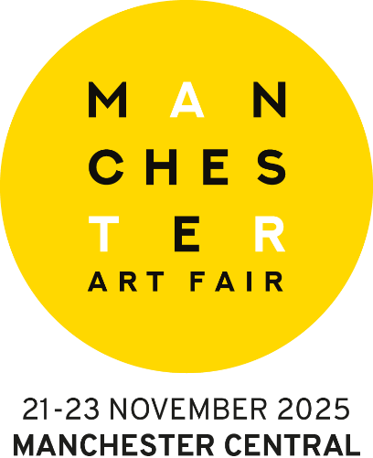

<insert gallery name> To Exhibit At Manchester Art Fair This November 21-23
- The Largest & Most Significant Art Fair In The North -

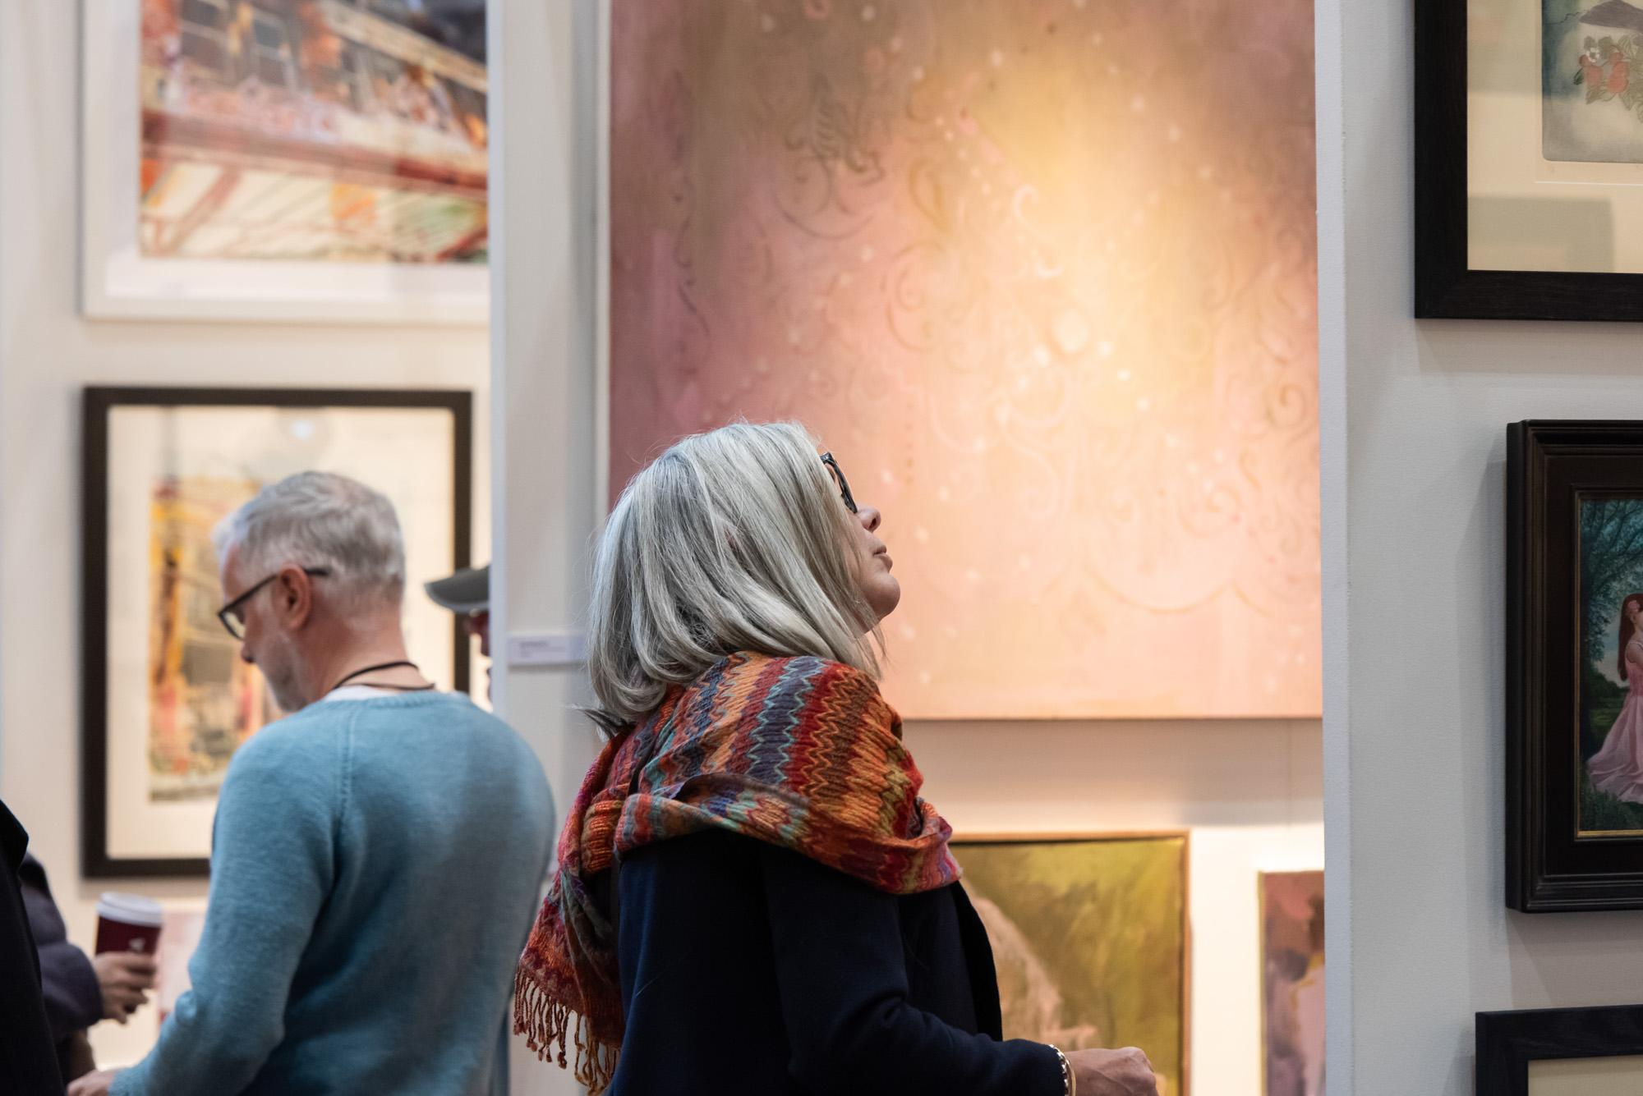
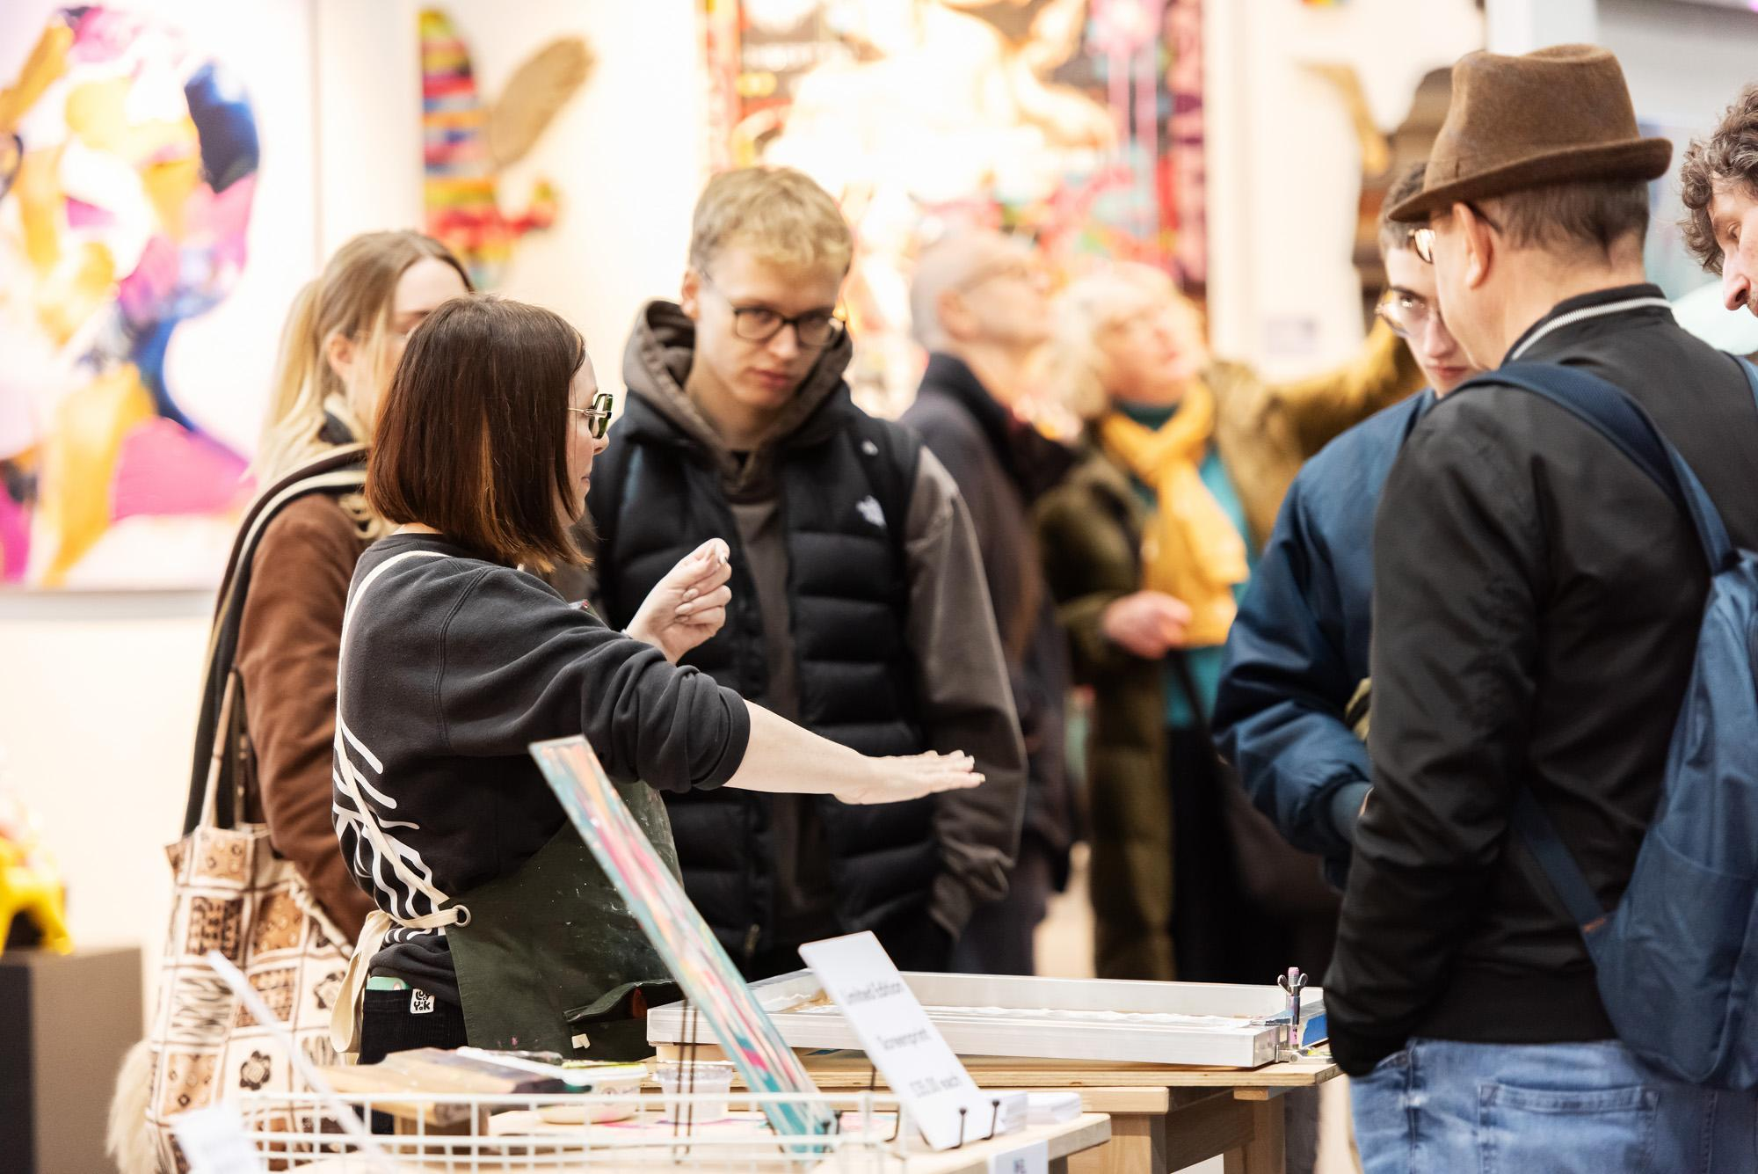
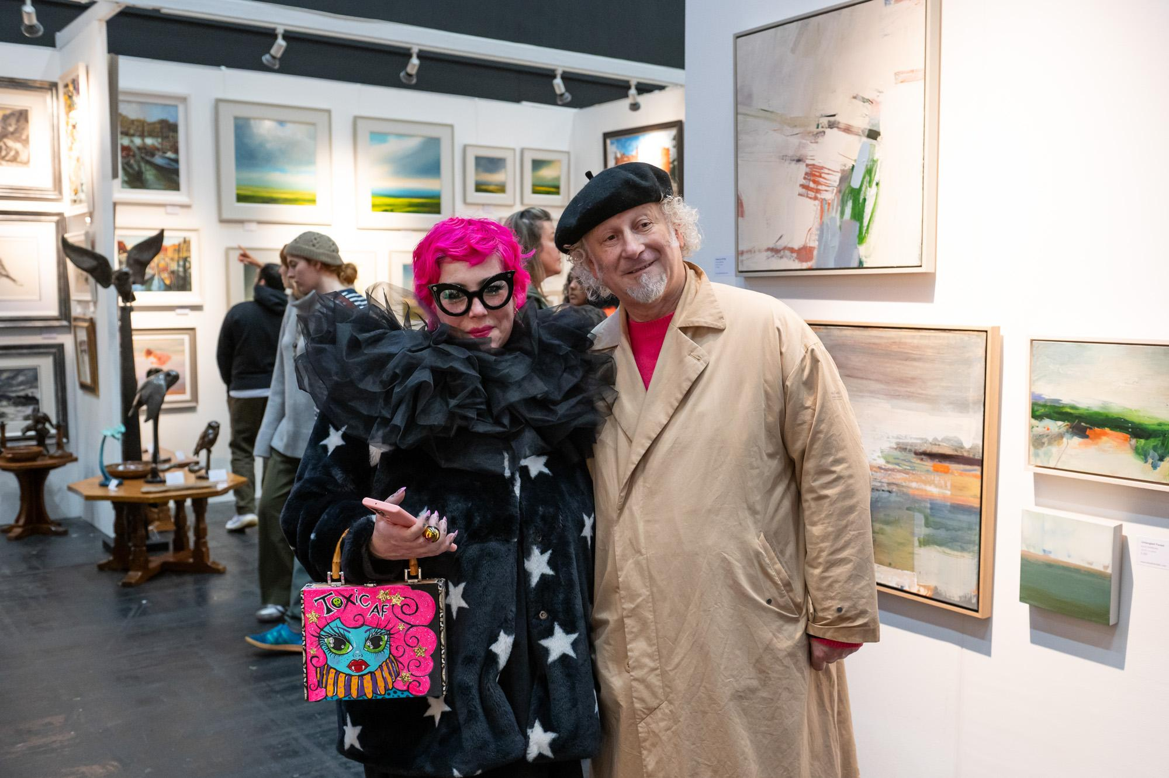

<insert location> based <insert gallery name>, is to exhibit at this year's Manchester Art Fair (November 21-23).

The gallery, located on <insert address i.e. Turner Street in Knutsford>, will join over 170 UK and international individual artists, galleries and artist-led spaces showing the works of some of the world’s most exciting up-and-coming and celebrated artists.
Exhibiting for the first time / returning for its <xx> year, <insert gallery name> will showcase <insert detail of the works to be shown>.
<Option for gallery to insert par on the business’s back story.> i.e. gallery name can be found on Stand <insert number>.

Speaking ahead of the acclaimed art fair, <insert name> <insert title> at <insert gallery name>, said: "Insert quote."

Managing Director of Manchester Art Fair, Sophie Helm, added: “The depth of talent and creativity presented throughout this year’s applications stage made for an exceptionally challenging selection process. It is therefore with great pleasure that we welcome <insert gallery name> to Manchester Art Fair 2025. The gallery’s selection is testament to the strength and relevance of its work, which we are confident will captivate and inspire art enthusiasts new and established when the fair returns this November.”
The North’s largest and most significant art fair, Manchester Art Fair has welcomed over 122,000 visitors since its inception in 2008, amassing over £7.8m in art sales.
Showing a uniquely diverse mix of acclaimed galleries and independent artists, with a rich programme of artist talks, panel discussions, performances, and installations, it blurs the boundaries between the traditional and the contemporary, creating a friendly and unpretentious Northern art-buying experience.
Hosted alongside Manchester Art Fair is The Manchester Contemporary which presents a carefully curated selection of independent galleries and artist-led spaces from across the UK and internationally. It platforms new work by emerging artists, create opportunities for artists from underrepresented backgrounds and provide an opening for artist-led spaces outside of London.
Tickets are available now at manchesterartfair.co.uk and priced at £12 for a day ticket, £15 for a two-day ticket, or £25 for a preview night ticket including access throughout the weekend. A booking fee applies.
Ends

For further information please contact Phoebe Melmoth or Julie Wilson at The Strong Agency on:
Phoebe@thestrongagency.co.uk / 07510 558 163 & Jules@thestrongagency.co.uk / 07873 231 615

For supporting images, please see the following link:
https://www.manchesterartfair.co.uk/press-images

Note to Editors
Manchester Art Fair 2025 is kindly supported by Porsche, Boodles, INNSiDE By Meliá, San Carlo, Blok Projects, Cass Art, Cheadle Hulme School, CIVIC, EPR Architects, Jack Arts, Manchester School of Art at Manchester Metropolitan University, Torevell & Partners, and urbanbubble.
Cultural partners include a-n, Castlefield Gallery, Contemporary Visual Arts Network England, esea contemporary, Friends of the Whitworth, Oldham Council, Grizedale Arts, Hallé, Liverpool Biennial, Manchester Art Gallery, Own Art, Grundy Art Gallery, The Harris, Lowry, The Portico Library, and The Whitaker Museum & Art Gallery.
The Manchester Contemporary is supported using public funding by the National Lottery through Arts Council England.

