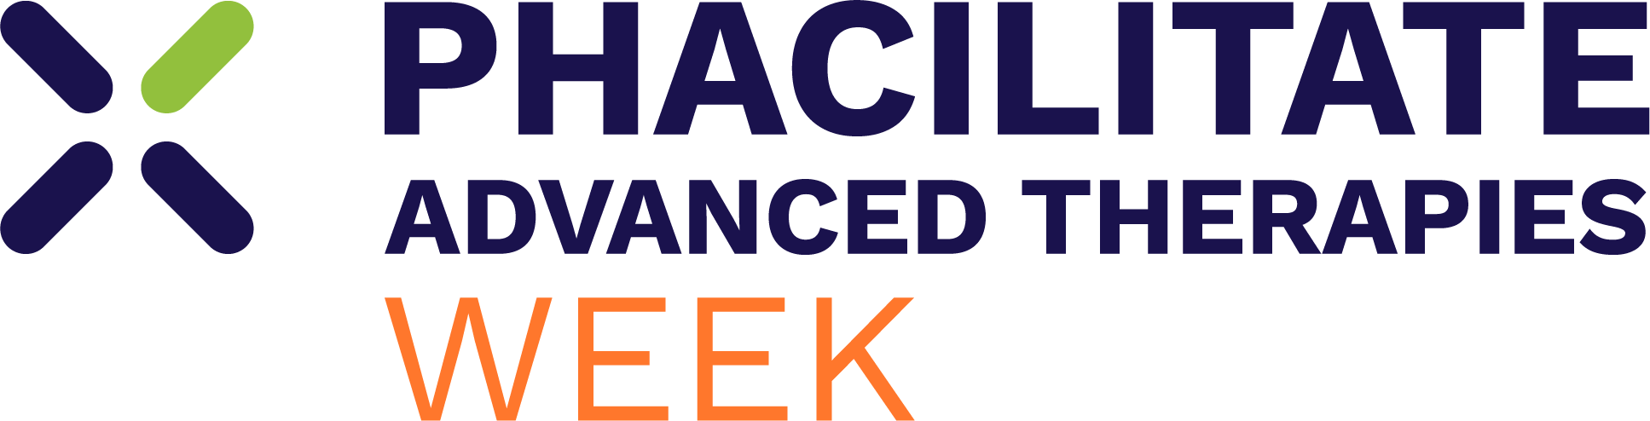

Event Description

Advanced Therapies Week 2027: San Diego, 18–21 January

The first major gathering of the year for the global cell and gene therapy community, Phacilitate Advanced Therapies Week brings the people shaping the future of advanced therapies together in San Diego.

Produced by Phacilitate, Advanced Therapies Week has spent more than 20 years connecting the science, people and partnerships needed to move advanced therapies forward. In 2027, more than 1,800 leaders from across biotech, pharma, academia, investment and the technology and service community will come together to tackle the industry's biggest challenge: turning scientific progress into therapies that can reach patients.

What sets Advanced Therapies Week apart is the breadth and influence of the community in the room. From early discovery and clinical development to manufacturing, commercialisation and patient access, the event brings the entire advanced therapies ecosystem together under one roof. Scientists share the stage with CEOs, leading key opinion leaders and the people shaping regulatory decisions. Developers meet investors. Technology providers sit alongside the teams translating, manufacturing and commercialising the next generation of therapies.

It means the conversations shaping the year happen here first, with the latest scientific, regulatory and commercial developments discussed by the people directly influencing what comes next.

Across four days, 250+ speakers will explore the decisions shaping the future of cell and gene therapy, while dedicated partnering, workshops, roundtables and networking create the space to turn those conversations into collaborations.

For 2027, Advanced Therapies Week will welcome:

- 1,800+ attendees
- 250+ speakers
- 550+ biotech and therapeutic developers
- 90+ investors

The week begins with the Investment Summit, bringing together biotech CEOs, founders, and investors at a pivotal moment in the industry's calendar, immediately following the J.P. Morgan Healthcare Conference. It is joined by the Biotech Founders Forum and a Patient Plenary, putting the people these therapies are ultimately designed to serve at the heart of the conversation from day one.

New for 2027, Phacilitate Advanced Therapies Week is expanding its global reach with a dedicated China CDMO delegation, a new Investigator-Initiated Trials (IIT) workshop, and greater visibility for emerging APAC biotechs, bringing more of the innovation, expertise, and perspectives shaping advanced therapies across Asia to San Diego.

Also new for 2027: Curechella. Created in partnership with the Emily Whitehead Foundation, this brand-new festival will take over the San Diego waterfront with live music, food trucks, drinks, and the Phacilitate Advanced Therapies Week community all in one place. It's set to be the biggest night of the week, bringing the industry together to celebrate, connect, and support a bigger purpose.

The Innovation & Poster Zone will also expand for 2027, giving more emerging companies, researchers, and academic innovators a platform to showcase the science that could shape what comes next.

Phacilitate Advanced Therapies Week 2027 isn't simply where the industry talks about what's next. It's where the people responsible for delivering it come together to make it happen.

Find out more about attending Phacilitate Advanced Therapies Week 2027 and secure your place: www.phacilitate.com/advanced-therapies-week

About Phacilitate
Phacilitate has been bringing the advanced therapies community together for more than 20 years. In 2005, we launched the world's first event dedicated to advanced therapies, when 200 scientists gathered in a Washington, D.C. hotel basement to ask whether the science could really work.

Today, the question has changed. The science is delivering, and the challenge is how we manufacture, scale, fund, and commercialize these therapies so they reach the patients who need them.

That shift, **from possibility to delivery**, has shaped Phacilitate and Advanced Therapies Week ever since. We bring together the science, partnerships, and people needed to move advanced therapies forward and ultimately reach more patients.

