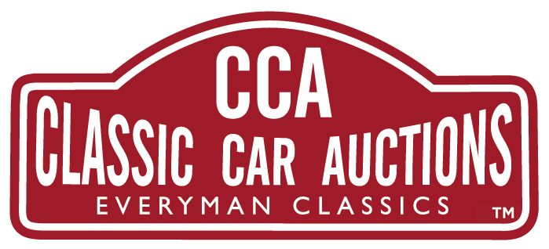

7TH JANUARY 2023
“FIRE UP THE QUATTRO”

AN ICON OF ITS TIME THIS 1992 Audi Quattro Turbo 20V (RR) BELOVED BY FILM MAKERS IS FOR SALE WITH CLASSIC CAR AUCTIONS 25TH-26TH MARCH AT A GUIDE PRICE OF £55,000 - £65,000.
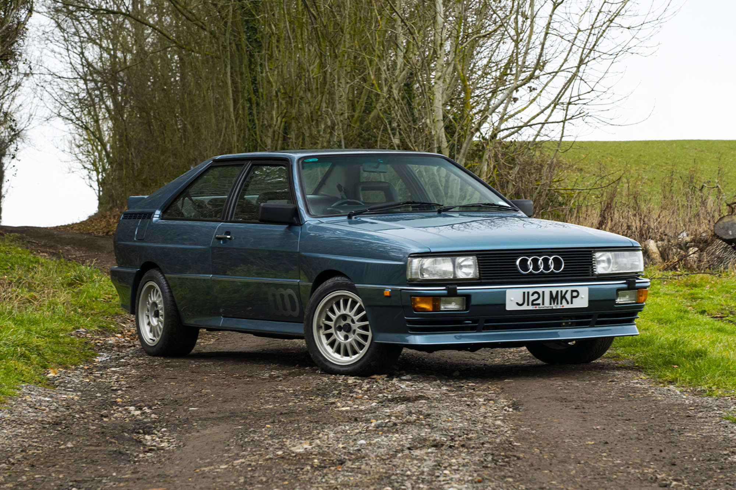
Britain’s love affair with the Audi Quattro is reflected in the prices being achieved at auction over the last ten years, starting at well below £50,000 in 2013, good examples are now pushing close to £100,000 as investment buyers move into this market.
The glamour this car represents was not lost on film makers as we saw in the BBC TV series ‘Ashes to Ashes’, starring Phil Glenister and Keeley Hawes. DCI Gene Hunt and his red Audi Quatro certainly cut to the criminal chase. As baddies fell in front of the car the phrase: “You’ve just been Quattroed,” entered the English lexicon. As did the rallying cry “Fire up the Quattro,” the command from legendary TV cop Gene Hunt, was also the cue to launch this Audi classic into popular culture. With its gleaming red paint job and cult cop Hunt behind the wheel, the 1983 model Quattro featured in the show soon drove itself into the affections of a whole new generation of fans.

But, long before this show the Quattro had already established a devoted fanbase as a result of its feats on the road and the rally circuit. All this glamour plays a part in the rising value of this car in the classic car auction market.
The Quattro being sold by CCA is one of only 295 right-hand drive, 20V RR models built, this very late production example benefited from a full nut and bolt restoration a few years ago and remains in impressive condition. In July 2016, the car was subject to a complete strip and respray by AM Cars in Ilminster at a cost of £29,000.
The car has done 8,000 miles since and has been maintained and serviced by AM. Air-con fitted in 2019. Cambelt service in June 2022.
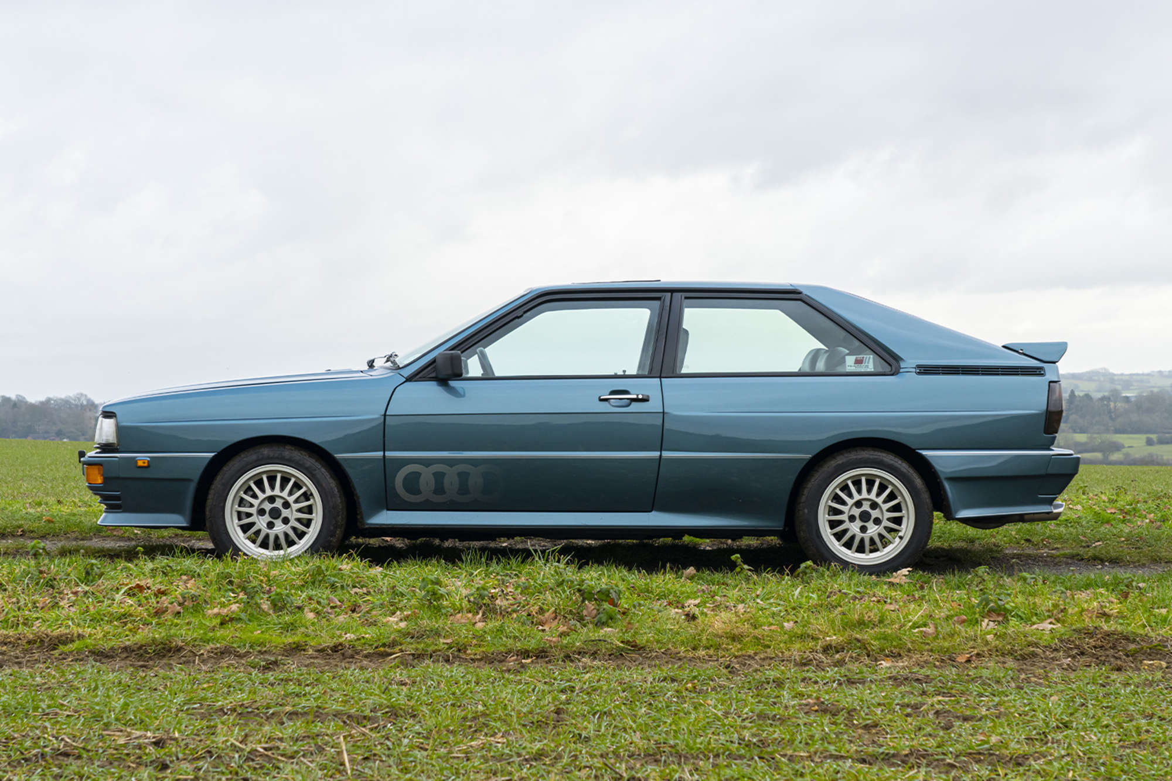
Gary Dunne, CCA Sales Manager, says of this brilliant car that established Audi’s name in the UK: “Audi’s claim of 6.3sec 0-62mph is perfectly credible. When you put your foot down the 1.3-tonne Quattro hurls forwards with vigour. Everything about this car reminds us of the 80’s era, although this car is one of the last of this model made in the early 90s. The car is for me a paragon of eighties indulgence, Filofaxes, rain macs, braces, yuppies. Remarkably, this model still handles exceptionally well given its 31 years.”
An original, UK-supplied car in Lago Blue with Platinum Grey /Quattro script interior it was first UK-registered in April 1992 and purchased by our vendor in 2015 with105k miles indicated. All original apart from a Milltek exhaust previously fitted (now replaced with the original) it is refinished in its (rare) original colour of Lago Blue. Full invoices and 200 photos with the car.
Supplied with both sets of keys, all handbook and service records since new, invoices and a complete set of MOT documents. One of 295, a rare colour, superbly presented, air-conditioning, essentially original and from long-term enthusiast ownership - a really lovely example.
This car is just one of many beautiful cars coming to Auction as CCA’s first sale of 2023 at the Practical Classics Classic Car and Restoration Show 24th - 26th March at the NEC, Birmingham, B40 1NT. All lots are available to view online where you can also register to bid in person, online or via commission www.classiccarauctions.co.uk. If you have a classic that you are looking to sell, why not take the opportunity to sell your car with CCA in a LIVE auction at the show – a show which attracts an audience of 1000s of buyers. Get in touch with Classic Car Auctions now, the official auction partner now - Tel: 01926 801088 or enquiries@classiccarauctions.co.uk.

CCA is the sister company of Silverstone Auctions and caters for 'Everyman Classics'.

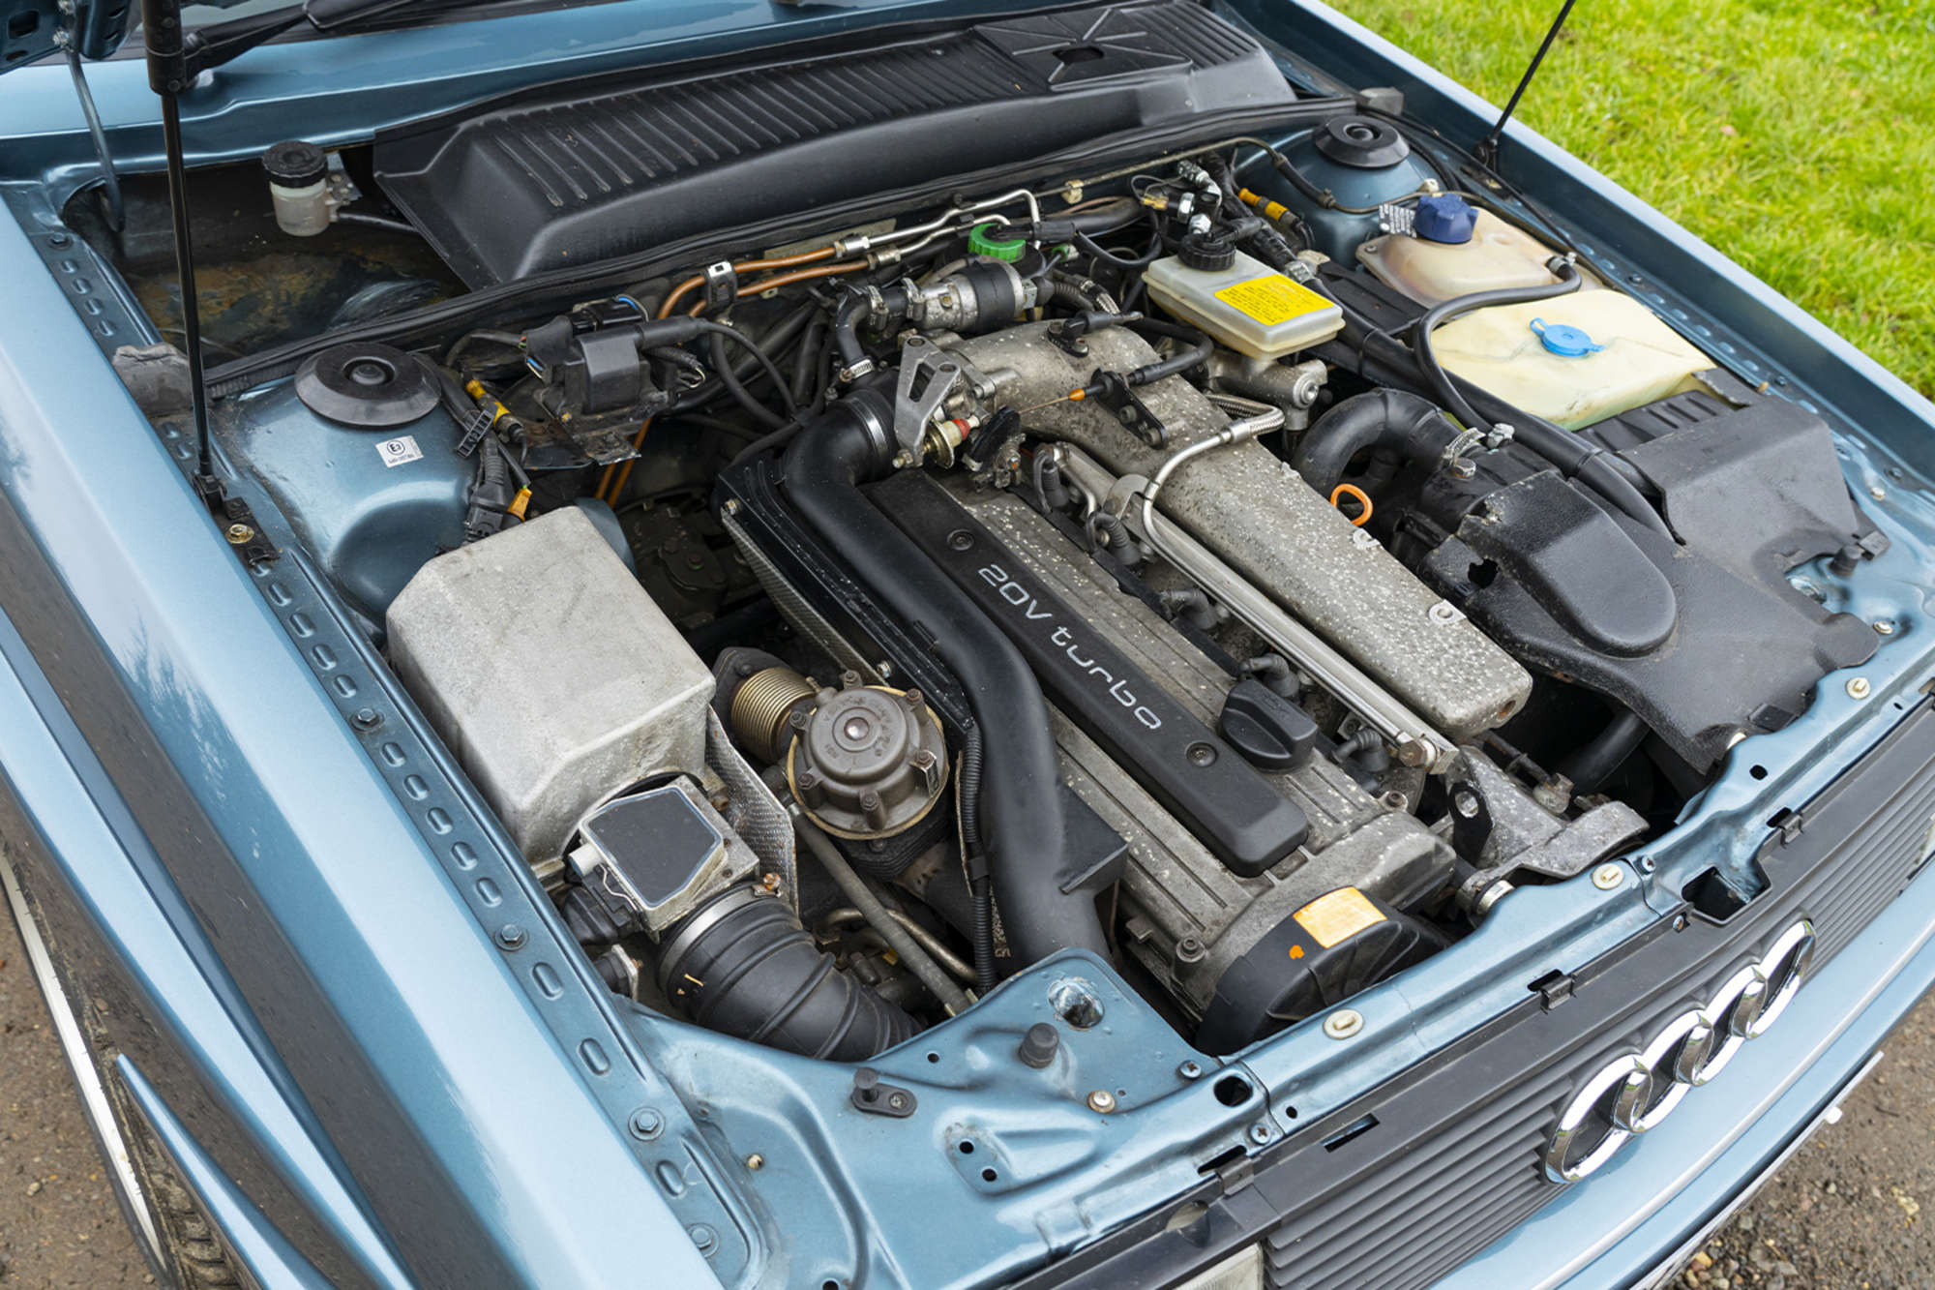

FOR MORE PRESS INFORMATION PLEASE CONTACT
Gary Dunne
44(0)1926 640888

gary@classiccarauctions.co.uk

About Classic Car Auctions CCA Classic Car Auctions

CCA is a specialist auction house for the sale of 'Everyman' classic cars; offering enthusiasts the opportunity to buy an impressive selection of iconic classic cars from across the eras.

Created in 2015 by the highly respected team from Silverstone Auctions and now a firmly established business itself; we have a consistent sales rate of over 75% for the last five years and have proudly sold over £25,000,000 worth of cars since our formation. The majority of our sales are held at our home from home, The Warwickshire Event Centre, Leamington Spa. Here our sales typically consist of around 180 cars with hundreds of dedicated buyers from around the country attending these one-day sales. We are also established at the Practical Classics Classic Car and Restoration Show which is held annually at the National Exhibition Centre (NEC), Birmingham, where we have been the official auction partner for the last five years.

At CCA we aim to make buying and selling a classic car as easy and as straight forward as possible. Our dedicated team of knowledgeable classic car specialists will provide sellers with honest and realistic estimates, combined with worldwide marketing and well-presented sale days which will help your car achieve a great price. We offer buyers a fantastic selection of affordable classic cars presented with extensive information and detailed condition reports.

If you'd like to know more about buying or selling a classic car with Classic Car Auctions, call us today on 01926 640888 or email enquiries@classiccarauctions.co.uk

