**12th January 2024**

**EX - HRH Prince Charles Special royal options Land Rover Discovery 3 for AUCTION at the Practical Classics Classic Car and Restoration Show, NEC Birmingham On 23-24 March**

**Land Rover Discovery 3** - **Ex HRH Prince Charles** – ESTIMATED: £20,000 - £30,000

This beautifully presented Land Rover Discovery 3 previously property of HRH Prince Charles is just one of the interesting lots presented by Classic Car Auctions for their first sale of 2024 at the Practical Classics Classic Car & Restoration Show.

This Royal Land Rover, in Tonga Green with an ebony trimmed leather interior, features some special items - alternate flashing headlamps and fog lamps, front and rear strobe lights, all adding to the interest and provenance of this special vehicle. It is being sold with its original Book Pack consisting of the handbook, fully stamped service book plus navigation leaflet and a letter confirming its delivery to the Head Chauffer at Clarence House for HRH The Prince of Wales and HRH The Duchess of Cornwall

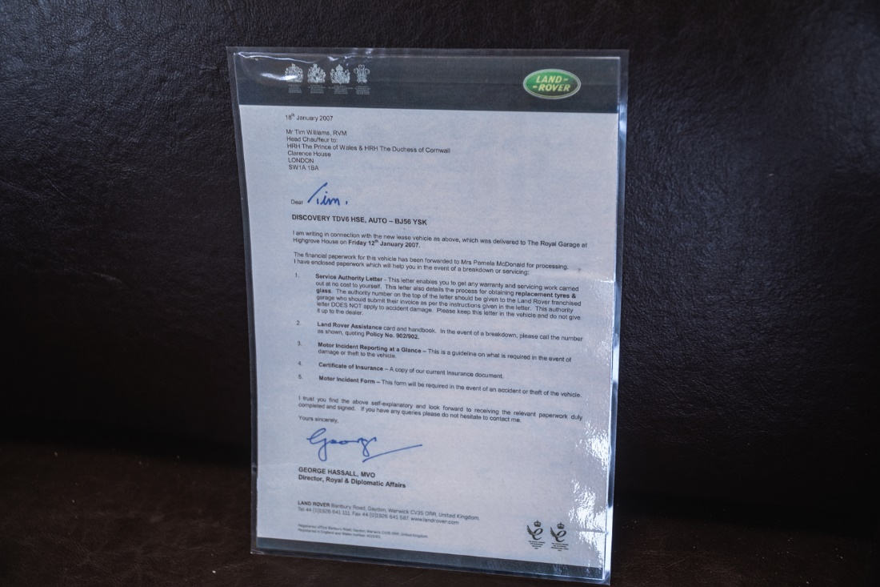

It is fitted with the durable 2.7 litre TDV6 diesel power plant producing 195 BHP coupled to a six speed "Steptronic" automatic transmission. The Land Rover has a mileage of 117,500.

Simon Langsdale who sourced the vehicle for CCA, says: “This is surely one for a serious Royal family collector, with Prince Charles now King Charles III, the vehicle has even greater Royal provenance adding to its value. One wonders if this will be the third royal 4x4 to make a World Record with us?”

Recently Iconic Auctioneers, CCA’s parent company, sold two Royal 4x4 vehicles**. Her Late Majesty Queen Elizabeth’s 2004 Range Rover** entered the **auction World Record** books in November 2023 selling for **£132,750.** Another vehicle with Royal Heritage was **HRH Duke of Edinburgh’s Land Rover 110** which received much pre-sale publicity around the world and sold in February 2023 for **£123,750** at the Race Retro Sale, setting another auction World Record.

The Land Rover was delivered new to a Mr Tim Williams, Head Chauffer to HRH The Prince of Wales & HRH The Duchess of Cornwall at The Royal Garage at Highgrove House on Friday the 12th of January 2007 with provenance by way of a signed letter from the manufacturer to substantiate this.

This particular Discovery, as you would imagine, was specified to the highest standards and comes with a full detailed list of options and also a Heritage Certificate confirming its authenticity.

The Practical Classics Classic Car and Restoration Show, attracts close to 30,000 classic car enthusiasts and potential buyers for a weekend of all thing’s car. It is a truly unmissable event for anyone who loves cars, along with a car auction offering hundreds of vehicles. Last year’s auction highlights included a 1970 Ferrari 365 GT 2+2 which sold for £106,000, a 1992 Audi Quattro Turbo 20V (RR) which sold for £56,500 and a delightful 1970 Austin Mini 1275GT - Garage find which had immense interest selling at £34,000.

**Classic Car Auctions,** the sister company of **Iconic Auctioneers** (formerly Silverstone Auctions) is a specialist auction house for the sale of 'Everyman' classics; offering enthusiasts the opportunity to buy an impressive selection of classic cars from across the eras. They are now inviting further entries to the Practical Classics Classic Car & Restoration Show Sale, and aim to make buying or selling a classic car at auction as easy and as straight forward as possible. Their dedicated team of knowledgeable classic car specialists will provide sellers with FREE honest and realistic valuations, combined with worldwide marketing and well-presented sale days to help your car achieve a great price. If you'd like to know more about buying or selling with Classic Car Auctions, call today on +44 (0) 1926 640 888 or email [enquiries@classiccarauctions.co.uk](mailto:enquiries@classiccarauctions.co.uk).

**FOR MORE PRESS INFORMATION PLEASE CONTACT**

Simon Langsdale

+44 (0)7496 556325

simon@classiccarauctions.co.uk

or

Gary Dunne

+44(0)1926 640888

gary@classiccarauctions.co.uk