

15th January 2025

1989 ROVER MINI THIRTY ELECTRIC - HERITAGE RECHARGED Offered Directly From SINGER Chris Rea.

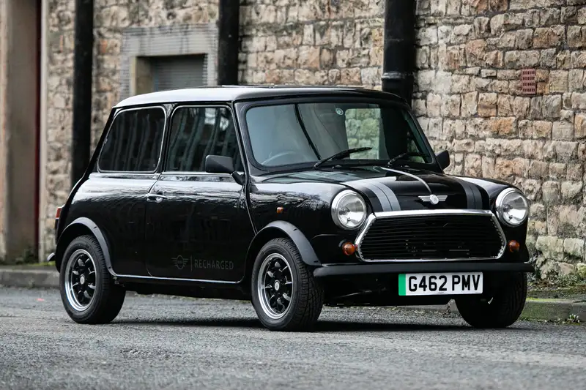

THis 1989 Rover Mini Thirty Electric - Heritage Recharged, with echoes of ‘driving home for christmas’ will be sold at The Iconic SALE at Race Retro On 22nd February, with all proceeds donated to domestic ABUSE charity refuge

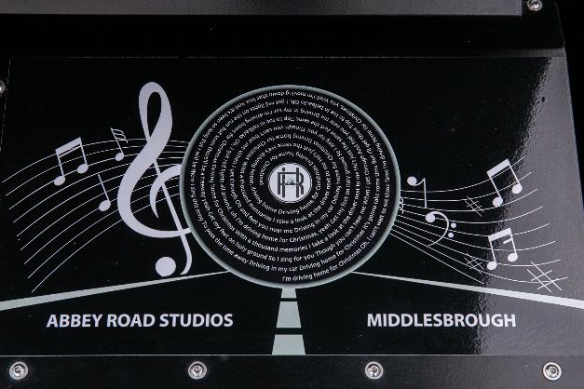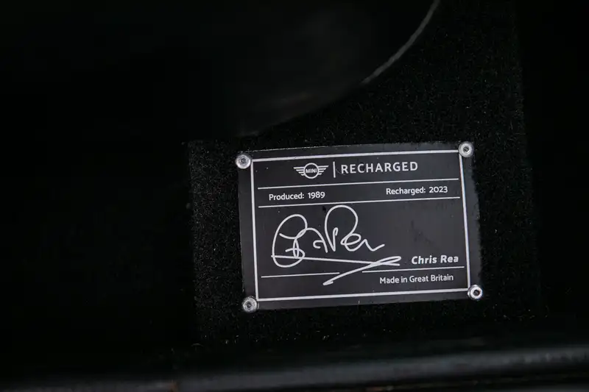
A tailor-made ‘Recharged/Heritage’ Mini Thirty commissioned by BMW Mini for rock legend, Chris Rea, comes to sale with Iconic Auctioneers for an estimate of £30,000 - £35,000 at Race Retro, Stoneleigh Park, Warwickshire.
Chris is donating all the proceeds from the sale of the car to Refuge, the country’s largest specialist provider of domestic abuse services, which is deeply grateful for the singer’s support. Iconic Auctioneers will also be donating all its associated fees to the cause
Abigail Ampofo, Interim Chief Executive of Refuge, said: "Chris Rea’s generous donation, alongside the support of Iconic Auctioneers, is a truly heartwarming gesture that will make a significant impact in helping us continue our vital work to provide life-saving support to those experiencing domestic abuse.
"The lucky buyer will not only be purchasing a beautiful and unique car, but they will also be offering hope to the thousands of women and children we support every day, through our emergency accommodation, community services and National Domestic Abuse Helpline. We’re incredibly excited to see how well the auction goes and hope that people are encouraged to dig deep for this important cause."
A delightful addition to any Mini or music collector’s stable, this is in many ways a unique Mini, with a real story to tell. It was unveiled and presented to Chris at the Abbey Road studios in February 2023, bringing the story full circle and underlining the profound connection between this car, its heritage and the pop culture that it celebrates.
Most people will know the Yuletide song Driving Home for Christmas, but what they might not know was that Chris Rea penned it on Christmas Eve 1978 during a memorable journey home in a different earlier Mini, from Abbey Road Studios in London to their, then, home in Middlesbrough with his wife Joan at the wheel. A difficult five-hour journey that was accompanied by heavy snow and ‘top to toe’ tailbacks but was to result in one of the most memorable Christmas hits ever to grace the airwaves and a staple on almost everyone’s festive playlist.
The full story, in Chris’s own words, on how the song was written can be viewed onYoutube:
https://www.youtube.com/watch?v=IZq762v-DuA&ab_channel=MINI
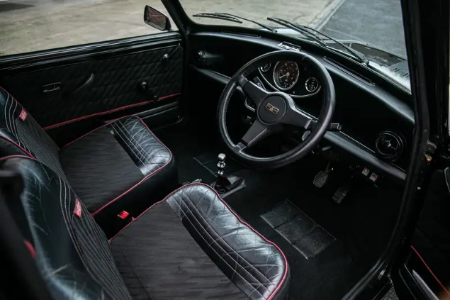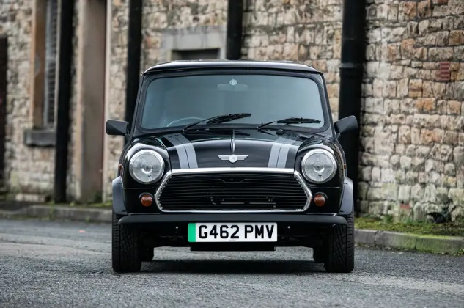
With that thought in mind, BMW-MINI instigated a winter advertising campaign in 2021 based around the song and its back story, encouraging Mini owners worldwide to produce their own Driving Home for Christmas videos, a concept that the Mini community seized upon and took to their hearts, resulting in a memorable and very successful marketing program.
In recognition of Chris' contribution, BMW-MINI commissioned 'Mini Sport & Recharged Heritage' to locate a suitable ‘classic’ Mini and work their magic, converting and future-proofing the sourced 1989 Mini Thirty to full electric power courtesy of Fellten in Bristol. Lest ye forget this car's unique provenance, the words to Driving Home for Christmas are emblazoned, 45rpm vinyl disc-style, across the power unit and Chris' signature engraved on a plaque to underline the significance of the Mini’s part in this very familiar song.
Chris said: "I’m incredibly proud to see this Mini, which holds such personal significance, being auctioned for such a vital cause. 'Driving Home for Christmas' has always been a special song for me, and to know that the proceeds from this car will go towards supporting those affected by domestic abuse gives it even more meaning. It’s a privilege to be part of this collaboration with Refuge, and I hope it helps raise both awareness and much-needed funds for the charity’s life-changing work."
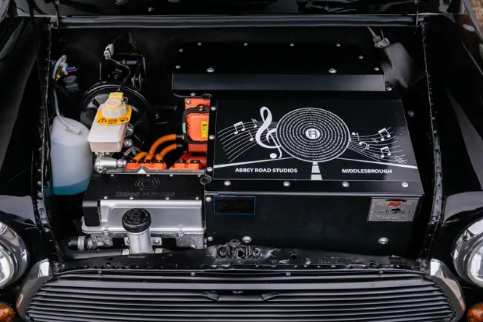
This special little Mini will be auctioned at a dedicated Collections’ & Competition Car Sale at Race Retro on the 22nd February at Stoneleigh Park, Warwickshire. Iconic Auctioneers are welcoming further entries for this Sale up until 24th January. Full details about the auction along with the other 100+ cars already consigned for this event can be seen at www.iconicauctioneers.com . Viewing in person will be available at the auction venue on Friday 21st February. For more information contact enquiries@iconicauctioneers.com or call +44 (0) 1926 691 141.
For more information about this car please contact:
Charles Smalley
Car Specialist
+44 (0) 7421 007866
charles@iconicauctioneers.com

IMAGES
For further high-resolution images please contact:
Penny Tyler, Marketing Manager
penny@iconicauctioneers.com
+44 (0) 1926 691 141

ABOUT ICONIC AUCTIONEERS
Iconic Auctioneers, formerly known as Silverstone Auctions, started in 2011 and rebranded in August 2023. They are a world-class, specialist auction house for the sale of classic cars, competition cars, modern supercars and all types of collectors’ cars, as well as modern and historic motorcycles and items of automobilia.
As one of the UK's leading auction houses they have exclusive automotive auction rights to hold Sales at some of Europe's biggest motoring events such as The NEC Classic Motor Show, The Silverstone Festival, Supercar Fest, Race Retro and the Practical Classics Classic Car and Restoration Show at the NEC. They also offer Private Sales and monthly Timed Online Auctions as part of their auction portfolio.
The team are passionate about seeking out the finest cars, motorcycles and collectibles and connecting them with right buyers from around the world, which has helped them achieve a number of record-breaking auction prices on behalf of vendors (17 Live Auction World records in 2023 and 12 to date in 2024).
In October 2024 Iconic Auctioneers acquired its sister company Classic Car Auctions Ltd (CCA) to operate both its Iconic Sales and Classic Sales (formerly CCA Sales) under the Iconic Auctioneers umbrella.
The company has achieved the following impressive statistics for its live car and motorcycle auctions:
- UK Market Leaders in 2021 and 2023 for live car auctions
- Held 141 auctions (as of October 2024)
- Sold 10,796 cars and motorcycles (as of October 2024)
- An average sales rate of 71% (as of October 2024)
- Total sales in excess of £332 million (as of October 2024)
- Customers in over 30 countries
More about Iconic Auctioneers can be found on their website iconicauctioneers.com, by emailing enquiries@iconicauctioneers.com or by calling +44(0)1926 691 141.
Head Office and Registered Address: Iconic Auctioneers Ltd. The Forge, Harwoods House, Banbury Road, Ashorne, Warwickshire, CV35 0AA.

About Refuge:
Refuge supports thousands of survivors on any given day, and every two minutes someone looks to Refuge for help. Refuge runs the National Domestic Abuse Helpline, which is the gateway to accessing specialist support across the country. More than one in four women in England and Wales experiences domestic abuse at some point in their lifetime, and on average every five days a woman is killed by a current or former partner.
Refuge’s National Domestic Abuse Helpline is available on 0808 2000 247, 24 hours a day 7 days a week for free, confidential specialist support. Refuge also offers a live chat service, which is available 10am-10pm, Monday to Friday. For further information and advice visit our website https://www.nationaldahelpline.org.uk/ For support with tech-facilitated abuse visit https://refugetechsafety.org


