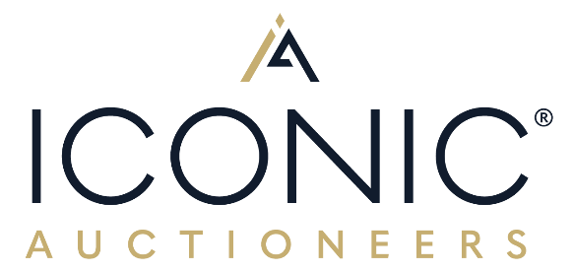

16th January 2025

THREE HOMOLOGATION specials come to market, INCLUDING A 1990 ‘ONE OWNER FROM NEW’ and another with just 3,423 MILES, TO GO UNDER THE HAMMER WITH ICONIC AUCTIONEERS AT THEIR RACE RETRO SALE ON 22ND fEBRUARY AT Stoneleigh Park.
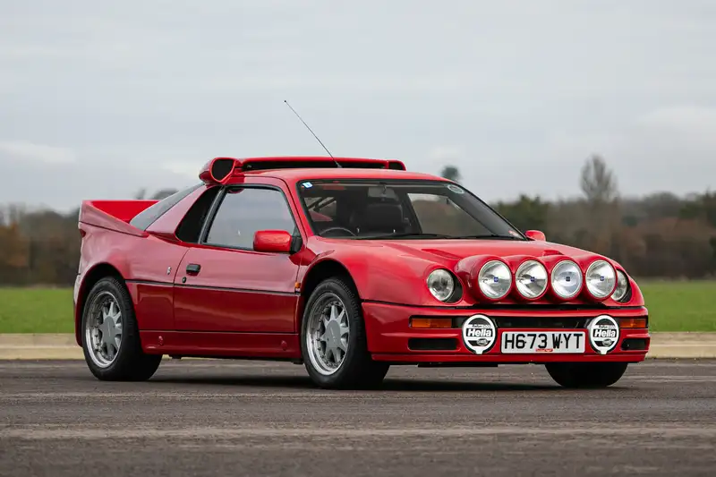

1990 Ford RS200 S, one owner from new. Estimate: £300,000 to £350,000
A homologation car is a road-legal car that is produced in limited numbers to meet the requirement of a race sanctioning body, so that they can be deemed fit for use in competition.

So, the bottom line when buying a homologation car is, that you are buying a wolf in a sheep’s clothing - and there lies the appeal. The car looks like a gent, but drives like a racing demon!

Iconic Auctioneers have a reputation as a specialist in selling competition cars in live auctions, with 12 Group B homologation specials sold last year (along with a basket load of fast Fords, another specialism!). With Race Retro Show kicking off the start of the motorsport season what better time to buy one of these very special cars, a boy racer’s dream and the darling of a racing man.

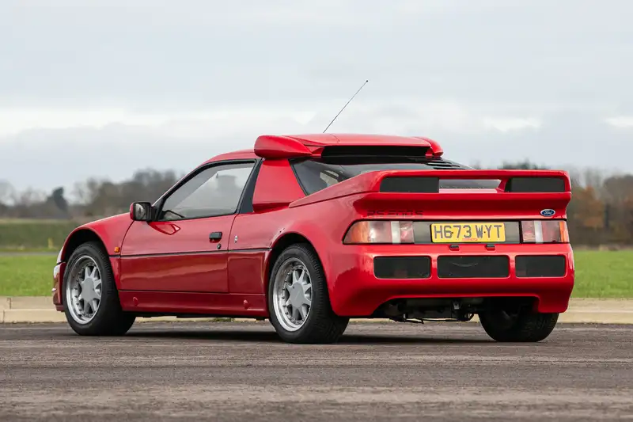

First on the auctioneer’s grid is this red race leading car: a 1990 Ford RS200, an exceptionally rare Ford RS200 S offered directly from its first and only owner, one of just 20 'S' models and one of only four finished by Ford in Ferrari Red. A truly unrepeatable opportunity. Estimate £300,000 - £350,000.

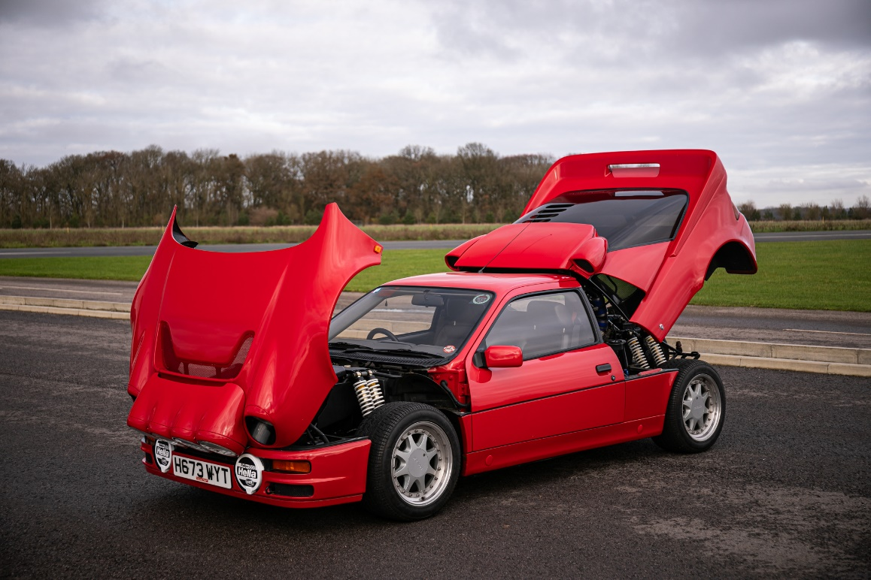

For the full details of this car see: https://www.iconicauctioneers.com/1990-ford-rs200-rec14406-1-stoneleigh-0225?pn=1&el=31639&pp=100
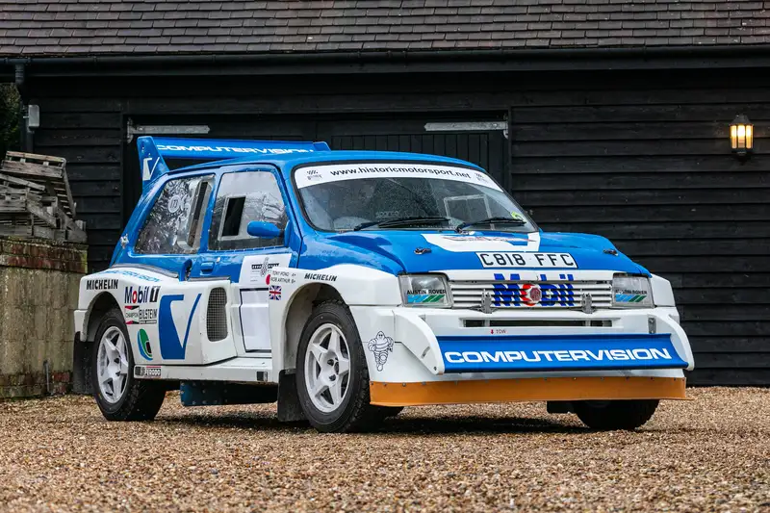
1986 MG Metro 6R4 'Group B' Ex-Works 'C818 FFC'. Estimated: £275,000 - £325,000

The second such homologation car is a 1986 MG Metro 6R4 'Group B' Ex-Works 'C818 FFC', chassis #208. An important Works 6R4, entered in the infamous 1986 Rallye de Portugal for Tony Pond and Rob Arthur.

Fresh to market having been privately owned and successfully campaigned since 1996 achieving some impressive results over the past 29 years, including winning the Tempest Rally in 1999 and numerous class wins at the Rallye Sunseeker from 1997 to 2012. More recently, C818 FFC has become synonymous with Goodwood, entertaining the crowds on the Goodwood Festival of Speed rally stage on no less than 16 occasions from 2005 to 2024. More recently, the car was selected as one of six MGs used in a special parade at the Festival for the MG 100 year celebrations, as well as competing on the infamous hill climb. The car has also competed at the Goodwood 72nd and 78th Members Meetings as part of the Rally Sprints.

More information of this car can be found here: https://www.iconicauctioneers.com/1986-mg-metro-6r4-rec14424-1-stoneleigh-0225?pn=1&el=31657&pp=100

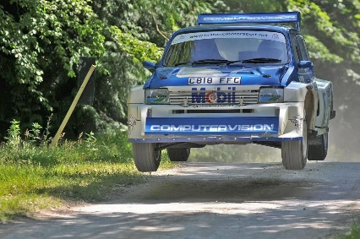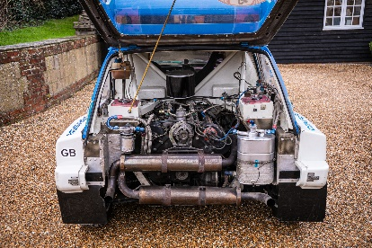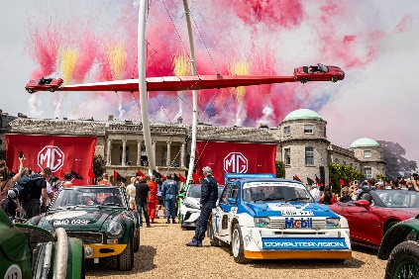

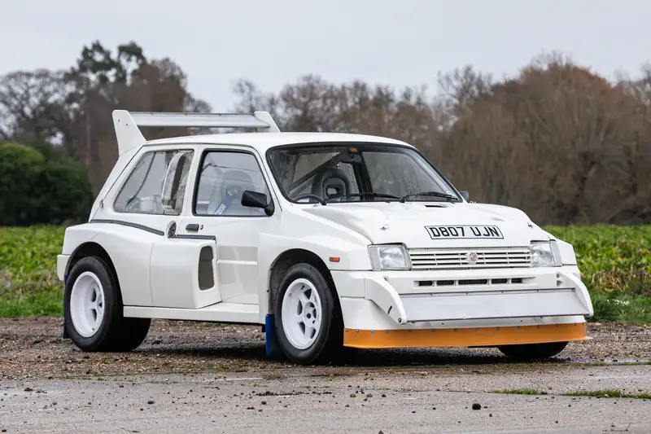
1987 MG Metro 6R4 'Clubman' - 3,423 Miles. Estimated: £200,000 - £240,000

Last but not least is this 1987 MG Metro 6R4 Clubman with just 3,423 miles. Sympathetically mechanically refreshed by its long-term owner, this road-registered 6R4 is as close to a totally correct, original 'Clubman' as you will find. Lionel Abbot the car’s specialist who consigned the car said “This is a remarkable example of a 6R4 Clubman, it has a perfect timeline, escaping any competition use and is truly on the button with an impeccable maintenance record that is fully documented in its history file”.
Full details on this car can be seen at: https://www.iconicauctioneers.com/1987-mg-6r4-rec14410-1-stoneleigh-0225?pn=1&el=31641&pp=100

These three cars will be auctioned at a dedicated Collections’ & Competition Car Sale at Race Retro on the 22nd February at Stoneleigh Park, Warwickshire. Iconic Auctioneers are welcoming further entries for this Sale up until 24th January. Full details about the auction along with the other 100+ cars already consigned for this event can be seen at www.iconicauctioneers.com . Viewing in person will be available at the auction venue on Friday 21st February. For more information contact enquiries@iconicauctioneers.com or call +44 (0) 196 691 141.
For more information please contact:
Rob Hubbard
Managing Director
+ 44 (0) 7775 511 825
rob@iconicauctioneers.com

IMAGES
For further high-resolution images please contact:
Penny Tyler, Marketing Manager
penny@iconicauctioneers.com
+44 (0) 1926 691 141
ABOUT ICONIC AUCTIONEERS
Iconic Auctioneers, formerly known as Silverstone Auctions, started in 2011 and rebranded in August 2023. They are a world-class, specialist auction house for the sale of classic cars, competition cars, modern supercars and all types of collectors’ cars, as well as modern and historic motorcycles and items of automobilia.
As one of the UK's leading auction houses they have exclusive automotive auction rights to hold Sales at some of Europe's biggest motoring events such as The NEC Classic Motor Show, The Silverstone Festival, Supercar Fest, Race Retro and the Practical Classics Classic Car and Restoration Show at the NEC. They also offer Private Sales and monthly Timed Online Auctions as part of their auction portfolio.
The team are passionate about seeking out the finest cars, motorcycles and collectibles and connecting them with right buyers from around the world, which has helped them achieve a number of record-breaking auction prices on behalf of vendors (17 Live Auction World records in 2023 and 12 to date in 2024).
In October 2024 Iconic Auctioneers acquired its sister company Classic Car Auctions Ltd (CCA) to operate both its Iconic Sales and Classic Sales (formerly CCA Sales) under the Iconic Auctioneers umbrella.
The company has achieved the following impressive statistics for its live car and motorcycle auctions:
- UK Market Leaders in 2021 and 2023 for live car auctions
- Held 141 auctions (as of October 2024)
- Sold 10,796 cars and motorcycles (as of October 2024)
- An average sales rate of 71% (as of October 2024)
- Total sales in excess of £332 million (as of October 2024)
- Customers in over 30 countries
More about Iconic Auctioneers can be found on their website iconicauctioneers.com, by emailing enquiries@iconicauctioneers.com or by calling +44(0)1926 691 141.
Head Office and Registered Address: Iconic Auctioneers Ltd. The Forge, Harwoods House, Banbury Road, Ashorne, Warwickshire, CV35 0AA.

