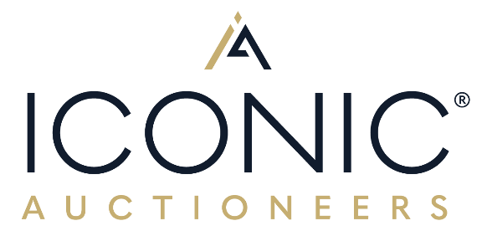

6th December 2024

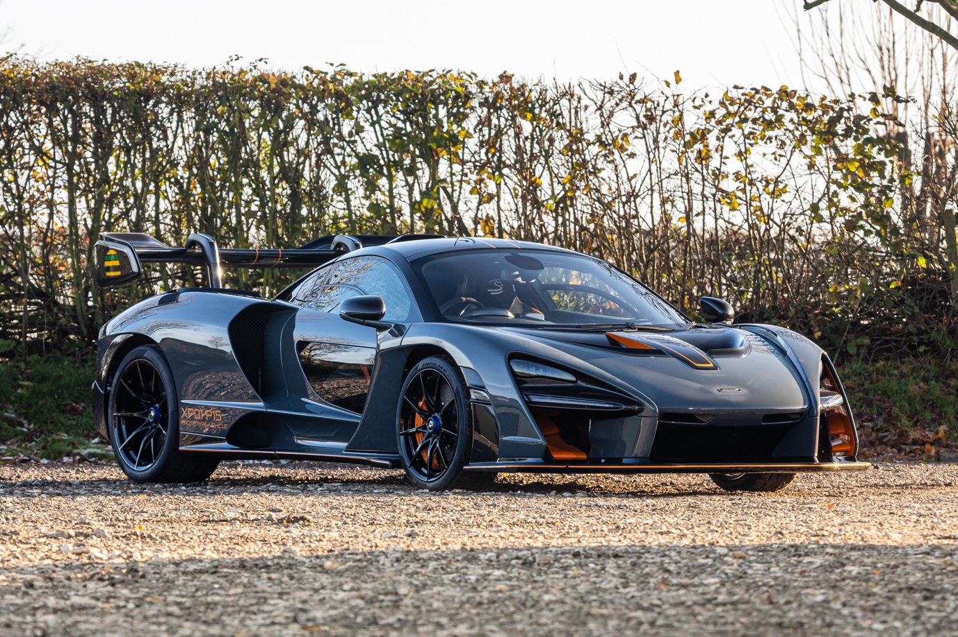
FIRST EVER MCLAREN SENNA No. 0001 UNVEILED IN 2018 AT THE GENEVA MOTOR SHOW, NOW FOR SALE WITH ICONIC AUCTIONEERS AT THE RACE RETRO SALE ON 22nd FEBRUARY

The first ever McLaren Senna, #0001, a whisper over 1,000 miles from new, fresh major service and fully loaded with MSO parts, comes to sale with Iconic Auctioneers on 22nd February 2025 at Race Retro in Stoneleigh Park, Warwickshire, estimated at £800,000 to £1,000,000.

The number one is rightfully synonymous with the 3-time World Champion Ayrton Senna, who was undeniably one of the best and most iconic racing drivers to ever exist, so what better representation of the Senna than the very first example, VIN #0001. To name a car after Ayrton meant the bar was set unprecedentedly high, but it's fair to say McLaren executed their tribute with flying colours.

The McLaren Senna had some big boots to fill, being the third iteration of McLaren’s ‘Ultimate Series’ following the legendary F1 and widow-maker P1, but it’s safe to say the Senna lives up to all expectations and more.
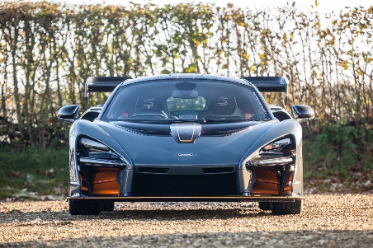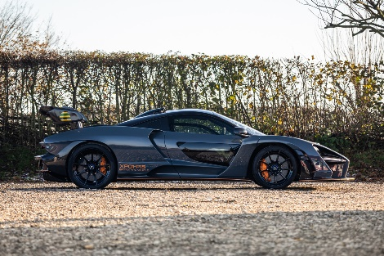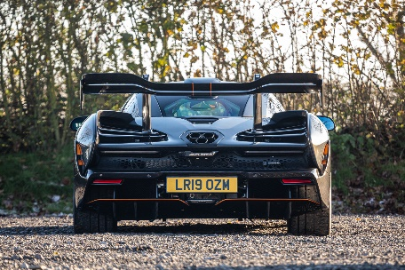

First unveiled at the 2018 Geneva Motor Show it was a sharp and purposeful car with one main goal; to be the fastest and most track-focused road car McLaren had ever produced. A fitting tribute to Ayrton Senna to say the least.

In contrast to its precursor, the P1, the Senna forwent any hybrid system or electrical powertrain assistance, instead opting for a modified version of McLaren’s own 4.0-litre twin-turbocharged V8, codenamed M840TR. This engine is an engineering feat on its own, being the most powerful engine ever installed in a McLaren road car, producing 789bhp and 800nm of torque, transmitted to the tarmac through a 7-speed dual-clutch transmission and the rear wheels.

The chassis is based around McLaren’s own 'Monocage III' tub and is constructed of lightweight materials and carbon fibre throughout for a combination of maximum stiffness and lightness. Retardation is achieved by Formula 1–inspired carbon brakes and currently holds the record for braking performance for production cars: 124 mph to a standstill in just 100 metres, decelerating with a force of 2.1g.

Other performance statistics to which the Senna can lay claim are no less impressive: 0–62mph dispatched in 2.8 seconds, 0–124 mph in just 6.8 seconds, and by doing away with any hybrid or electrical units the dry weight is just under 1,200kg, equating to a power-to-weight ratio of 668bhp per ton. It thus eclipses even the McClaren P1 statistic of 646hp per ton, whilst simultaneously offering significantly more downforce.

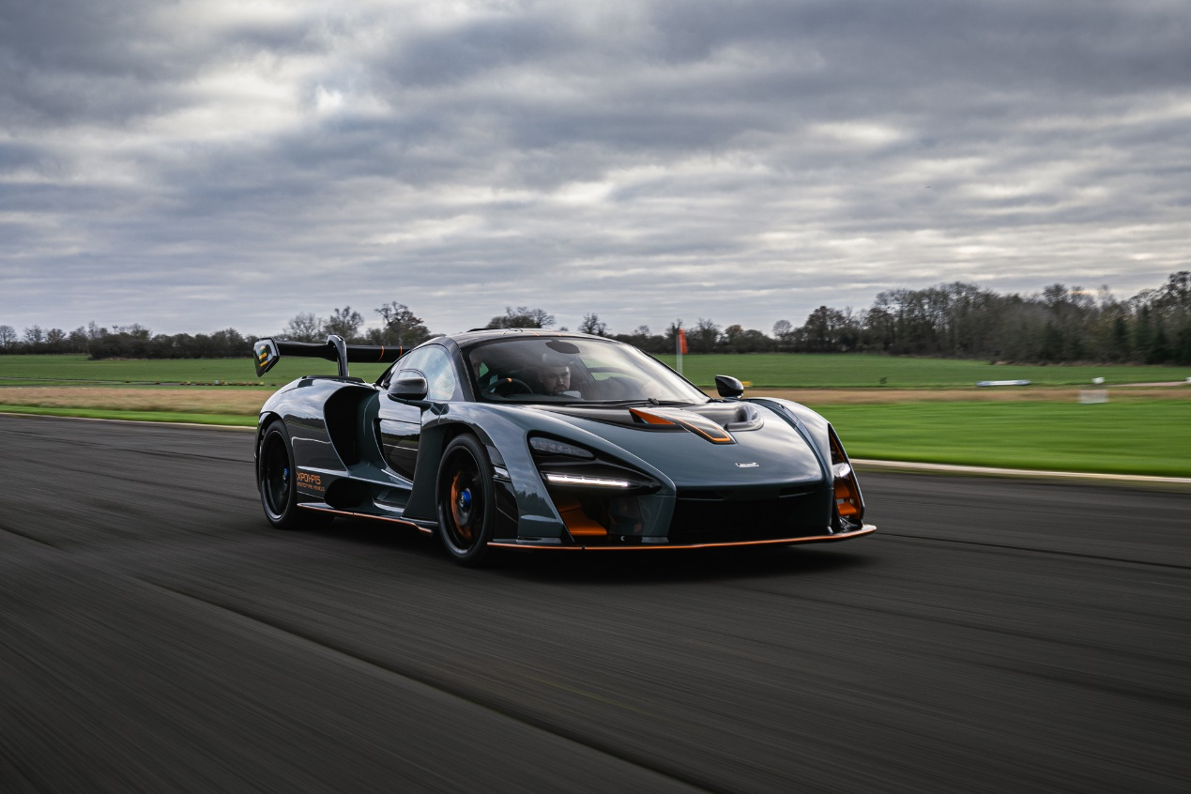

The McLaren Senna offered here is truly special, even within the context of being a Senna. This is XP01, VIN #0001, making it the very first Senna ever produced. Not to be confused with the first customer car, which is finished in a unique Blue and White colour scheme, this is a uniquely specified example which incorporates almost every conceivable McLaren Special Operations (MSO) bespoke and optional equipment.

XP01 has a full McLaren Service History with two major services undertaken by McLaren Manchester, with the most recent service in June 2024, costing nearly £10,000 as it had new front and rear suspension accumulators to ensure the car remains in perfect order throughout. Interestingly XP01’s Pre-Delivery Inspection was stamped by McLaren Central which no other Senna we’re aware of has received.

Iconic Auctioneers are now inviting further entries to join their already impressive line-up of cars for their first auction of 2025 at Race Retro in Stoneleigh Park, Warwickshire, in February 2025. Entries close at the end of January so now is the time to contact the auction house if you are interested in selling. You can request a free valuation and read their sellers guide on their website iconciauctioneers.com or call +44 (0) 1926 691 141 to speak to one of their specialists.
More information about this car and a 360 degree video can be found here: https://www.iconicauctioneers.com/2019-mclaren-senna-chassis-001-rec14358-1-stoneleigh-0225?pn=1&el=31472&pp=100
For more information please contact:
Harry Fox-Edwards
+44 (0) 7398 872032
harryfe@iconicauctioneers.com

IMAGES
For further high-resolution images please contact:
Harry Hudson, Marketing Assistant
harryh@iconicauctioneers.com
+44 (0) 1926 691 141

ABOUT ICONIC AUCTIONEERS
Iconic Auctioneers, formerly known as Silverstone Auctions, started in 2011 and rebranded in August 2023. They are a world-class, specialist auction house for the sale of classic cars, competition cars, modern supercars and all types of collectors’ cars, as well as modern and historic motorcycles and items of automobilia.
As one of the UK's leading auction houses they have exclusive automotive auction rights to hold Sales at some of Europe's biggest motoring events such as The NEC Classic Motor Show, The Silverstone Festival, Supercar Fest, Race Retro and the Practical Classics Classic Car and Restoration Show at the NEC. They also offer Private Sales and monthly Timed Online Auctions as part of their auction portfolio.
The team are passionate about seeking out the finest cars, motorcycles and collectibles and connecting them with right buyers from around the world, which has helped them achieve a number of record-breaking auction prices on behalf of vendors (17 Live Auction World records in 2023 and 12 to date in 2024).
In October 2024 Iconic Auctioneers acquired its sister company Classic Car Auctions Ltd (CCA) to operate both its Iconic Sales and Classic Sales (formerly CCA Sales) under the Iconic Auctioneers umbrella.
The company has achieved the following impressive statistics for its live car and motorcycle auctions:
- UK Market Leaders in 2021 and 2023 for live car auctions
- Held 141 auctions (as of October 2024)
- Sold 10,796 cars and motorcycles (as of October 2024)
- An average sales rate of 71% (as of October 2024)
- Total sales in excess of £332 million (as of October 2024)
- Customers in over 30 countries
More about Iconic Auctioneers can be found on their website iconicauctioneers.com, by emailing enquiries@iconicauctioneers.com or by calling +44(0)1926 691 141.
Head Office and Registered Address: Iconic Auctioneers Ltd. The Forge, Harwoods House, Banbury Road, Ashorne, Warwickshire, CV35 0AA.

