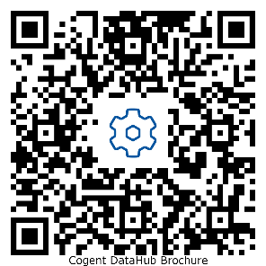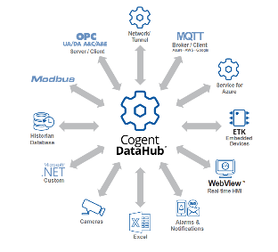
Cogent DataHub – All connections, full integration, and complete visualization package.
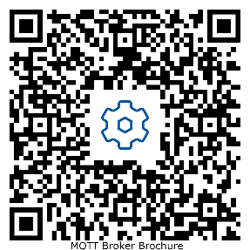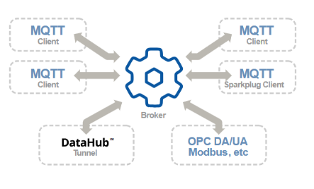
Smart MQTT Broker – Aggregate, standardize, and secure your MQTT data.
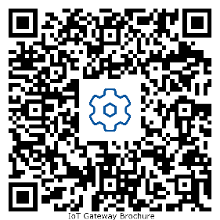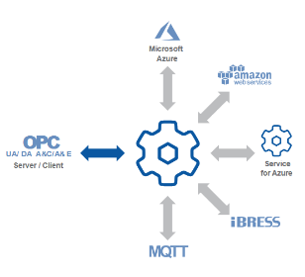
IoT Gateway – Send your OPC UA and DA data to Azure, Google, AWS, or any MQTT Broker.
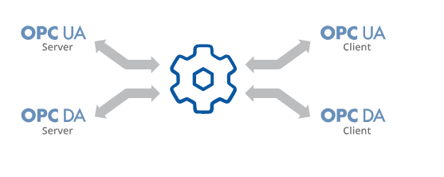
OPC Gateway - Connect OPC UA servers to OPC DA clients, or OPC DA servers to OPC UA clients.
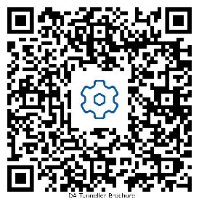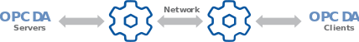
Tunnellers - Connect OPC DA, UA, A&E Modbus, or DDE over a network. Visit https://cogentdatahub.com/products/tunnellers/ for more tunnellers.
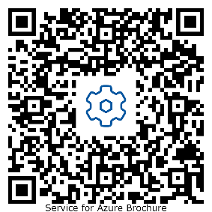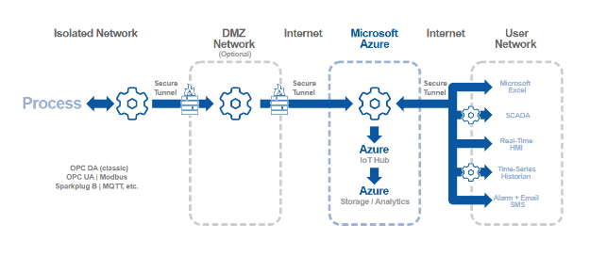
Cogent DataHub Service for Azure – Microsoft Azure Managed application for secure, real-time industrial data communications.
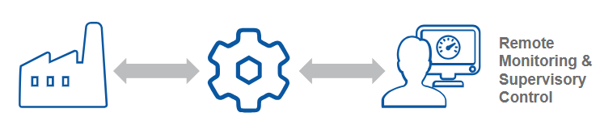
Webview - Build web-based HMIs to display and interact with OPC data.
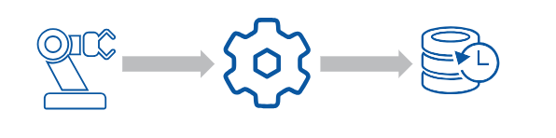
Historians - Store your data in a flat-file real-time historian in a compact, easily accessible format.
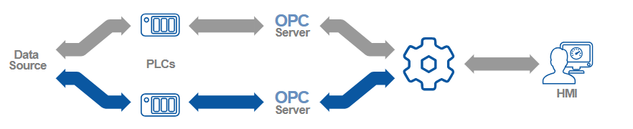
Redundancy – Ensure a reliable connection with hot-standby backup.
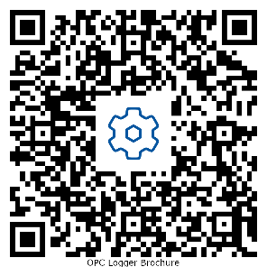
Loggers - Log OPC or Modbus data to a database, also query the database. Visit https://cogentdatahub.com/products/loggers/ for the Modbus logger as well.

