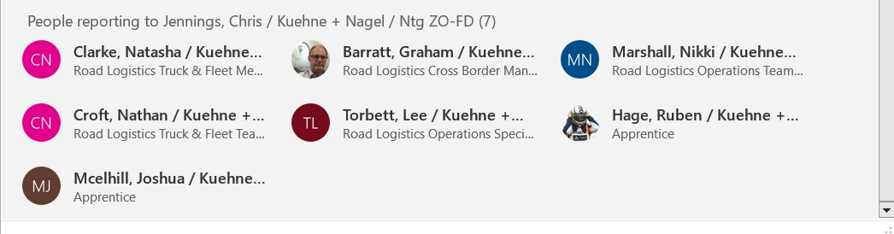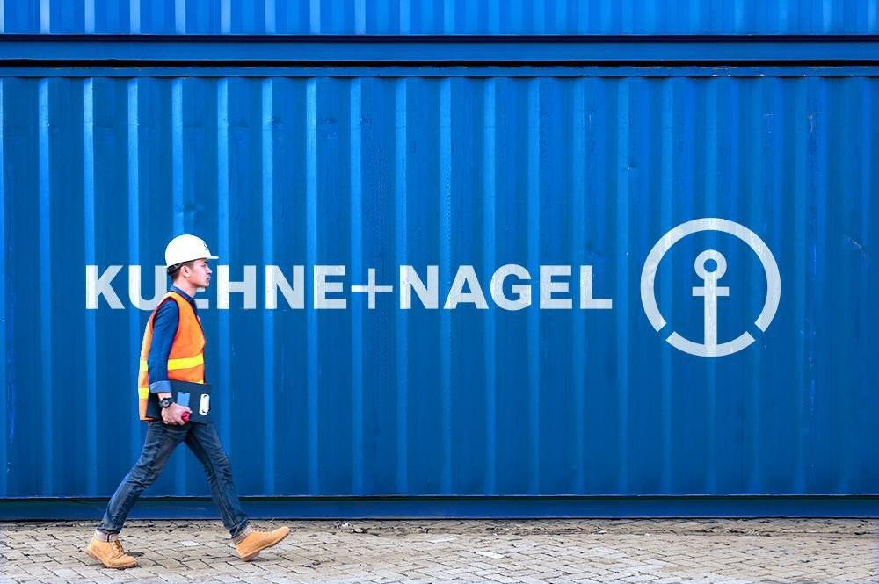

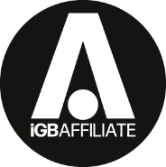



Traffic instructions

Fira Gran Via, 20th-22nd January 2025

Shipping instructions and tariff © 2024 Kuehne+Nagel. All rights reserved. This document & any attachments contain proprietary, confidential information. Unauthorised use or dissemination in whole or in part is strictly prohibited.

Page 1 of 6



**How to make a traffic booking**

[**BOOK HERE**](https://kuehne-nagel.syncrosupply.com/gui/%23/login)



**1**

**Registration & time slot allocation**

Register on the traffic system with your account.

**2**

Select ICE or iGBA 2025 to see available slots linked to your account & an overview of your bookings.

**3**

Search for available time slots.

**4**

Select your chosen time slot, enter your information, & confirm.



**After your booking**

You will receive an email with your time slot alongside a unique reference and QR code. **Please keep this to hand & ensure the information is shared with your driver.**

Registration at ICE & iGBA 2025 marshalling yard using booking confirmation (reference number) and / or QR code

# Your traffic booking process: a step-by-step guide

1. Access the transport management system
2. Driver arrives at marshalling yard for ICE & iGBA 2025 with QR code or reference, prior to booking slot.
3. Vehicle is matched with booking slot and provided with access accreditation
4. Book your designated arrival slot and time.
5. Receive automatic confirmation, including slot reference number and QR code. Please ensure this is given

to your driver.

* 1. Vehicle is processed and departs Fira Barcelona (when

space is available)



Shipping instructions and tariff © 2024 Kuehne+Nagel. All rights reserved. This document & any attachments contain proprietary, confidential information. Unauthorised use or

dissemination in whole or in part is strictly prohibited. Page 2 of 6

Shipping instructions and tariff © 2024 Kuehne+Nagel. All rights reserved. This document & any attachments contain proprietary, confidential information. Unauthorised use or dissemination in whole or in part is strictly prohibited.

Page 3 of 6

# A guide to access fees for ICE & iGBA 2025



**Access fees**

|  |  |  |
| --- | --- | --- |
| Booking Type | Fee | Comments |
| **Handling booked with**  **Kuehne+Nagel** (excluding small vans) | €65.00 | Venue access fee / traffic management |
| **Self-unloading trailers** | €140.00 | Venue access fee / traffic management |
| **Small vans** | €15.00 | Venue access fee (paid directly at marshalling yard) |



In order to secure a booking slot, all fees need to be paid, either in advance, or upon the driver’s arrival in the marshalling yard.

**Please note access fees are per vehicle, not per booking.**

**Vehicle marshalling yard**

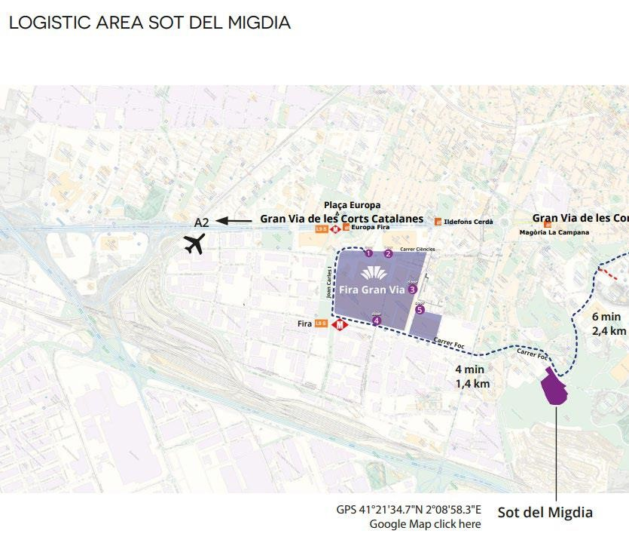

**How to find the vehicle marshalling yard**

All vehicles prior to entry into ICE & IGB 2025 will be required to attend the vehicle marshalling yard, also known as “SOT”.

Vehicles will be processed and receive the necessary accreditation to access the venue so please ensure timely arrival prior to your designated access slot to ensure adequate time for processing.

Vehicles arriving directly to the venue without the necessary accreditation will be turned away and sent to the vehicle marshalling yard.

## Please arrive to SOT 1hr prior to your confirmed STM booking slot for processing.

**Address:** Carrer del Foc, 139 – 08038 – BARCELONA

https://maps.app.goo.gl/T8UYC3ewCiAygh WYA

**GPS:** 41.21.34.7”N 2.08.58.3”E

# Important information

## Access to Fira Gran Via

+ Vehicle access only for un/reloading purpose—no parking.

+ Only cargo vehicles accepted—no passenger vehicles allowed to access.

+ All vehicles (no exceptions) first need to register at the vehicle registration area SOT.

+ High visibility vest and appropriate safety shoes need to be worn (including drivers).

Shipping instructions and tariff © 2024 Kuehne+Nagel. All rights reserved. This document & any attachments contain proprietary, confidential information. Unauthorised use or dissemination in whole or in part is strictly prohibited.

Page 4 of 6

## Barcelona low emission zone

Please ensure you have the correct permit for your vehicle to access.

https://[www.zbe.barcelona/en/zones-baixes-](http://www.zbe.barcelona/en/zones-baixes-) emissions/vehicles-afectats.html

## SOT opening times

Please contact Kuehne+Nagel for further information.

Shipping instructions and tariff © 2024 Kuehne+Nagel. All rights reserved. This document & any attachments contain proprietary, confidential information. Unauthorised use or dissemination in whole or in part is strictly prohibited.

Page 5 of 6



**Vehicle types & access**



**Trailer (articulated truck)**



**Mid-size truck**



**Van**

**Logistics handling**—forklift service requirements

**Self-unloader** (by hand or tail lift)— no Kuehne+Nagel service required



**Kuehne+Nagel forklift service required**

Vehicle booking processed via Kuehne+Nagel STM traffic system or onsite at SOT on a first-come-first- served basis.

Vehicle held at marshalling yard prior to space availability.

Vehicle booking processed via Kuehne+Nagel STM traffic

management system. Time slot allocated & booking confirmation issued to booking party with traffic instructions.

Vehicle processed at marshalling yard and permitted site access in accordance with slot provision.

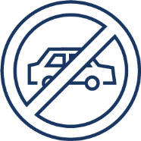

**Cars**—**non-cargo vehicles**

Non-cargo vehicles are not permitted access to venue loading bays at any time unless special access permission granted.

# FAQs

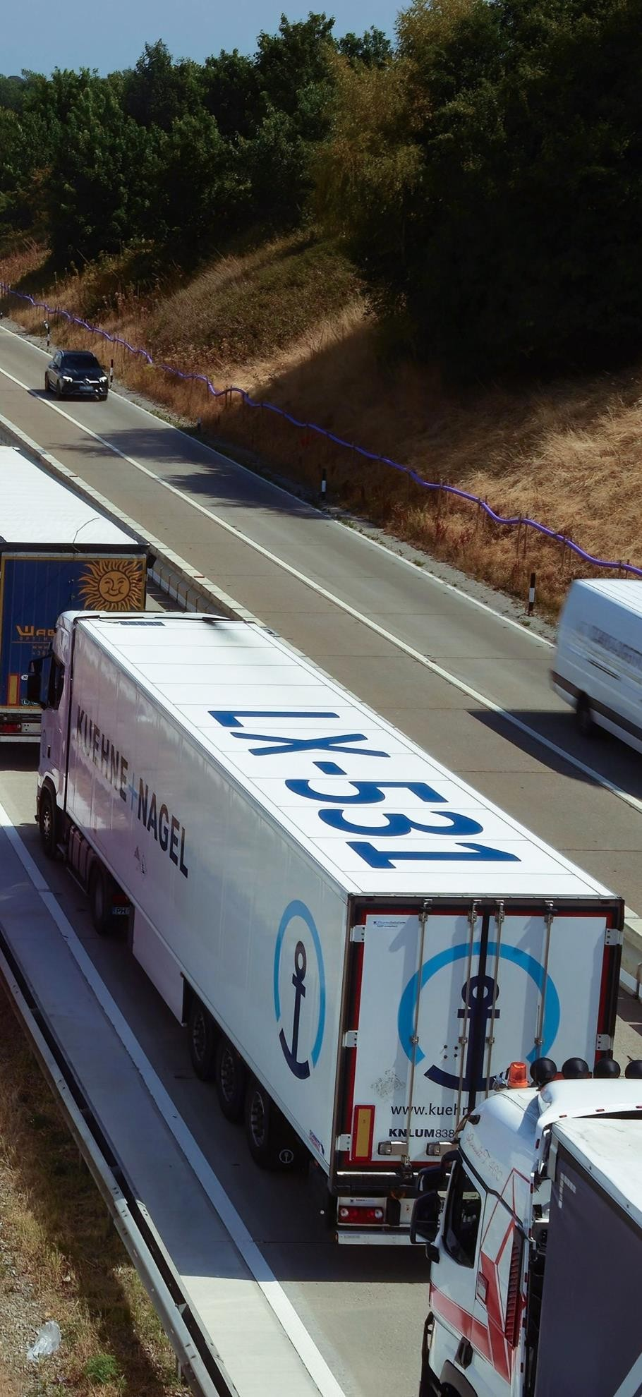

## Can I skip the SOT and go straight to the fairground?

All vehicles must attend the vehicle marshalling yard, commonly known as SOT for processing and to receive accreditation for venue access. Direct access to the venue is not permitted.

## Can I unload my good directly from my car at the venue?

Cars are permitted at the designated parking areas for the venue where goods can be transferred from car into the venue.

## Do I have to pay the access fees in advance?

No, you can either pay in advance or you can pay access fees once your driver arrives at the marshalling yard.

## Can I pay the access fees onsite?

Yes, you can pay access fees once your driver arrives at the marshalling yard.

## Do I need a vehicle booking slot?

Yes, all vehicles will need a pre booked slot before arriving at the vehicle marshalling yard.

## What if I need to amend my booking?

Our system can be amended and remains flexible after a booking is made, any issues we suggest to contact our event team for further support.

## When do I need to arrive at SOT?

We recommend you arrive 1hr prior to your required time slot confirmed by the Kuehne+Nagel STM.

Shipping instructions and tariff © 2024 Kuehne+Nagel. All rights reserved. This document & any attachments contain proprietary, confidential information. Unauthorised use or

dissemination in whole or in part is strictly prohibited. Page 6 of 6

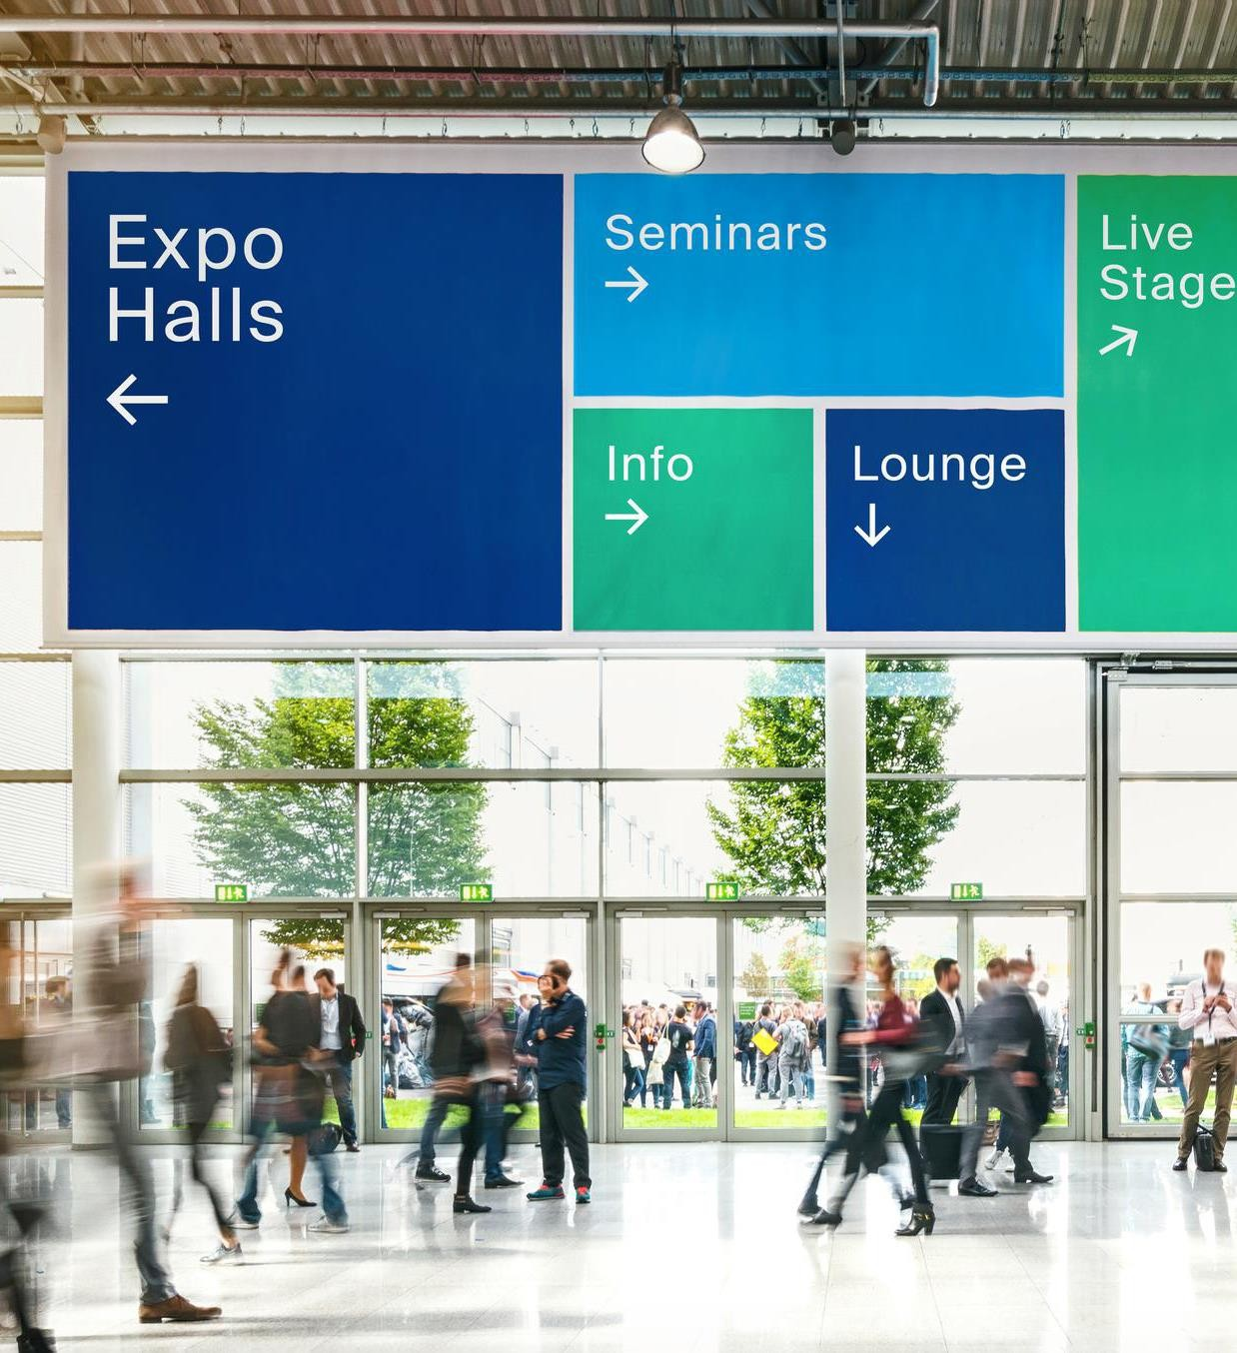

Inspire. Empower. Deliver.