Las Vegas Souvenir & Resort Gift Show Exhibit Booth & Tabletop Guidelines

EXHIBIT BOOTH GUIDELINES
The Las Vegas Souvenir & Resort Gift Show follows the cubic content rule, which allows exhibitors to make maximum use of their booth space. Under the cubic content rule , exhibitors may build up to the front of their booths, and up to the maximum allowable height (height restrictions below) according to booth type as indicated below.
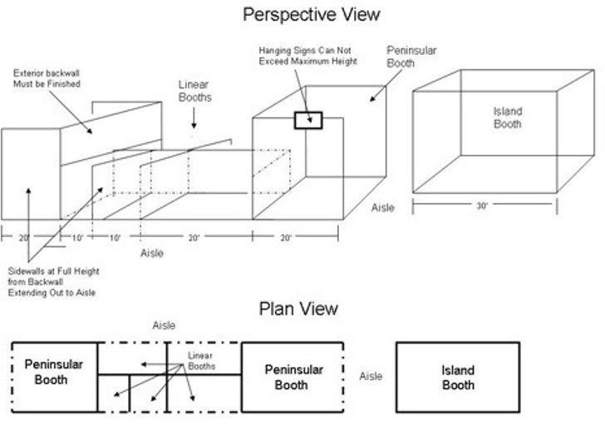

Height Restrictions:
The maximum height for all booths is 8’ High. Booths may not exceed the 8’ high pipe and drape. Height limits will be strictly enforced.

TABLE TOP GUIDELINES:
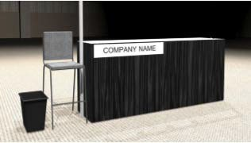

Table Top Package Includes:
- 8’ Draped 42” Tall Table
- 1 - Stool
- 1 - Wastebasket
- 1 - Exhibitor ID Sign

Table Top Rules:
- Exhibitors cannot build or display on the floor. Tabletop vendors must display on table (this is a tabletop display space, not a booth)
- Product Displays on the table cannot exceed 1' (1 foot), as shown on the image above -
- This is an open area, so please be cordial to your neighbors and respect their space
- Banners cannot be hung or displayed above table. Any signs or banners must be in front of table.
- Electrical is not included in the tabletop package and must be ordered from Fern if needed. Electrical Order Form can be found in the exhibitor manual.
- Tabletop area is not carpeted. Aisle carpet only.
- Stool to be set beside tables (Not in front or behind). As shown on image above.
- No back wall/drapes around or behind tables
- This is a table space, not a booth

