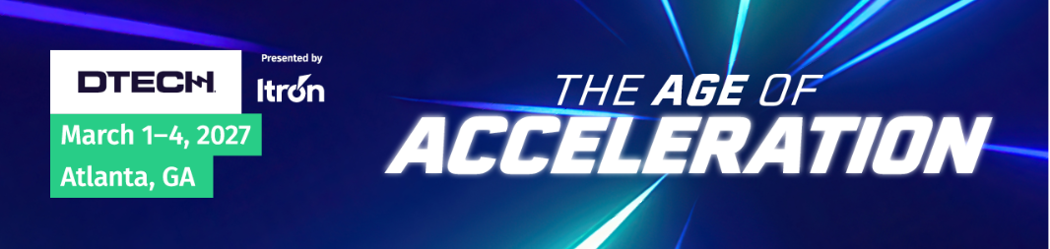
Dear [Recipient's Name],

I am writing to request approval for my attendance at DTECH®, the leading transmission and distribution conference, and exhibition, scheduled to take place from March 1-4, 2027, in Atlanta, GA. As an active participant in the T&D sector, I believe that attending this esteemed event will bring significant benefits to our organization and my professional growth.

Justification for Attendance:
- High-Value Educational Content: DTECH®, offers cutting-edge presentations, workshops, and technical sessions by industry experts, covering crucial topics such as technology advancements in renewable energy, smart city initiatives, advancements in energy storage, power distribution, and energy management.
- Networking Opportunities: The event provides a platform to network with industry peers, professionals, and stakeholders, opening doors to potential collaborations and business opportunities.
- Access to Industry Exhibitors: I will have the chance to evaluate the latest products, equipment and technologies offered by leading companies, facilitating informed decision-making for potential investments.
- Professional Development: Participation offers opportunities to earn PDHs, enhancing my skills and knowledge base.
- Knowledge Sharing and Innovation: I can share our organization's successes and innovative practices, positioning us as industry leaders and fostering collaboration.
- Market Intelligence: Staying updated on trends and regulatory developments will help identify challenges and opportunities for strategic decision-making.

Below is a cost breakdown. I would like to book travel as soon as possible to get the best price.
Registration: __________
Estimated Airfare: __________
Hotel: __________
Misc/Dinners: __________
Total cost of __________.

I kindly request approval to attend DTECH®, confident that this experience will contribute significantly to our organization's growth and competitive advantage.

Sincerely,

DTECH Justification Letter

