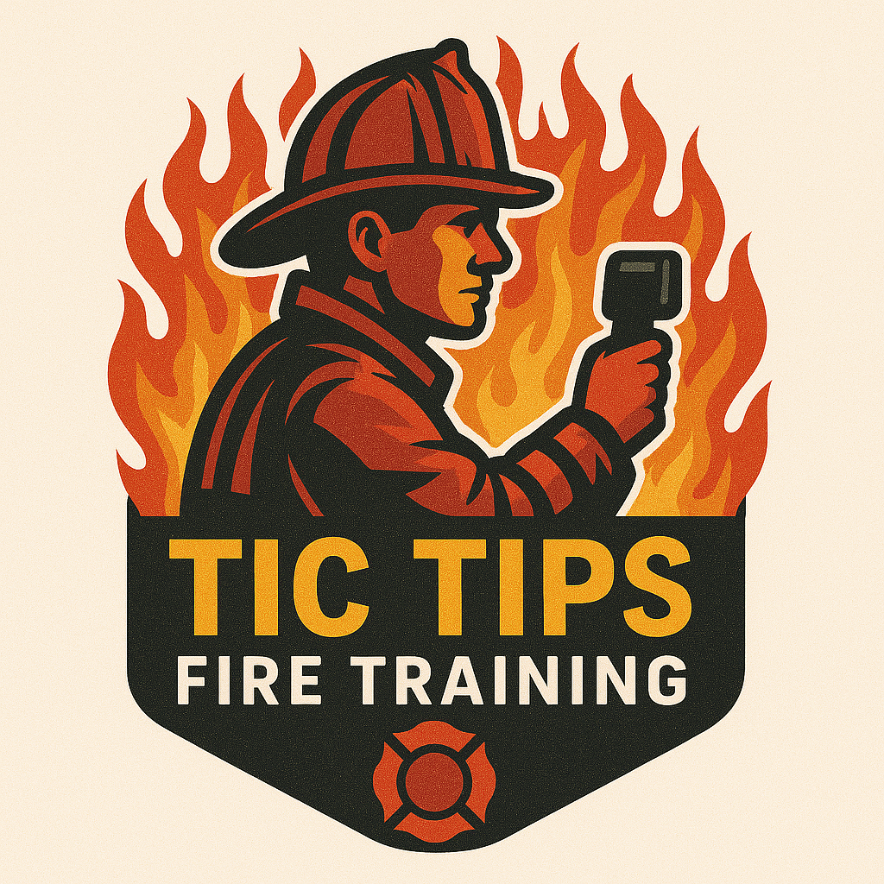
TIC Tips Fire Training
Joe DeVito
@joed911

Training Notes
Fire Behavior & Thermal Imaging: The Basics to Build on!
Joe started in the fire service as a volunteer in 1991. He is currently an interim Battalion Chief in SW Florida.

He is a CPSE Accredited Fire Officer and is Level 1 IR Certified. He has had the honor of presenting at many different conferences and participating in various webcasts and podcasts related to fire behavior and thermal imaging.

Joe has been fortunate to have had great mentors in fire behavior and thermal imaging. His biggest mentor is Andy Starnes, and he will always be grateful for being taken under his wing.

He could not do what he loves without the support of his wife and family.

@joed911 on social media
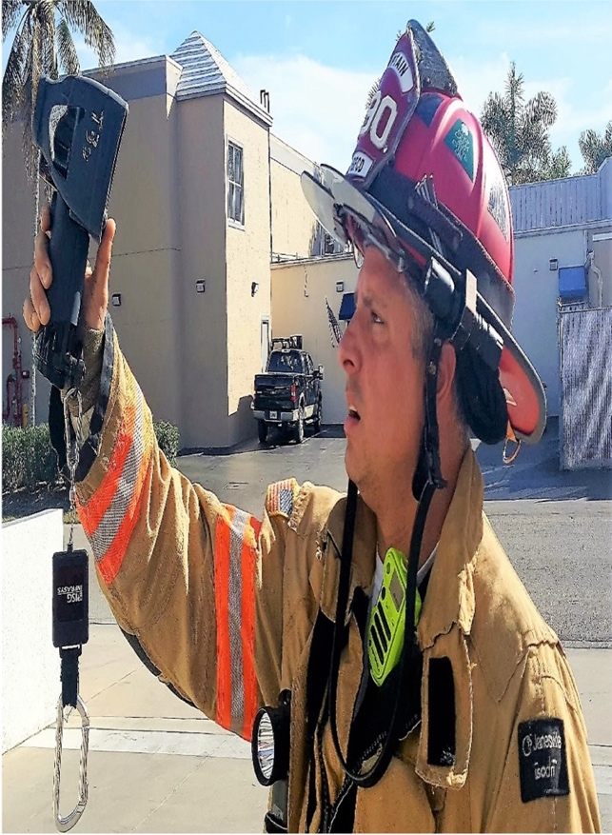

Fire Behavior Portion of Class
Oxygen – Kill the Air
- 21% room air
- 18.5% fire is significantly suppressed.
- Below 16% ceases to burn – too lean.

Kill the Heat
- Always transferred from hot to cold
- Conduction – transfer within solids
- Convection – transfer by movement in gases
- Radiation – transfer by electromagnetic waves

Stages
- Incipient Stage – light smoke (burning off the water)
- Growth – thermal layering begins.
- Fully Developed – flashover occurred.
- Decay Stage – oxygen or fuel is insufficient to sustain combustion.
- Flame Point – lowest temperature to sustain fire.
- Flash Point – Lowest temperature to ignite.
- Pyrolysis – the off-gassing of a material due to being heated. The gases are what ignite.

Due to more efficient sealed structures, the fire is under-ventilated and decays until oxygen is reintroduced.

Smoke
- Byproduct of combustion
- Not the target but the clue
- Smoke is fuel!
- Incomplete combustion
- Always watch the smoke, then the fire. It will provide more information about what is happening within the structure.
- Volume – Velocity – Density – Color
- Physics
  - Pressure Volume = Molecules Temperature
  - One side goes up, the other side goes up.
  - One side goes down, the other side goes down.
  - Must remain balanced.
- Volume
  - An indicator of the amount of fuel that is off-gassing within a space.
  - Hot, clean-burning fire emits little volume.
    - Incipient Phase
    - Fully developed – free burning
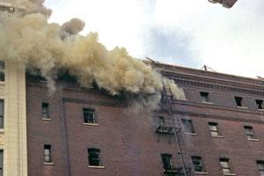
- Velocity
  - Due to:
    - Expansion of gases
    - Restriction of the container
  - If the box is still absorbing the heat, the smoke will be laminar
  - Heat-driven smoke (closer to the fire) will rise and gradually slow down as it leaves the exhaust.
  - Pressure-driven smoke will leave the exhaust and immediately slow down and balance with the outside air (laminar smoke)
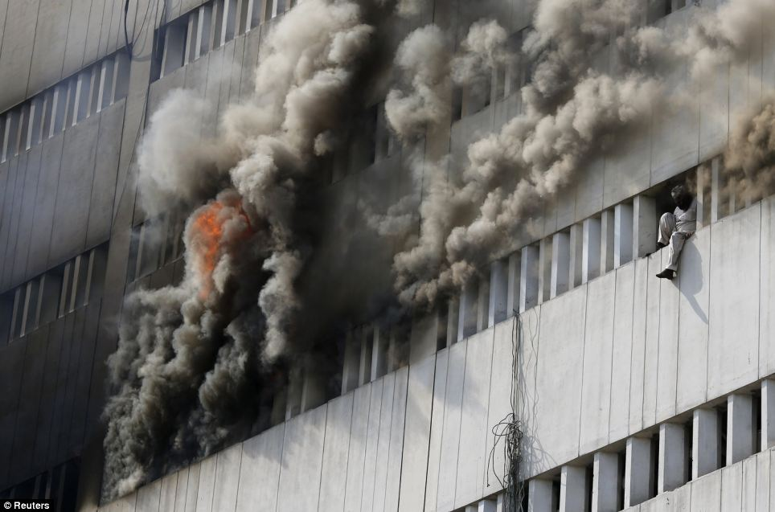
- Density
  - Degree of compactness = quality of burning
  - High-density smoke = incomplete combustion
  - Light or thin smoke = good ventilation or incipient burning
  - Density that changes from heavy to light is a sign that flashover has occurred or the fire has been ventilated.
  - The denser the smoke, the more fuel there is.
  - Dense, rapid, turbulent smoke is a sign of an impending hostile fire event.
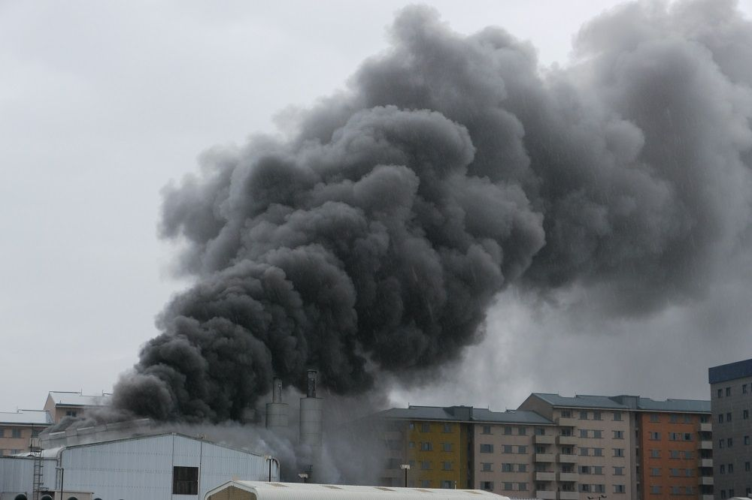
- Color
  - Stage of heating
  - Can determine location.
  - Solids emit white smoke when first heated due to burning off the water in the material.
  - Smoke leaves the fuel, and the carbon gets absorbed in the walls and materials.
  - The smoke gets filtered and will eventually be white.
  - When the smoke is close to the fire or the box can no longer absorb the heat, the smoke will be darker.
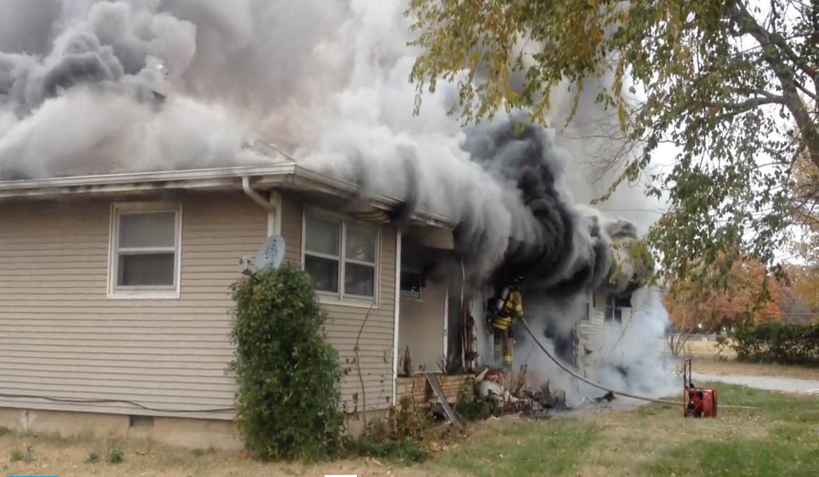
Hostile Fire Events
- Flashover
  - Surfaces in the room reach ignition temperatures simultaneously.
  - Most dangerous stage of fire development
  - It can take minutes to go from zero to five hundred degrees but seconds to go to five hundred to flashover temperatures.
  - The upper portion of the compartment reaches a temperature of approximately 1100 degrees.
  - Large volume of heavy, dark turbulent smoke
- Vent Point Ignition (Auto Ignition)
  - Smoke has the temperature needed to ignite, contains the fuel (smoke), but lacks the oxygen.
  - It achieves the perfect mixture and ignites, then returns to the room.
- Backdraft
  - Rapid explosion following the introduction of oxygen.
  - Fire enters a decay phase before flashover, and pyrolysis continues.
  - High pressure ignites when oxygen is introduced and exits the opening.
- Smoke Explosion
  - Lower temperature smoke than backdraft
  - Smoke collects in void spaces.
  - Needs an ignition to explode.
  - The fire goes out after the smoke explosion.
  - Does not need an opening.
    - It can cause structural damage.
    - Break windows, etc.

Flow Path
- Volume between the inlet and the exhaust
- Neutral Plane – separation between high pressure and low pressure
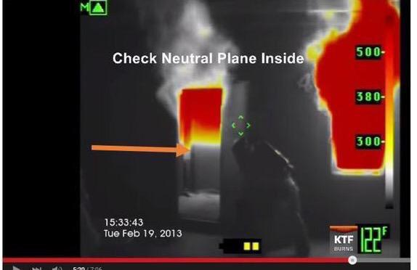
- Lift – neutral plane rises due to cooling or ventilation.
- Unidirectional Flow Path
  - The exhaust is filled with smoke or fire.
  - The air coming from another area is pushing it out through the exhaust.
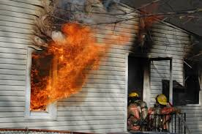
- Bidirectional Flow Path
  - Ventilation opening has clean air coming in the bottom of it and smoke or fire coming out of the top of it.
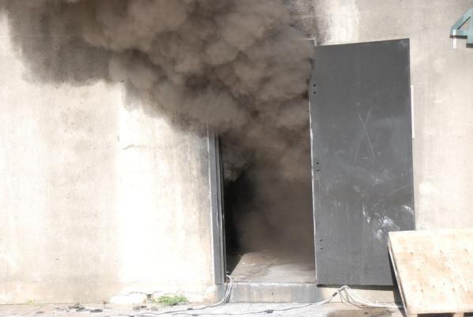
- Controlling the Flow Path
  - Winds of 10 to 20 MPH can cause rapid fire progression and alter the flow path.
  - Door Control – tough to maintain.
  - Smoke Curtain – hang in entry.
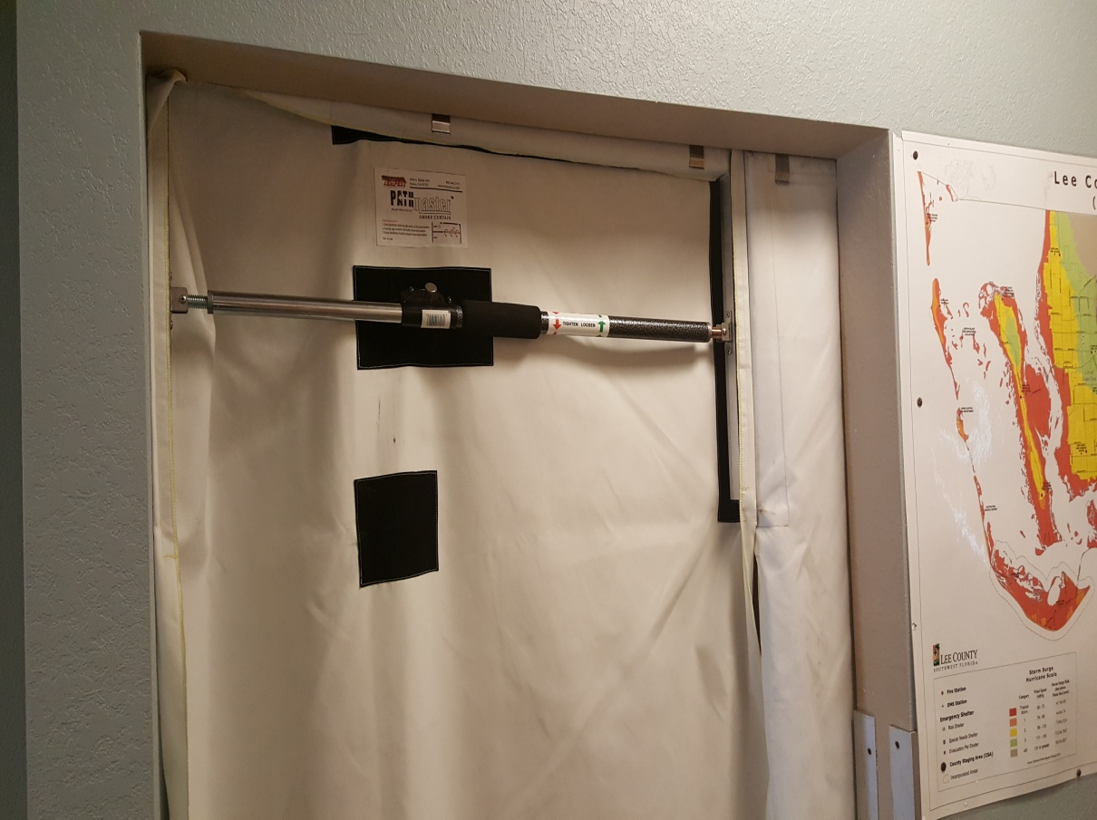
The End of Fire Behavior Portion
Thermal Imaging Portion of Class
What is a thermal imager?
- Reads infra-red (IR) heat and makes it visible on our thermal imaging camera (TI)
- It cannot see through:
  - Water
  - Windows
  - Walls – can see studs in the wall.
  - Floors
  - Furniture
  - Cannot see through anything!
- Limitations of the TI
  - Not the actual temperature
  - Reflectors
  - Water vs Hole in the floor
- Limitations of the user
  - Poor or no training
  - No experience with it
  - Over-reliance on it
Emissivity
  - An object’s ability to emit heat.
  - Emissivity of zero (shiny mirror) to emissivity of 1.0
  - Organic Painted Oxidized objects 0.95
  - The higher the emissivity, the more accurate the temperature reading

Types of Emitters
- Active Emitter – gives off heat at a low to medium rate on its own without assistance
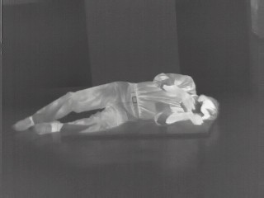
- Active Emitter with Insulator
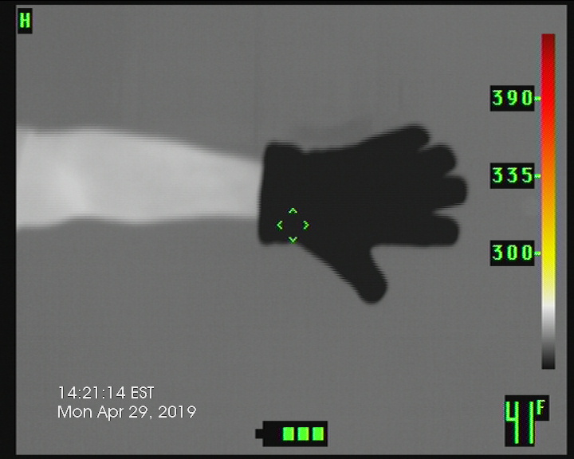
This can be a problem in search. If you do not recognize what you are looking at, you must investigate it. An anomaly!

- Passive Emitters cannot generate their own heat, but they can absorb heat and release it.
  - Found in inanimate objects.
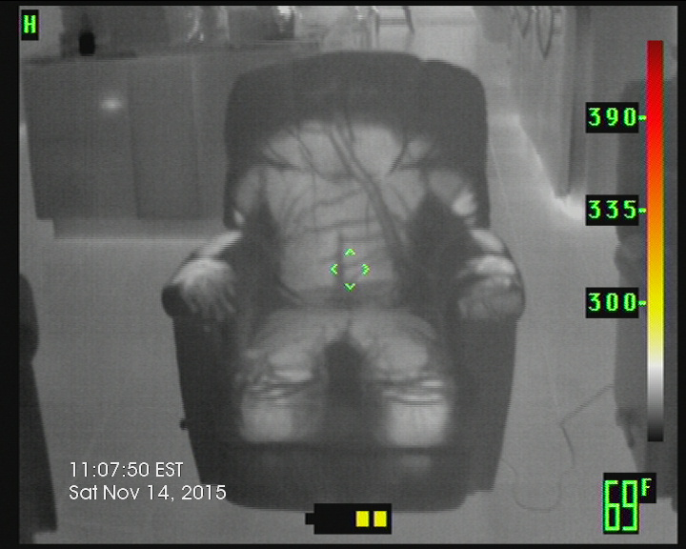
- Density and mass are key factors in absorption.
  - Example of lightweight vs heavy timber construction
- Direct Emitter
  - Gives off constant high-strength IR energy on its own like the sun.
  - Never point the TI at the sun, as you will burn out the microbolometer.
- Reflectivity is ambient IR reflected from a body unrelated to the body’s own heat.
  - An example is a mirror.
- Follow angle in = angle out
  - If we change our angle, the reflection will move but the actual object will not
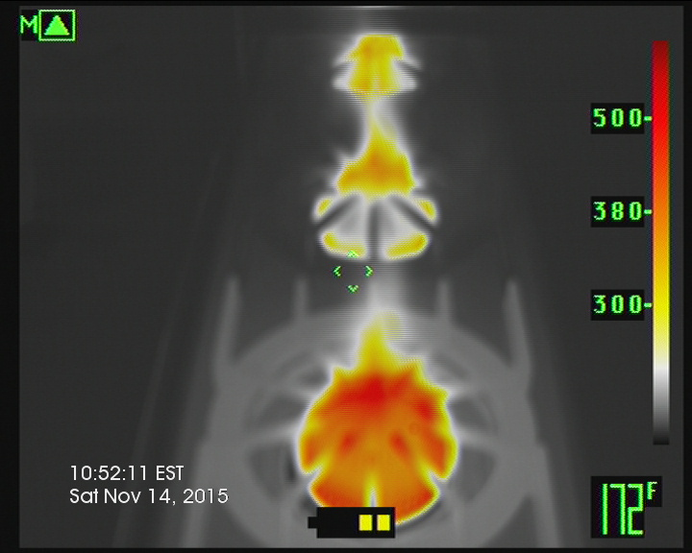
Pictured are two burners with two reflections in the backsplash.

- Transmissivity
  - An object’s ability to let heat move through it.
  - Glass and water are bad.
  - Gas is good.
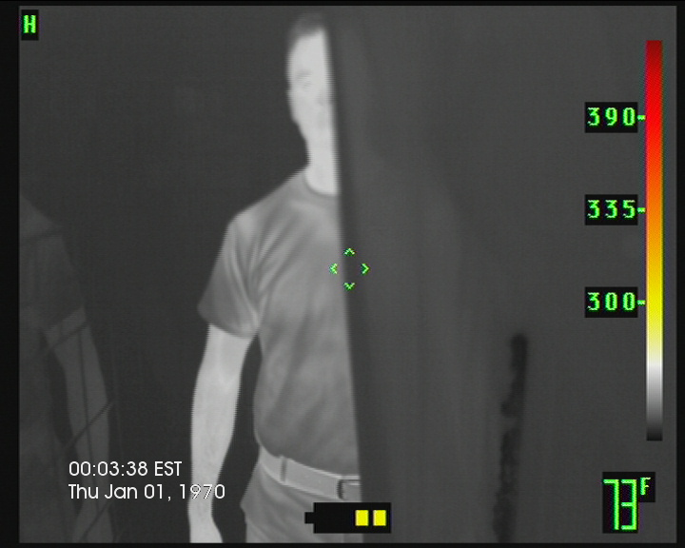
This picture shows the firefighter in the middle, a reflection on the left, and only half of the person due to the lower emissivity of the shower curtain. All showers and bathtubs should be treated as closets and should be checked during the search.

Parts of a Thermal Imaging Camera
- Optics system
- Field of view
  - The area visible by the TI. The field of view (FOV) is measured in degrees and can be expressed as horizontal, vertical, or diagonal measurements.
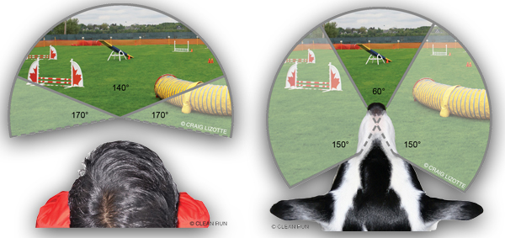
  - TI FOV is less than a dog’s FOV.
  - The larger number is always horizontal FOV.
  - When you rotate your TI, the display does not auto-rotate like your phone.
  - When you need to see more up and down, rotate the camera sideways, and your larger FOV is now vertical.
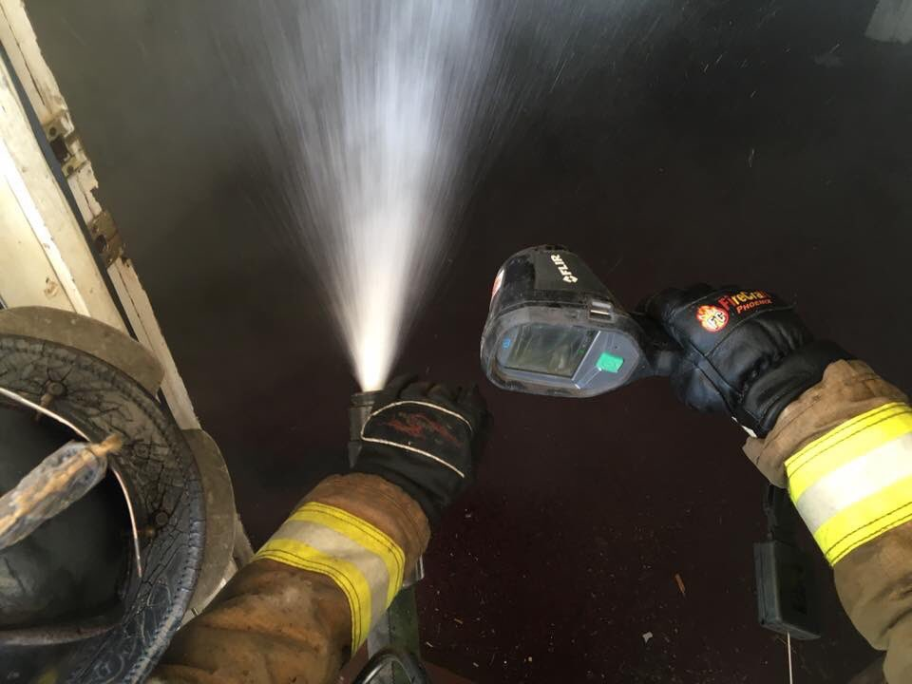
- Distance to spot ratio D:S
  - Think of a flashlight on the wall
  - If you stand 10 feet away, you have a 1-foot circle of light on the wall.
  - The further away you are, the less accurate and bright the light will be.
  - Same for temperatures on your TI
  - Know your camera to find your D:S
- The Detector
  - Detects and converts the image to a temperature map.
  - Focal Plane Array
  - Refresh rate – frames per second.
  - Our eyes see 30 Hz.
  - Move too quickly, and the camera gets dizzy and shutters.
  - Shutter – image freeze on TI.
  - If shutters, return to scan where the shutter occurred.
- Resolution
  - 160 x 120 child’s hand 7 feet away
  - 320 x 240 child’s hand 15 feet away
  - 364 x 288 child’s hand 20 feet away
  - 640 x 480 child’s hand ? feet away
- Display
  - Objects warmer than the environment
    - White
    - Yellow
    - Orange
    - Red
  - Objects warmer than the environment
    - Grey
    - Black
- Thermal Contrast – how well objects stand out.
  - If no contrast, create it by spraying water.
- Thermal Inversion – Objects change shade due to the temperature of the environment, not the object.
- Numeric Temperature Measurement (NTM)
  - The number in the crosshairs
  - Should not be used in fires.
    - Reads surface temps, not air temps.
    - Convection waves move through the room faster than the surfaces can absorb heat.
  - The NTM is the approximate temperature of the surface at the crosshairs.
  - Used in machinery and electrical.
- TI Basic High Gain
  - Automatically starts here when turned on.
  - Field of view under 300 degrees
  - Greyscale
  - Focuses on objects, not heat.
  - It should be used when searching.
- TI Basic Low Gain
  - % of the field of view over 300 degrees
    - Or per manufacturer
  - Green triangle top left corner
  - Colorization
  - Focuses on heat, not objects.
- Diagnostic vs Awareness
  - Diagnostic
    - High Resolution at least 320x240
    - Refresh Rate per NFPA min 25 Hz.
    - Larger display screen
  - Awareness
    - Any one of these makes it an awareness-level TI
    - Under 320x240
    - Refresh rate less than 25 Hz.
    - Small screen
    - Used for flow path and egress.
- Get the Picture
  - When scanning, start low and use a gangster grip!
    - High gain mode
    - Under the heat
    - If changes to low gain, point TI toward the ground.
  - Scan the lower half of the room side to side.
    - Assure the TI field of view matches your field of view.
  - Scan the upper half of the room side to side.
    - Assure the TI’s field of view matches your field of view.
  - Think of 7 sides, including the temperatures of materials inside the box
- Practical Applications
  - Size Up
    - Heat area location of the structure.
    - Extent
    - Ventilation profile
    - Access
  - Search
    - TI led
      - Larger areas
      - Scan area.
      - Inform FFs of plan.
      - Advance
    - TI directed.
      - Bedrooms
      - Either scan and show FF where to go, or
      - Scan and label walls clockwise.
        - Left wall #1 door wall #4.
        - Tell FF bed on #2, closets on #1 go!
    - Point to Point.
      - The quickest way is the direct line.
      - Like a mix of TI lead and TI directed – separate to cover more ground while staying in voice contact.
    - VEIS
      - Mix of size up and search
  - RIT
    - Remember thermal inversion.
    - Look for dark SCBA bottles.
    - Look for dark hose lines.
  - Water Application
    - Do not pencil, erase the heat.
    - Hold the TI off to the side of the nozzle.
      - The nozzle person erases the heat at the base of the fire.
      - Erase all the heat in the thermal picture.
    - Another method, the Clock method
      - Stand behind the nozzle person and give them directions via clock numbers.
  - Ventilation
    - Superheated gases
    - Trusses
    - Structural Integrity
    - Could use investigative mode
  - Overhaul
    - Heat in walls.
    - Investigative mode if TI has one.
  - Electrical
    - Powerlines
    - Fuse Boxes
    - Wires Arcing
  - Water Rescue
    - Cannot see through water.
    - Last known area
    - Boats
    - Floating
  - Outdoor searches
  - Motor Vehicle Crashes
    - Patient-to-seat ratio

- Haz Mat
  - How much is left in the container
  - Release point.
    - Endothermic
    - Exothermic
  - Specific gravity less than one will float in water.
- Brush Fires
  - Drones
  - Fences
  - Livestock
  - Other vehicles
  - Hot areas
- Medical
  - DVT
  - Amputations
  - Circulation Occlusions

The uses are endless based on the imagination of the end user!

