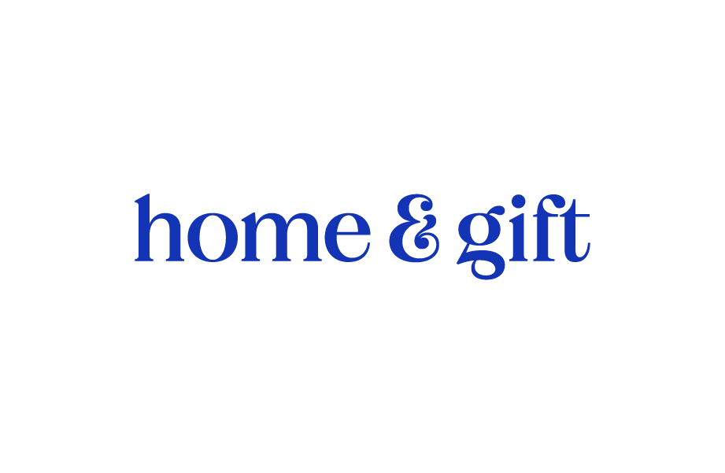

**Home and Gift Buyers’ Festival | Blog Feature**

Every year we want to give our exhibitors the best chance at getting their brand noticed and enjoy offering free promotion for them through our *Behind the Brand* blog feature. All we need is for you to share your brand’s story to help us connect you with our thousands of buyers. Your feature may appear on our website, email, and social media.

Please answer the below questions highlighting the features of your products, along with giving a taster of the new collections you may be launching at the show and add any images we could include as well. These images could be anything from your brand’s latest collection, product imagery or even some behind the scenes photos of you in action – anything that is representative of you and your brand to help our readers visualise your story and portray it on our blog.

Answer the following in as much detail as possible, and remember to make it as personal and human as possible: (*Please note, the answers to the questions below may also be used in the show’s press campaign giving you further opportunity to have your brand shared with interested buyers)*

Once completed please send your response to [marketing@homeandgift.co.uk](mailto:marketing@homeandgift.co.uk) in order to be considered for the blog campaign.

* Tell us about your brand; what inspired you to start your brand? Where did you get the idea for your products?
* How long has your brand been operating? Have you been at Home & Gift before?
* What’s your biggest highlight of owning your brand? Why do you love what you do?
* Looking back, what advice would you give to yourself when you first started out? (e.g. any struggles and how you overcame them)
* What can we look forward to seeing from your new collections that you are bringing/launching at Home & Gift? (include any events you’ll be arrange onsite if applicable)
* Do you have any personal favourites from your new collection?
* What are you most excited for when exhibiting at Home & Gift?
* If applicable, how do you operate your brand sustainably?

**PLEASE NOTE – Feature submission does not guarantee a 100% confirmation that your article will be featured on the blog as this is at the discretion of the content team.**