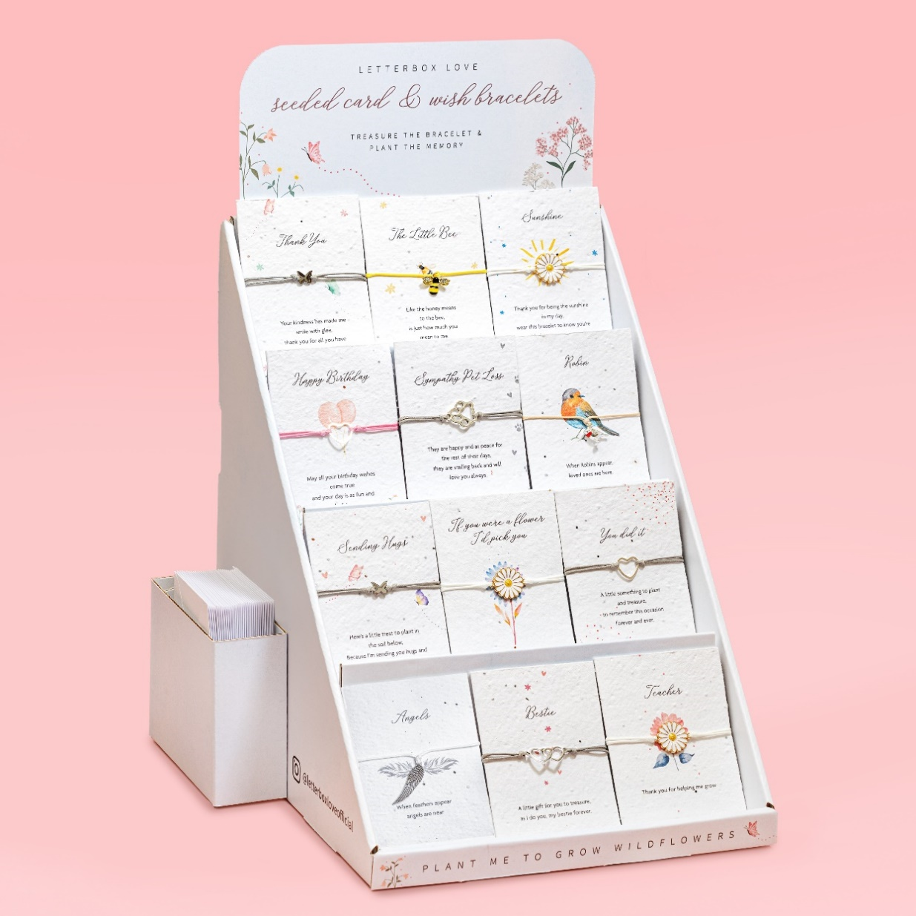
LETTERBOX LOVE SEEDED CARD & WISH BRACELET STAND
Trade Price £209.40 +VAT
RRP £539.40
Free Delivery

Includes 60 bracelets & envelopes
(choose 12 designs)
Individual Bracelet Cost Price £3.49
RRP £8.99
Stand Dimensions: H 41cm L 28cm W 24cm
Material – Card- Waste cotton & wildflower seeds
Bracelets – Zinc alloy, stainless steel, copper
Product Code-SCM900

