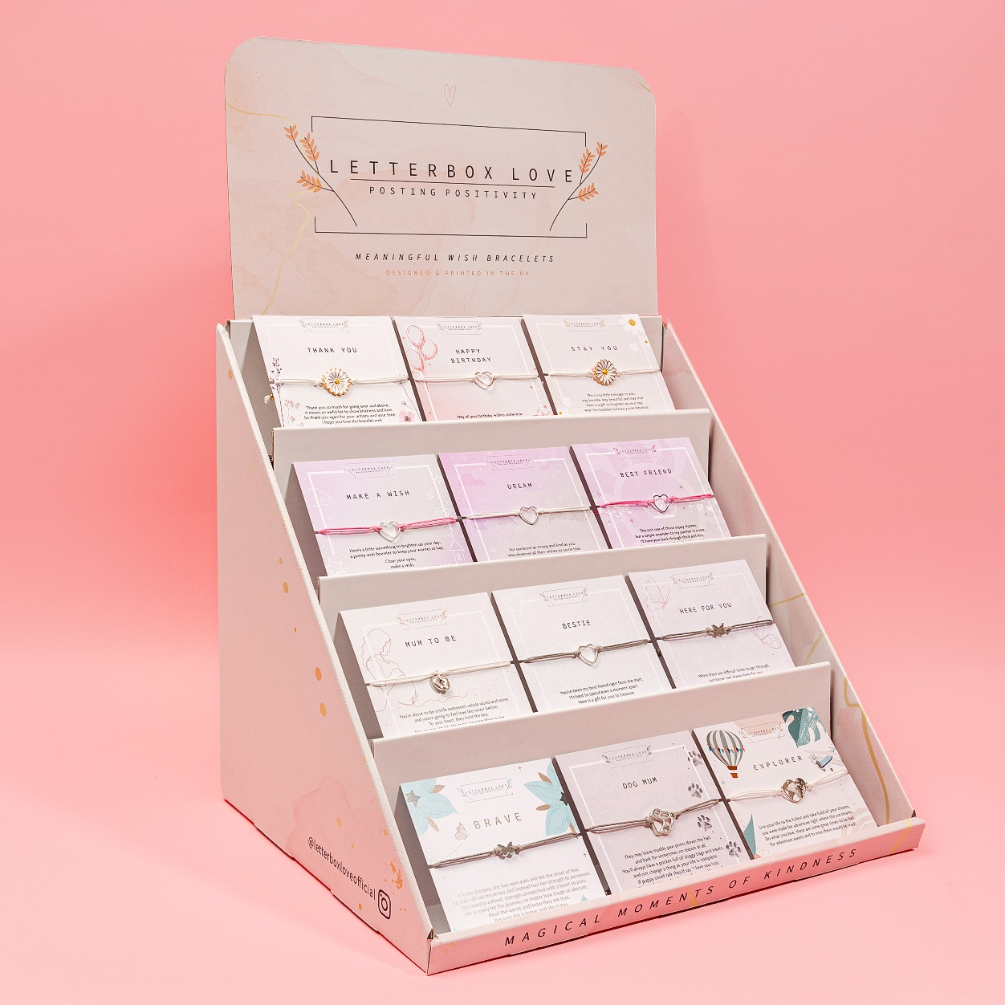
MINI BEST SELLING WISH BRACELET STAND

MINI | LARGE
Contains 60 (12 of each design) of best selling designs | Contains 80 (16 of each design) of best selling designs
£135 +VAT | £180 +VAT
Dimensions of stand - H28cm x Width: 45cm x Length: 33cm | Dimensions of stand: 49cm x Width: 28cm x Length: 47cm
Material of bracelets – copper, zinc alloy & stainless steel
Unit price per bracelet £2.25
RRP £6.99

