SERENITY STONE CRYSTAL CHIP BRACELET STAND
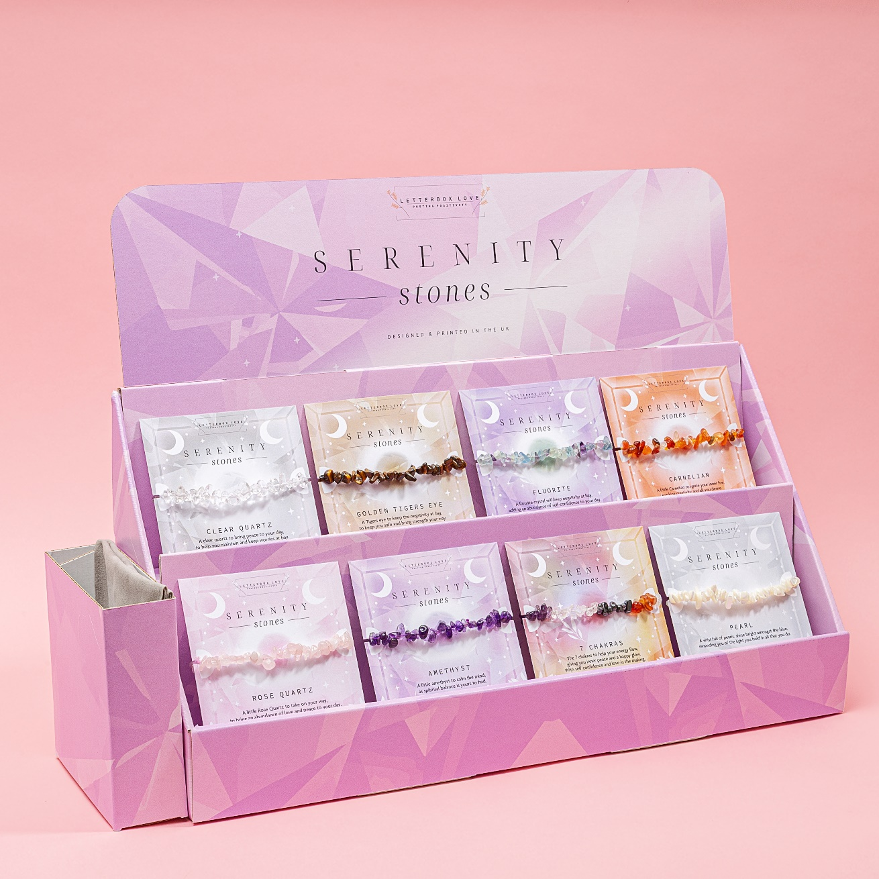
£139.60+VAT
Bracelets Included:
Clear Quartz, Rose Quartz, Carnelian, Fluorite, Golden Tigers Eye, 7 Chakras, Pearl, Amethyst
Stand Includes 5 of each type of Elasticated Crystal Chip bracelet and accompanying poem card.
Individual Bracelet Cost Price £3.49 RRP £8.99
Stand Dimensions: H45cm x W13cm x L47cm

