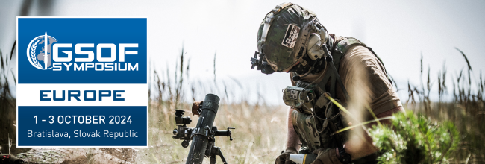

[TODAY’S DATE]

[TO WHOM IT MAY CONCERN]:

Bottom Line Up Front: I believe that I would be missing out on a great opportunity for [your organization] if I do not attend the upcoming GSOF Symposium Europe 2024 in Bratislava, Slovak Republic. Special Operations Forces (SOF) are a critical part of modern warfare and nations across the globe are growing their SOF at an exponential rate–especially in Central and Eastern Europe.

This event will give me, and our organization, access to current and future leaders from the Special Operations, Intelligence, and Cyber communities from roughly 30 impactful countries. I’ll have the opportunity to listen to these leaders talk about national security challenges and to see what they are doing to grow and transform their militaries.

If you look at the conflicts around the world, you see that modern warfare is now about surrogate operations, partnered warfare, cyber operations, and AI. These “new” types of operations are all over the battlefield, and SOF are being used in all of these missions. I believe that we can contribute to those missions.

GSOF’s European symposium is in its eigth year, and is unique for several reasons--including support from the Slovak Republic’s Ministry of Defense, industry matchmaking, networking events, and their largest ever European exhibition hall. There will also be educational sessions on the Wednesday and Thursday of the event, which I believe will further contribute to our growth.

Specifically, the exhibition hall will feature the below capability areas that are of interest to our organization: [DELETE IRRELEVANT OR HIGHLIGHT RELEVANT AREAS]

- Aviation (Fixed Wing & Rotary)
- Artificial Intelligence / Machine Learning
- Communication Systems
- Cyber / Electronic Warfare Solutions
- Data Analysis / Visualization
- Land Systems, Manned and Unmanned
- Maritime Systems
- Medical Capabilities
- Munitions
- Optics / Situational Awareness
- Other
- Procurement Support
- Sensors
- Specialized Training
- Translation Solutions
- UAV / UAS and Counter-UAV / UAS
- Warfighter Protection

Additionally, these sessions on the agenda will provide current perspectives on topics that can be impactful to our organization’s business decisions and strategies: [DELETE IRRELEVANT OR HIGHLIGHT RELEVANT AREAS]

- Fortifying Special Forces Operations with Intelligence and Cyber Capabilities
- Legislation as a Pathway to National Security Reform
- Innovation at NATO
- Keynote Speech (Virtual) from Admiral (Ret.) William McRaven
- What We Learned from SOF Operations in UKR that Will Apply to Taiwan or Other Nations
- What Winning (Can) Look Like: Utility of Special Operations in Compound Security Competition
- Keynote Speech from Dr. Seth G. Jones, Senior Vice President and Director of the International Security Program, Center for Strategic and International Studies
- "The Role of SOF in Competition, Crisis and Conflict: Situation Reports
- Keynote Speech from BG Viktor Khorenko, UKR SOF CDR
- Capability Accelerator Theater featuring industry experts

I would like to attend the Symposium to network and build our business opportunities in this region. I have calculated the costs, and attendance would not be cost prohibitive, totaling approximately [$XXXX] to attend. In addition, the Symposium takes place from 1-3 October 2024, which does not conflict with any other critical events on my schedule.

Thank you for your consideration of this great opportunity!

Sincerely,

[YOUR NAME & SIGNATURE]

