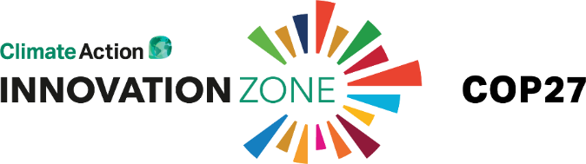
Collaborations for Net Zero: Content inputs
[Your company name]
1. ABOUT
The aim of the Climate Action Innovation Zone is to bring public and private sector actors together to create tangible impacts in the real economy – i.e. to help close the implementation gap.

Collaboration is the name of the game when it comes to this ‘Implementation COP’.

In the run-up to COP27, we would like to produce a piece of original content – Collaborations for Net Zero – to share examples of:
- (1) How partners are already working in public-private partnerships or cross-sector partnerships
- (2) Areas in which event partners are still looking to form partnerships, and why.

The term ‘public-private partnerships’ is widely used. Your concrete examples will help bring the term to life for our readers – both for our media audience and our wider subscriber base.

OUTPUT CONCEPT & FORMAT:

The article will consist of brief introductions to the Innovation Zone and the term collaboration, followed by a selection of the examples provided by our partners (below). Your examples will be attributed to a member of your team as a direct quote.

Please provide your inputs below, thank you!

1. Who should your example be attributed to?:
Name, Job Title, Company Name:

2. [Up to 200 words]: Are you involved in any public-private partnerships that might offer inspiration to others? Please share a concrete example to help bring the concept to life. If possible, show how it contributes to implementing transition to net zero (e.g. by overcoming specific named barriers, or enabling a quicker pace, or other specific and interesting reasons). If there is something interesting to say about how the partnership came about (e.g. through a Climate Action event or roundtable or through trying to solve a different problem, etc.) please include that information so we can highlight the different ways in which partnerships are born.

3. [Up to 200 words] In which areas of your business are you still looking to form new cross-sector or public-private partnerships and why? Please provide some engaging info about this and if possible a clear example of why you need to work with others to address this particular challenge or opportunity.

4. [Up to 200 words] What are the biggest challenges for your sector or region in relation to net-zero? How does your company factor into those challenges and the solution? Are you advocating for any specific changes?

5. If you have any accessible, engaging and relevant content you would like us to consider sharing on social media as part of content marketing for the Innovation Zone, e.g. op-eds, blogs, video, please share links to this info here. It should be directly relevant to your engagement in the Innovation Zone and COP27.

