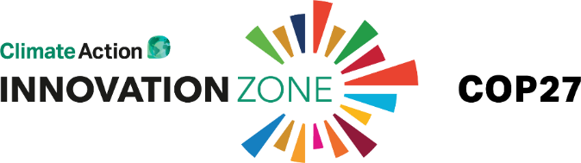
Please remove textbox and place your logo here

Media Briefing Note
[Your company name]

1. [Company name] at Innovation Zone 2022 - COP27
Summary of up to 200 words – geared to a COP27 media audience. Please summarise your organisation’s contribution to global net zero and to Innovation Zone / COP27 specifically. If you will announce or launch anything ‘newsworthy’ at COP27 that you can share or tease in advance please also include that information here – e.g. a report launch, result, new initiative, etc. with details of where and when this will happen. You can provide further details and angles on this below.
2. [Company name] events at Innovation Zone
Please provide details of any events you are hosting that media can attend / apply to attend, and provide info on how they can register their interest in attending if needed.
3. Notable projects and statistics:
- Please bullet
4. Recent announcements or press releases:
- Title & hyperlink
5. Spokespeople:
If applicable, please provide details of your media spokespeople at the Innovation Zone. Please provide a separate entry for each spokesperson. Please include sessions they are speaking in, if applicable, or provide info of the exhibition space if they will be there.

Name
Job Title
Email
Twitter
Contact Tel at COP27
Innovation Zone Sessions | (Date, Time, Name of Session, Venue)
Exhibition
What other specific issues or topics can journalists interview you about? | Please be concise
Bio and additional info on spokesperson
Photo (optional)

