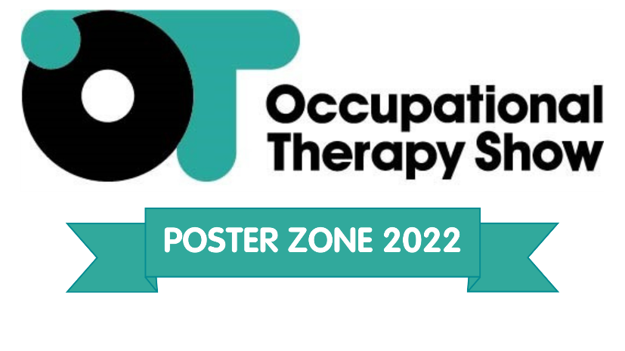

*DEADLINE FOR SUBMISSIONS IS FRIDAY 14th OCTOBER 2022!*
All boxes must be completed
Name:
Job title:
Place of work:
Email address:
Direct telephone number:

Please provide an abstract of your poster content in no more than 300 words. The abstracts should provide the title of the poster, the background for the project/innovation and the significance of the project/innovation to Occupational Therapy practice. The abstracts will be reviewed using the following criteria:
- The positive impact of the project/innovation on Occupational Therapy practice and/or patient care - supported by qualitative or quantitative evidence or published literature.
- The quality of the innovation and/or research within Occupational Therapy practice.
- The potential application of the project/ innovation to other areas or settings.
- The extent the project enhances the occupational therapy role and/or collaboration across the sectors.
Has this abstract been presented in the last 12 months? Yes/No. If yes, which event: …………………………………...
If you have already registered to attend The Occupational Therapy Show please advise which day in order that your poster, if selected, can be displayed on that day: Wednesday / Thursday
References

Please read the following and sign on behalf of your application. We declare that all information contained in this application is accurate and fairly presented. We agree to abide by the rules, including the understanding that the judges’ decision is final and that no correspondence will be entered into regarding their decision.
Name: | Date:

Please save this document and title with your name before emailing to otshow@closerstillmedia.com no later than Friday 14th October 2022.

