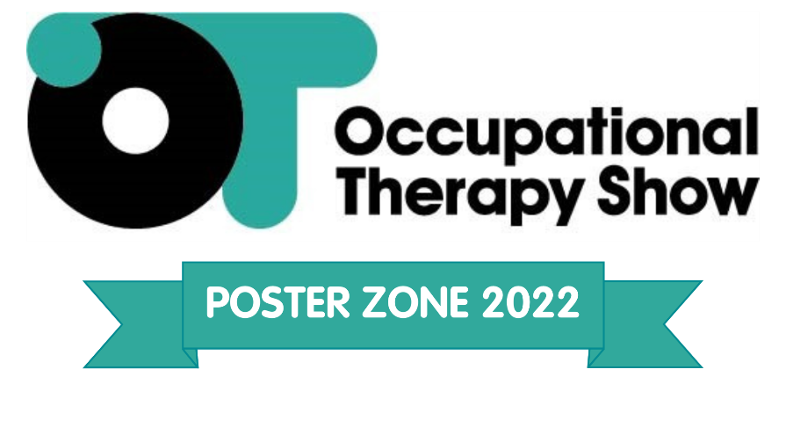
Planning your poster
Give yourself enough time to design your poster. Remember that you may need to get it approved by your supervisor and the named authors of the study. You will also need to allow time for the poster to be printed.

The Occupational Therapy Show requires your poster to be a maximum of A0 in portrait format. Any in landscape will not be able to be displayed.

Designing your poster
Your poster should be eye catching and draw the reader in. There are going to be lots of other posters at the conference so be creative (but remember creativity should not be at the expense of the relevant information) with your design in order that you can draw the delegates to yours.

Making the most of your poster
- Make sure the content is accurate
- Avoid too much text
- Include photographs, figures and colour to make it visually attractive
- Space your text and figures to make it easy to read
- Use clear headings and conventional format (Aims, Methods, Results etc) to fit with the conference requirements

A poster cluttered with data is not attractive and will not hold an audience. There should be a clear but succinct introduction and statement of aims to help the audience with some context for why the work is important and what it aimed to add to existing evidence. The rest of the information – Methods, Results/Evaluation, Discussion/Conclusion and References - should follow logically and clearly.

Colourful charts, diagrams and images should be used to display data wherever possible. Relationships between variables and complex findings can be taken in at a glance when figures are appropriately displayed, and bold illustrations always attract the reader's eye.

The poster must be legible from a distance of about four feet to allow several people to read it at the same time.

The most common way of creating a poster is with PowerPoint. Hand-written material is not suitable. We have created a template which you are free to use if you wish but do not have to it is purely a guide should you require it. Your department may have its own template that you will be required to use.

Confidentiality & Publicity
CloserStill Media holds no responsibility for any sensitive patient information that may be displayed within these posters. Please ensure that you have checked your poster thoroughly for any information that you may not want to be shared.

Please note that successful abstracts and posters may be used in event publicity before / during and following the event.

Practicalities
If you need to transport the poster a long distance, you may want to consider carrying your poster in a poster tube. You can buy these at stationary shops or your department or colleagues may have one you can borrow.

The conference organisers will provide Velcro for you to mount your poster on arrival on your presentation day.

Your poster will be displayed for one entire day at the conference (either Wednesday or Thursday), but you will only be required to stand with your poster for 60 minutes, meaning you won’t miss out on all the other opportunities available at The Occupational Therapy show. You should look professional and approachable. You should be able to give a succinct explanation of your work. You are sure to receive some interesting questions so don't forget to take along a notebook so you can note down these points along with the names and addresses of useful future contacts.

All abstracts will be made available online prior to the conference as well as printed and handed out at the conference.

We would suggest that you prepare a brief hand-out for viewers to take away: it’s often easiest to print off copies of PowerPoint posters on A4 sheets. Make sure your contact details are included as well as where readers can find information regarding your work.

Giving a poster presentation provides you with the opportunity to speak to many people and discover what is going on in your area of interest. It is a highly stimulating and motivating experience. Good luck and enjoy!

