
SHELL SCHEME
ELECTRICAL PRE PAYMENT ORDER FORM

CREATIVE LIVE LTD VAT NUMBER: 380313423
Post Code
Invoice Adress

Mobile Number
Telephone Number
Company Name
Email Adress
Contact Name
DATES:
STAND NUMBER:
SHOW:
VENUE:
EARLY BOOKING DEADLINE DATE:
Please note that in ordering electrics you may
have a mains box and cable on your stand.
IMPORTANT INFORMATION- PLEASE READ

CUSTOMER DETAILS
Email: Sales@creativelive.uk
Telephone:01676 545 410
Creative Live LTD
2-3 Arley Industrial
Estate
Colliers Way
Arely, Coventry
CV78HN
3rd August 2026

2-3 September 2026
Olympia, London
Jewellery Show 2026

Power Circuits up to a maximum 2kw will be charged @ £ (Mandatory Cost) | £17.50
Lighting Circuits up to a maximum 1.2kw will be charged @ £ ( Mandatory Cost) | £15.00

SUBTOTAL
VAT @ 20%
TOTAL COST

SHELL SCHEME ELECTRICAL ITEMS | EARLY BOOKING  RATE  UNTIL 3RD AUG | STANDARD PRICE  4TH AUG – 26TH AUG | VENUE SURCHARGE  27TH AUG – 2ND SEPT | QUANTITY | TOTAL
Lighting Track with 3 x LED Track Spotlights | £201.33 | £241.60 | £289.92
General Purpose LED Spotlights | £89.76 | £107.71 | £129.25
5ft (1.5m) LED Light Batten | £102.56 | £123.07 | £147.68
Switch Socket 500w (2amp) | £162.78 | £195.34 | £234.41
Switch Socket 1kw (4amp) | £236.84 | £284.21 | £341.05
Switch Socket 2kw (8amp) (Single Appliance Only) | £388.08 | £465.70 | £558.84
Switch Socket 3kw (13amp) (Single Appliance Only) | £513.91 | £616.69 | £740.03

SHELL SCHEME
All costs shown below are exclusive of VAT (@ 20%) |Onsite orders will be subject to a 20% on site surcharge.
In line with the current Exhibition Industry Alliance (AEO, AEV & ESSA) e-Guide / Rules & Regulations, the Testing Charges noted below will be implemented and will automatically be added to your invoice. These charges are compulsory.
IF YOU REQUIRE TEMPORARY POWER DURING BUILD UP, THIS WILL NEED TO BE ORDERED – PLEASE CONTACT US FOR A PRICE. THE BELOW POWER WILL ONLY BE LIVE DURING THE SHOW OPEN PERIOD
Electrical Fitting Options: When Submitting your order please indicate what appliances each socket with be used for, please refer to our socket outlet usage guide for information – see page 3. Please state the required position on overleaf of all items ordered.

*ISLAND SITES WILL REQUIRE THEIR OWN MAINS SUPPLY, PLEASE CONTACT US FOR A BESPOKE QUOTATION*
*IF YOU REQUIRE A MAINS SUPPLY FOR YOUR STAND THIS IS AVAILABLE ON REQUEST*
Please note that in ordering electrics you may
have a mains box and cable on your stand.
IMPORTANT – EQUIPMENT POSISTION DIAGRAM


STAND NUMBER
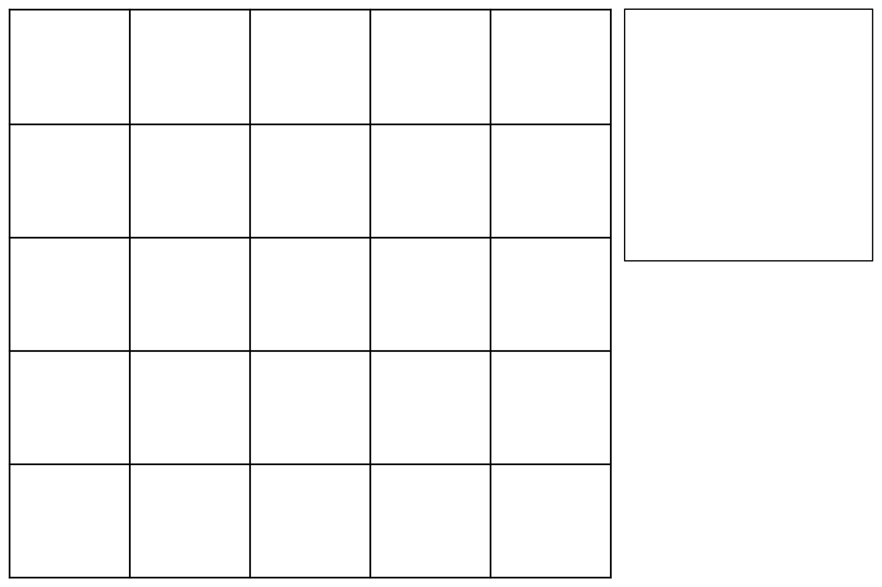
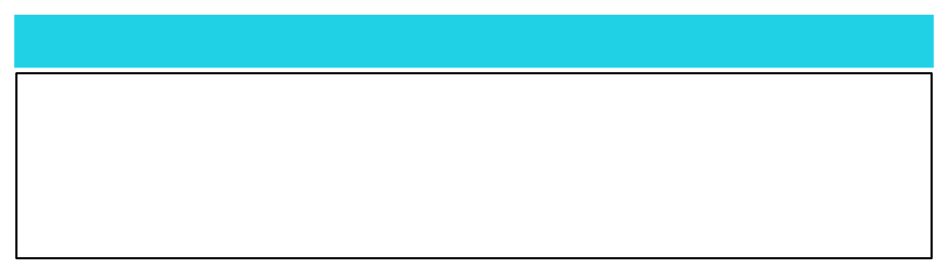

TERMS AND CONDITIONS – Please see our website for full terms & conditions
COMPANY NAME
1 SQUARE = 1M
BACK OF STAND
1 SQUARE = 2M
Please indicate the scale to which you have drawn your stand
If you do not complete this diagram or indicate the heights and dimensions of all orders, items will be placed at our discretion. Subsequent change will be subject to a £65 charge
Spotlight: O
Switch Socket at Floor Level: X
Switch Socket at ceiling height: Ø
Light Track: O-O-O
Fluorescent: ======
Mains: M
This diagram will be used to place all orders on your
stand. Please ensure you complete the diagram
clearly and show all heights and dimensions for the
placement of all the items you have ordered.

ANY ADDITIONAL INFORMATION
SPACE ONLY
SHELL SCHEME
PLATFORM ON STAND?
FRONT OF STAND


E-Guide & EIA 18th Edition Electrical Regulations.
In the experience of Creative Live in providing electrical supplies for exhibitions, we find that many exhibitors are not aware of the power requirements of equipment that they will be using. This Quick Reference Guide is designed to assist exhibitors in planning their power requirements, and if followed, will reduce the likelihood of problems occurring at the exhibition venue.
Creative Live Limited provides standard 3-pin English 13A socket-outlets, but with four different power ratings. The list below indicates the sort of equipment that can be used with each of the power ratings:

SK1 (500W) IS RATED AT 2AMP AND CAN SUPPLY:
One computer [or 2 x laptops]
A small domestic fridge
Four mobile phone chargers Television and video
Or any combination of the above using a single 4-way extension (maximum length 2m) subject to a total load of 500W
THE USE OF TRAILING/BLOCK TYPE 4 WAY FUSED SOCKETS (4 WAY extension lead) SHALL BE
RESTRICTED TO THE FOLLOWING: One 4 way unit per fixed socket outlet, subject to a maximum loading of 1000watts TOTAL and its plug shall be fused accordingly.

SK2 (1000W) is rated at4AMP AND CAN SUPPLY:
Small domestic coffee machine (750W – 1kW) Small domestic steamer (900W – 1kW)
Small microwave cooker (750W – 1kW) Vacuum Cleaner (800W – 1kW)
SK3 (2kW) AND SK4 (3kW) ARE RATED AT 10 AMP AND 13 AMP AND CAN SUPPLY: (No 4 WAY

extension can be used in conjunction with the 2kw & 3kw socket outlets)
Jug Kettle (2kW – 3kW) Catering coffee machine (1.5kW – 3kW) Industrial Cleaners (1.2kW – 3kW)
Please Note:
Creative Live will now audit each stand on-site during build-up & opening period to ensure the regulations are being acknowledged.
The list indicates individual items that can be used with each socket, with the exception of the 500W socket above. All sockets are supplied on daytime power only unless 24-hour continuous power is requested and quoted for.
Actual power requirements will vary dependent upon the individual equipment used. All electrical equipment
has a Rating Plate that shows its power consumption in Watts (W) or kilowatts (kW). You should carefully examine all equipment to be used and calculate the exact power usage before ordering your electrical power requirements.
If you are ordering a socket so as to be able to supply your own lighting arrangement(s), then in accordance
with the regulations, the maximum power rating of any single lighting circuit is 1000W (1kW), so if, for example, you had 3kW of lighting on your stand, you would need to order 3 x 1kW sockets for this arrangement. Lighting circuits must have a designated socket outlet separate to any outlet used for power.

Under the current regulations it is not permissible to order a socket and use it to supply a consumer unit if you are carrying out the installation of your own electrical wiring and equipment. In these circumstances you will need to order an electrical mains supply.

QUICK REFERENCE GUIDE TO APPLIANCE POWER CONSUMPTION

