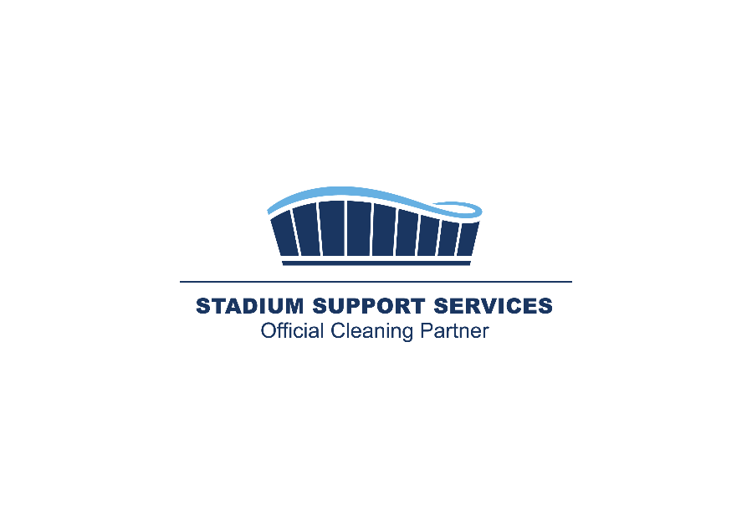



|  |
| --- |
| **Exhibition Stand Cleaning Request Form** |

|  |  |
| --- | --- |
| Your details | |
| Your company name |  |
| Your client company name if different from above |  |
| Your Email address |  |
| Your Phone number |  |
| Company name and address quotation should reference |  |
| About the event | |
| What event or show do you require cleaning for? |  |
| What date(s) is the event/show live for |  |
| What is your stand location? |  |
| Please tell us any further information about the show that might be of relevance… | |
|
| About your stand | |
| What size is your stand *(please provide dimensions & SQM)* |  |
| What floor surface is your stand? *(hard-surface or carpeted)* |  |
| Is there any metal work that requires polishing |  |
| Is there any glass that requires polishing |  |
| Is there any furniture that requires cleaning |  |
| Are you serving any food or drinks *(please provide details)* |  |
| Please tell us any further information about the design or layout of your stand that might be of relevance…  *(Please attach any CAD drawings, floorplans or renders if you have them)* | |
| Cleaning Schedule | |
| What evenings do you require us to clean your stand ensuring it is ready for the next day? |  |
| Would you like an additional visit during the day to clean smears, empty bins and carry out any other adhoc cleaning requests? |  |

Upon submission of this form a quotation will be sent to the email address provided.

Should you wish to proceed you will need to confirm via email and make payment 48 hrs prior to the event going live.

Please send the above completed form to [info@StadiumSupportServices.co.uk](mailto:info@StadiumSupportServices.co.uk)

Our dedicated team will provide you with a quotation within 72 hours

**Thank you for your enquiry**

**www.StadiumSupportServices.co.uk**