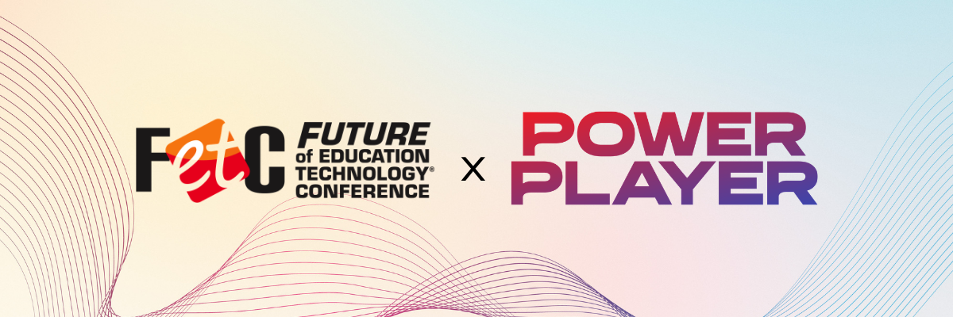
[Your Name]
[Your Position]
[Your School/District Name]
[School/District Address]
[City, State, Zip Code]
[Date]
Dear [Educator/Decision Maker's Name],
I am writing to request approval and support for professional development funding to attend the Future of Education Technology Conference (FETC) taking place January 26-29, 2027, in Orlando, Florida. As [your role, e.g., teacher, instructional coach, technology leader, district administrator], I recognize the growing importance of strategic technology integration, AI readiness, cybersecurity, instructional innovation, and future-focused leadership in K-12 education.
FETC is one of the nation’s leading conferences for education and technology leaders, bringing together the “Power Players” shaping the future of teaching and learning. Attending this event directly aligns with my professional growth goals and supports our school/district priorities related to [insert initiative, strategic plan, technology goal, curriculum focus, etc.].
Conference Benefits
FETC offers hands-on professional learning, practical implementation strategies, and direct access to emerging technologies and instructional best practices. With hundreds of sessions, workshops, and leadership-focused learning opportunities, the conference provides actionable strategies that can immediately support our district’s work in areas such as [insert focus area: AI integration, cybersecurity, student engagement, instructional innovation, digital equity, STEM, etc.].
In addition to educational sessions, FETC provides opportunities to evaluate tools and solutions that may improve efficiency, strengthen student outcomes, and support long-term strategic planning across our schools.
Proposed Expenses
Transportation (Mileage/Airfare): [Insert Amount]
Ground Transportation: [Insert Amount]
Accommodation: [Insert Amount]
Meals: [Insert Amount]
Registration Fee: [Insert Amount]
Total Estimated Cost: [Insert Total]
Professional Development Focus
The sessions and workshops I plan to attend will focus on [insert specific topic areas], which directly support our school/district initiatives surrounding [insert initiative or strategic goal]. FETC also offers opportunities to earn Continuing Education Units (CEUs), supporting ongoing professional growth and reinforcing our district’s commitment to educational excellence and innovation.
The knowledge and strategies I gain will help strengthen our efforts in areas such as [insert relevant areas: instructional technology integration, AI literacy, cybersecurity preparedness, student-centered learning, operational efficiency, etc.]. I believe the insights gained at FETC can help improve implementation, increase staff confidence with emerging technologies, and positively impact student achievement and engagement.
Collaboration and Networking
FETC provides valuable opportunities to collaborate with educators, district leaders, and industry experts from across the country. These conversations and connections often lead to practical solutions, innovative ideas, and partnerships that extend well beyond the conference itself. Learning from districts facing similar challenges will provide meaningful insight that can help inform our own strategies and decision-making.
After the Conference
Following the conference, I am committed to sharing key takeaways, resources, and implementation strategies with our staff through a presentation, workshop, or collaborative planning session. This ensures the value of the conference extends beyond my individual participation and benefits our broader school and district community.
Call to Action
I believe attending FETC 2027 is a strategic investment in both my professional development and our school/district’s continued growth and innovation. I appreciate your consideration and welcome the opportunity to discuss how this experience can support our goals for the upcoming school year.
Thank you for considering my request and for supporting opportunities that strengthen teaching, learning, and leadership within [School/District Name].
Sincerely,
[Your Name]

