[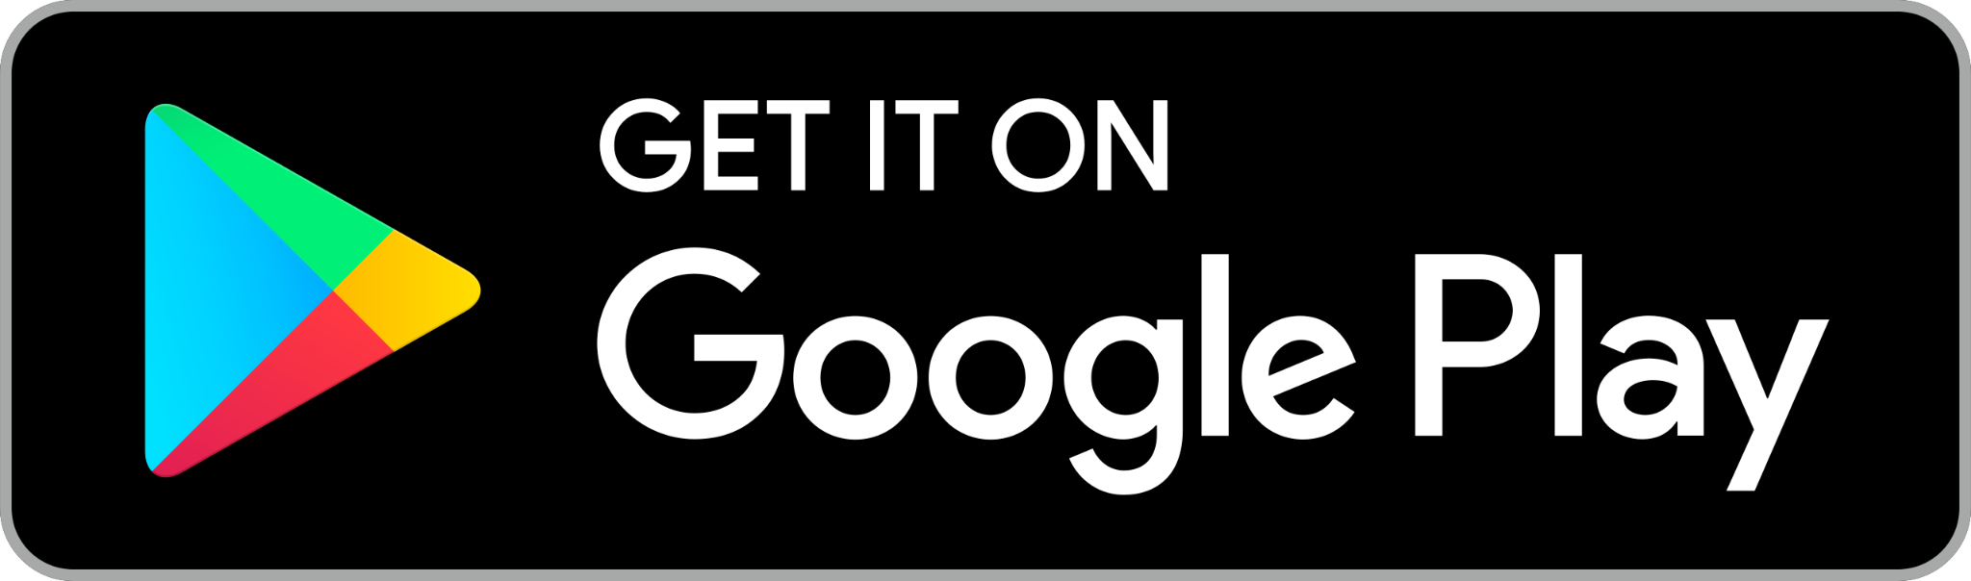](https://play.google.com/store/apps/details?id=com.brella) [](https://apps.apple.com/app/brella-io/id1178449878)

**Smart QR code link:** [**qrco.de/beGAWl**](https://qrco.de/beGAWl)