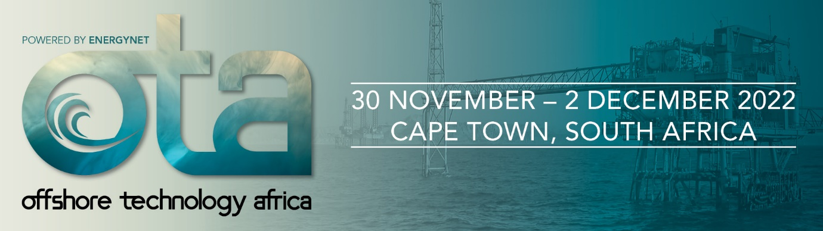

HEALTH AND SAFETY DECLARATION FORM

Compulsory for  all exhibitors | To be completed by a senior person and returned by 30 October 2022 to Larelle@energynet.co.uk

Important | It is a condition of entry into the show that every sponsor, supplier, contractor, sub-contractor and their agents comply with the Offshore Technology Africa 2022 Sponsor Manual.  The sponsor accepts that it is their legal and moral responsibility to ensure that their own and others health & safety is not put at risk by their actions (or inactions) during the Offshore Technology Africa 2022.

* indicates required fields.
- SPONSOR DETAILS

Sponsor name *
Table number *
Sponsor address *
Contact person *
Email address *

Stand type * | Table top stand

- GENERAL

Rules and regulations * |  | I agree that I have thoroughly read through the COVID guidelines, which are on the event website and agree to adhere to the rules within. I understand that failure to comply with the rules may result in denied entry to the event.
Waste Management |  | I am aware that charges may apply if waste/materials from my stand is left behind after the last event day, Friday 30 October 2022.
Freight and Deliveries | I am aware that the organisers and its contractors are not responsible for any items sent directly to the venue.  I am aware no items should be left unattended on my stand for collection during breakdown, unless arranged with the official freight provider.

- RISK ACTIVITIES

Risk activities * | Our planned exhibits / demonstrations and work practices offer no significant risk to either ourselves or others on site.  High-risk activities will be undertaken on our stand (as detailed below). I / my contractor will submit a suitable and sufficient Risk Assessment covering these and other risks identified.

Those high-risk activities will be undertaken on our stand | Naked Flames / Hot surfaces / Flammable substances / LPG  Working machinery / demonstration model or turntable/ vehicle on stand / strobe or flashing lights / smoke machine / fumes / exhaust  Audio Visual display or film / product demo gathering a large audience / Laser product  Water feature exhibit or activity  Closely seated audience  Dangerous exhibit e.g. knives  Other (please email details to Larelle@energynet.co.uk)

FILLED IN BY:

JOB TITLE:

DATE:

