Sunshine Trail Campers and Trailers
OVERVIEW
Exterior Length (mm) – 6700 Exterior Width (mm) – 2280
Collapsed Exterior Height (mm) –3050 Occupants Capacity – 2

EXTERIOR
Type 16ft Poptop caravan
Fully Galvanized & Welded Drawbar with lifetime warranty
Fully Galvanized & Welded Chassis with lifetime warranty
Underbody Anti-Chip Protection, Powder-coated Wheel Arch Flairs
3.5 Tonne ARK Off Road Hitch, ADR Compliant Safety Chain - 2
Adjustable Independent Trailing Arm Coil Spring Suspension, Gas Shock Absorbers - 4
265/70R16 Off Road Tyres with 6 Stud 16" Alloy Wheels
Matching Alloy Spare Wheel - 2, 9kg Gas Bottle Holders 2
Front Utility Box with gas storage compartments and 2 x 20LJerry Can Holders
Fully Integrated Stone guard with Anti-Chip Protection
ARK XO dual jockey wheel 750Kg rated
4 x Drop-Down Heavy-Duty Stabilizer Legs Fully Adjustable
Emergency Breakaway System, Ventilation Fan in Fridge compartment
CAMPING COMFORT
Rear Food Grade Polypropylene Water Tank with Aluminium Checker Plate Protection - 120L
Middle Food Grade Polypropylene Water Tank with Aluminium Checker Plate Protection - 80L
Front Polypropylene Grey Water Tank with Aluminium Checker Plate Protection-80L
High Volume Electric Water Pump, Water Tank Aluminium Checker Plate Guard
Slide Out Premium Stainless-Steel Kitchen with Cutlery & Utility Draw Multipurpose Cutting bench/Wind/Splash Guard
Dish Drying Rack
High Output 4 Burner Gas Stove with Flame out Protection, Fully Plumbed to Front Gas Bottle Holder
Main bed - W 1700mm L 2000mm, Premium Density Foam Mattress
Premium Internal Lounge and Height-360 degrees Adjustable Dining Table Leatherette Seating
Premium Integrated 4 Speaker Entertainment System with CD/DVD/USB playback & Bluetooth Function & 22-inch digital ready HDTV TV System 22inch
Commercial Grade Vinyl Interior Floor
Ensuite with Premium Shower, Sink & Chemical Toilet
135L Dometic Fridge, 2 Burner Dometic Cook-Top, Diesel Heater

STORAGE
Front Fridge Slide Compartment, Front storage toolbox with three enclosed hatches
External Pantry Slider, Internal Utility Draws , Internal Utility Cupboard

ELECTRICAL SYSTEM
1 2V Power System - 3x 150Ah Lithium Battery
Battery Management System with Voltage Metre, Amp Draw, Power Level Indicator, Water Tank Indicators & 50 Amp Mega fuse , 300W Roof-Mounted Solar Panels
2000W 12V to 240V Inverter 240 to 12V Super Quick Charger,
Water Tank Level Gauge, Switch Box with Independently Fused Circuit Board Hot Water System - Truma 240V/Gas 14L Boiler, 30 Amp Automatic Battery Charger
240V Power Input, Double Pole 240V sockets - 4x Int/ Ix Ext
Anderson plug with HD fridge power feed.
240V double pole socket to fridge slide compartment
12V Cigi Socket in Front Fridge Slide, USB Port Internal, Internal LED Lighting System
LED Kitchen Light, Spare Portable LED Light with Pole Clamp, Antenna TV and Video
Manual Step , Vent in Ensuite , Smoke Detector , Air Conditioner Dometic HL 36 Cassette Awning Electrical and Manual , Air Fram Annex
TECHNICAL
Drawbar 150x
50x3mm Q345 steel tube certified ADR 62/02 for offroad use with Lifetime Warranty
Chassis 150x50x3mm Q345 galvanized steel tube certified ADR 62/02 for offroad use
Main Body Aluminium frame with composite panel cladding & Black Aluminium Checker Plate trims
Suspension - Adjustable Independent Coil Spring Suspension, twin shock absorbers, Q345 steel with 5mm thickness steel tube with powder coat finishing
Shock Absorber -4x Gas Shock Absorbers, Brakes 12" Electric brakes
Jockey Wheel - ARK XO dual jockey wheel 750Kg rated
Hitch - 3.5 Tonne ARK Off Road Hitch
Sunshine Trail Campers & Trailer
sunshinetrail.com.au
PH: 1300 930 998
Address: 99 Park RD Mandurah, WA, 6210
22 Shettleson ST Rocklea, QLD, 4106
Emergency Breakaway System
Tare - 2,400Kg, ATM - 3,000Kg, Ball Weight - 210Kg
Exterior Dimensions - 6700mm x 2280mm x 2400mm (to 3050mm)
Sunshine Trail Campers and Trailers
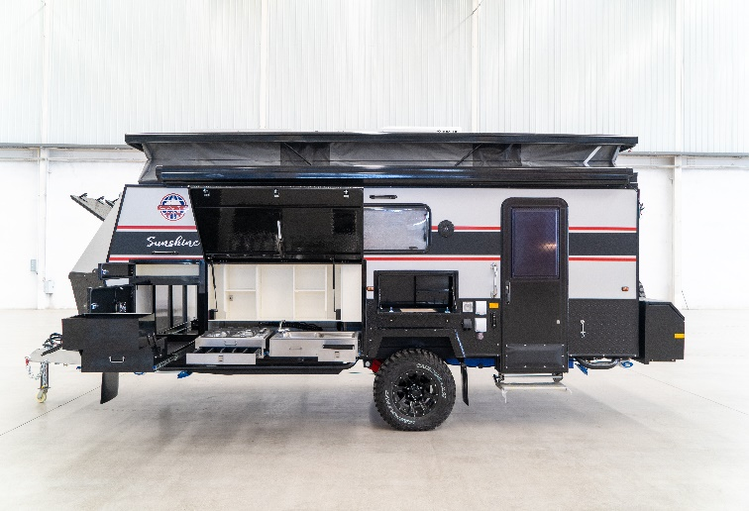 | 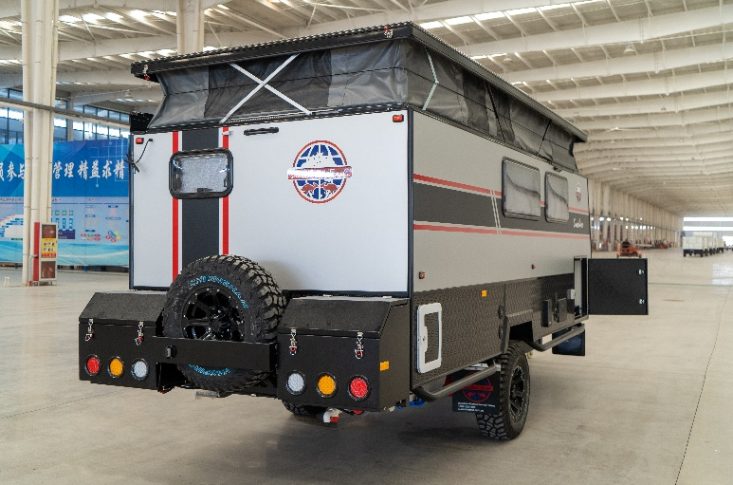
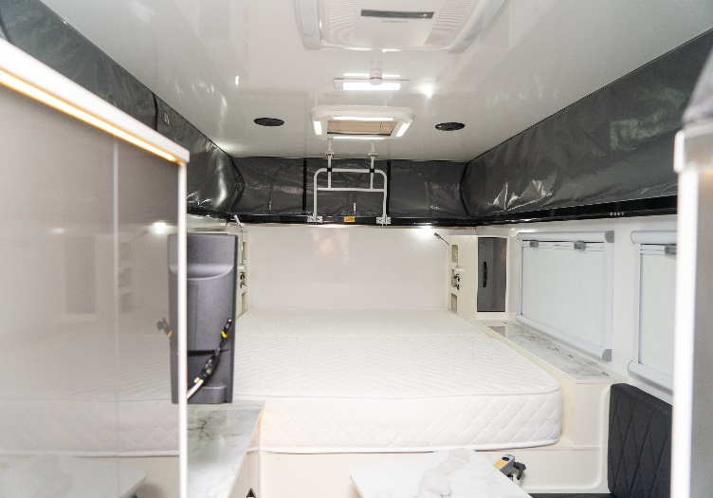 | 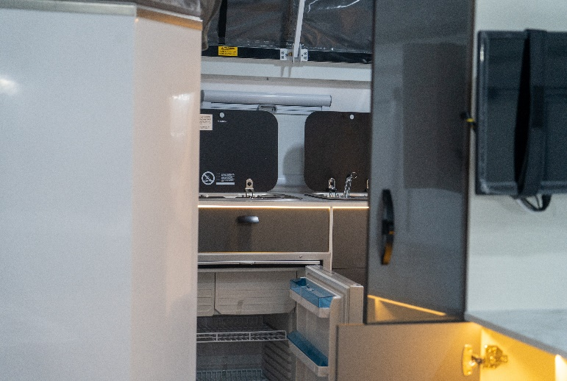
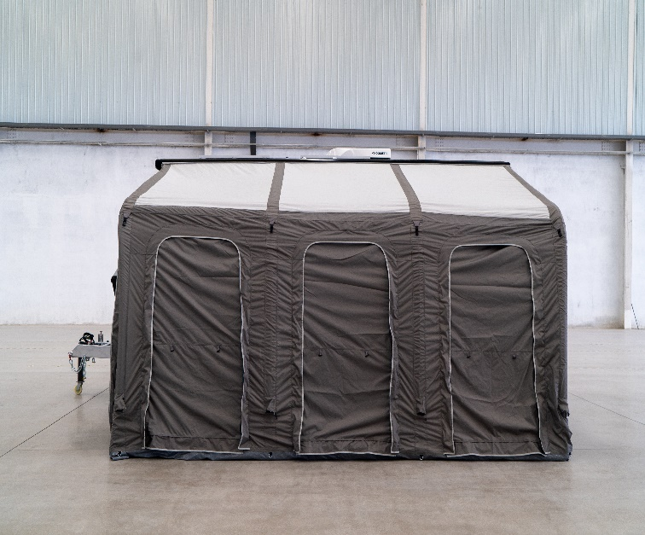 | 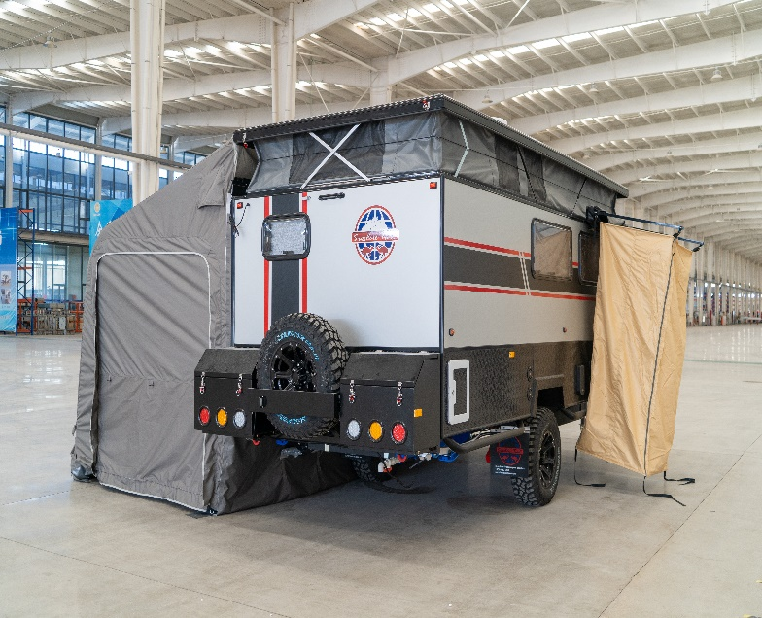

Sunshine Trail Campers & Trailer
sunshinetrail.com.au
PH: 1300 930 998
Address: 99 Park RD Mandurah, WA, 6210
22 Shettleson ST Rocklea, QLD, 4106

