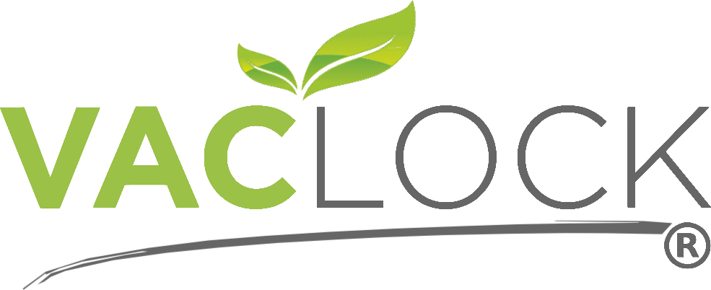

Portable Vacuum Sealer is perfect for home use or outdoor and travel use also.
- Keeps food fresher for longer
- Saves money
- Minimize waste on food going bad
- Eliminates freezer burn and maintains original flavour

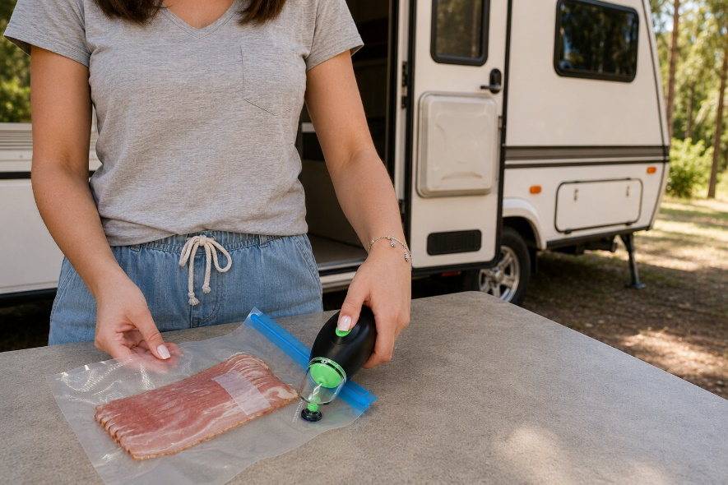
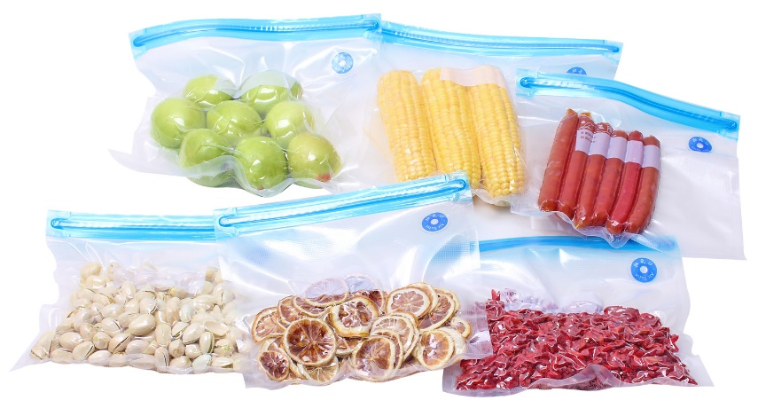

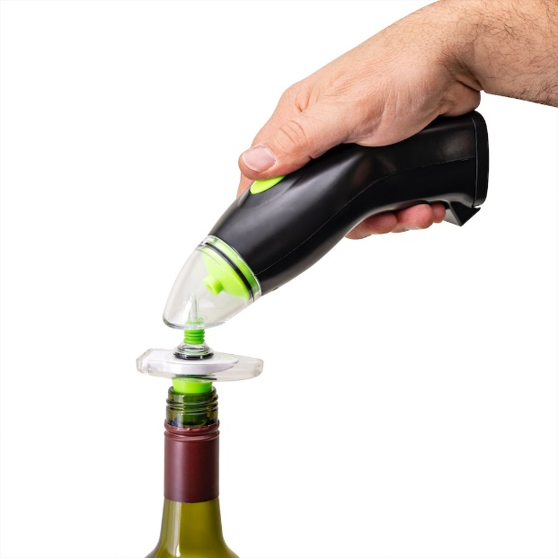
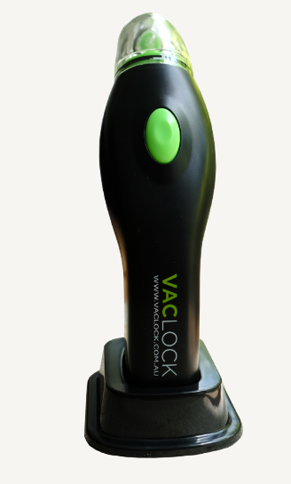
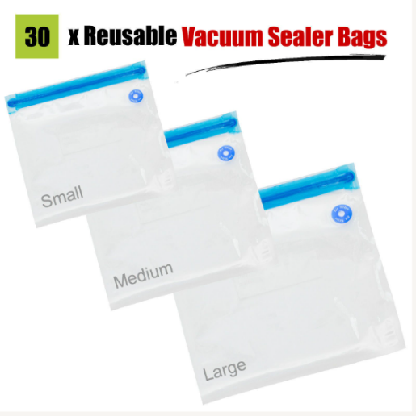
NEWSTYLE DIRECT- 18 MONTEFIORE ST, FAIRFIELD VIC 3078
WINE STOPPER INCLUDED

