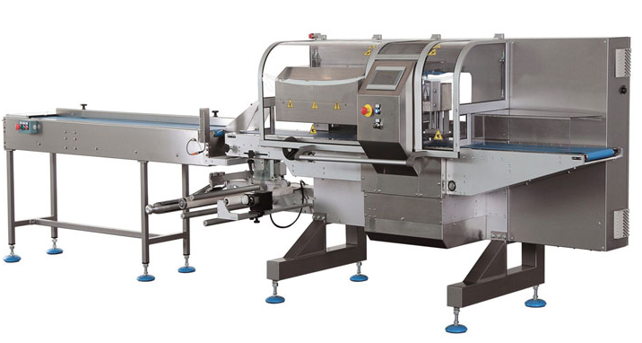
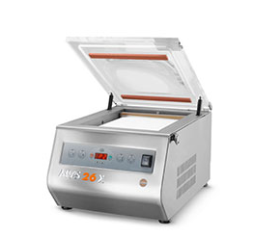
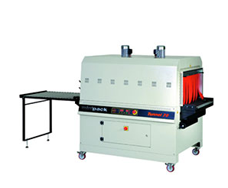
SHRINK YOUR COST OF PACKAGING AND SAVE $$$$$$$$$

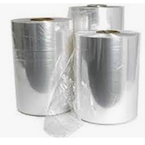
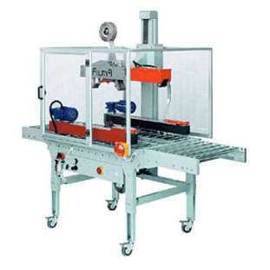
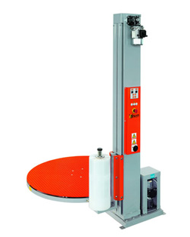
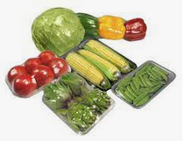
Machines up to 150 packs per minute -Pallet wrappers -Mailing machines
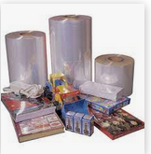
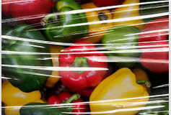
Box motions -high speed machine –
Labelling Machines
Skin Machines - Bundle machines
Vacuum machines - Flow wrappers
Shrink Tunnels – Carton sealer and erectors
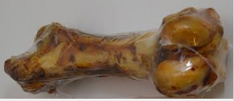
Manufacturers of custom made machines
Many more
High quality
Shrink film 100% recyclable
Food grade
From manual to sophisticated high-speed machines.
Custom made to suit your packaging requirements

