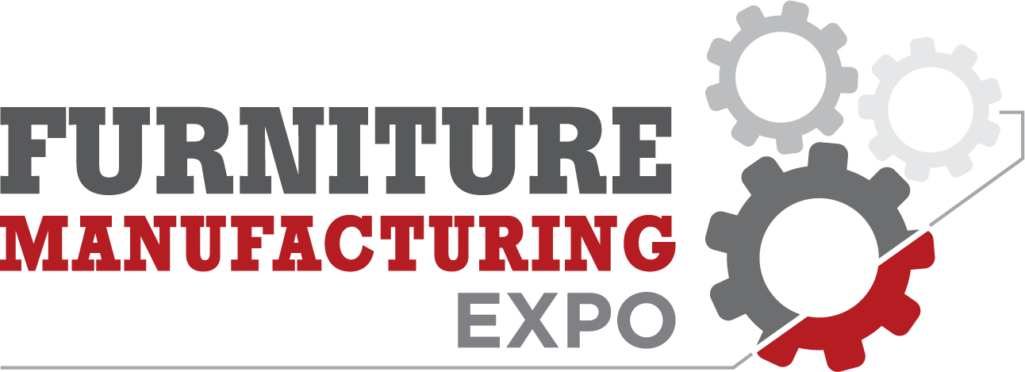

Lead Retrieval Made Simple
Custom Registration is Furniture Manufacturing Expo’s official registration company. As our registration company, Custom Registration offers lead retrieval scanning options for exhibitors.

A Lead Retrieval Scanner is a compact device or a mobile phone app that allows you to scan the barcode on an attendee's name badge and automatically capture the attendee’s contact information. Your company’s scans are compiled in an Excel spreadsheet and provided to you at the end of the event.
Whether you choose the mobile app or a handheld device, you will receive powerful features to capture and manage attendee leads seamlessly.
Features Included with Every Option:
- Instant Data Capture: Scan attendee badges to collect names, companies, emails, phone numbers, and more.
- Custom Tools: Add qualifiers and notes, and surveys to capture the details that matter.
- Secure Cloud Backup: Every scan is automatically saved for peace of mind.
- Web Dashboard: Log in from any device to download your leads or email them from the device.
- Streamlined Follow-Up: Organized data enables faster and more effective post-event outreach.
Please Click Here to review the Lead Retrieval options and to reserve a unit today. If you have any questions regarding Lead Retrieval, please call (817) 277-7187.

