Press Release
Be bold, be brave and be aspirational – Canon aims to inspire the large format graphics community to ‘Make It BIG’ at FESPA 2022

 | 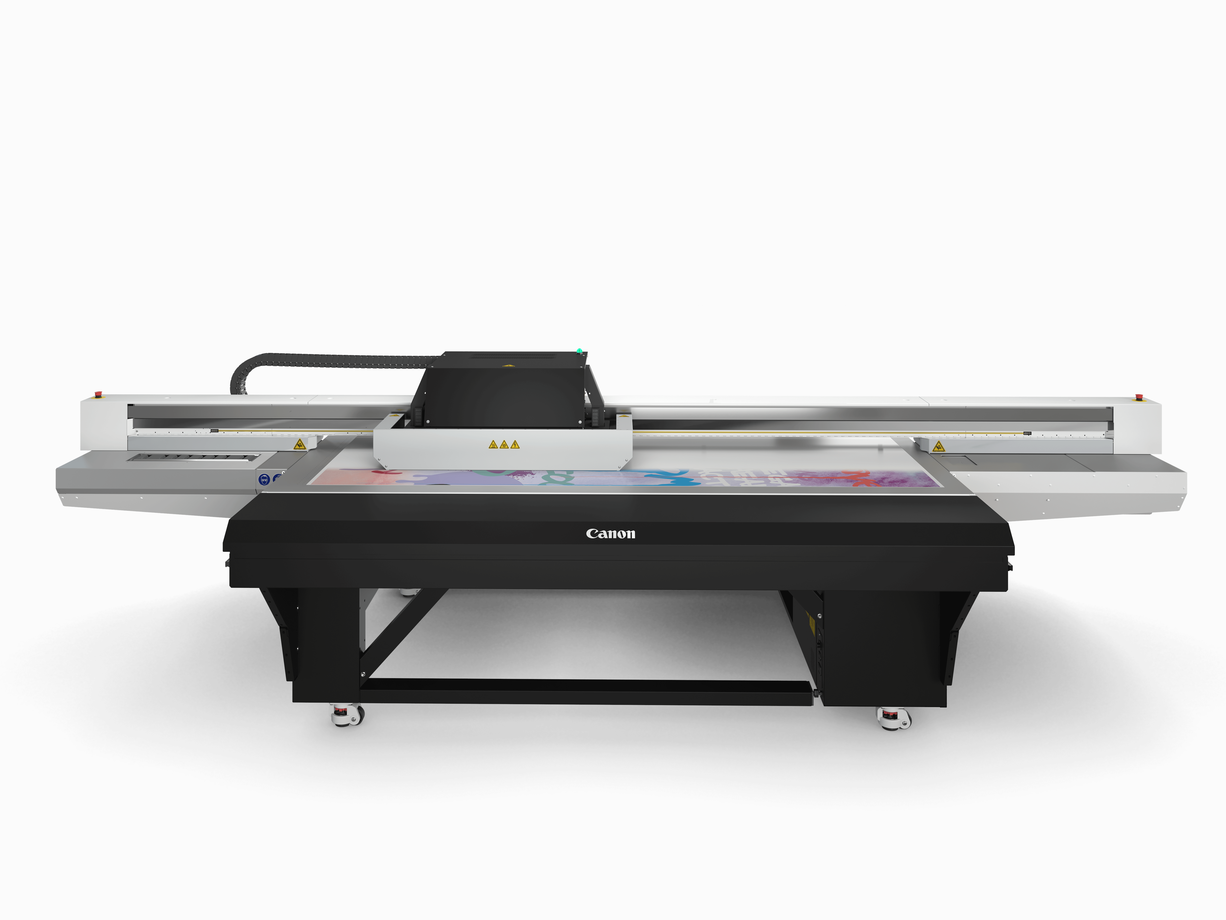 | 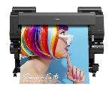
See the award-winning Colorado series including the UVgel Wallpaper Factory | Find out more about the capabilities of Canon’s flatbed printer family, the Arizona series | Boasting 10 ink colours including fluorescent pink, the imagePROGRAF GP-4000 can make vivid colours pop

At this year’s FESPA, 31 May – 3 June 2022, Berlin, Canon will be helping print service providers (PSPs) and print factories (Hall 3.2 Stand A30) to ‘Make It BIG’ by being bolder and leaving a more lasting impression on their customers. The bigger the impact, the greater the value. The ‘Make It BIG’ campaign has been developed for this year’s event as a continuation of our ‘Make It’ drive to help print professionals boost business growth, optimise performance and maximise new opportunities in large format graphics. To support customers with this, Canon will be showcasing three world premieres of new large format digital print solutions at the event.

Under the ‘Make It BIG’ theme, Canon will help large format graphics professionals to ‘Make It Eye-Catching’, giving them guidance on how they can leave a lasting impression on their customers, whether it’s in terms of sheer size, colour, special effects or personalisation of applications. To show stand visitors how to ‘Make It Smart’, we are demonstrating a fully automated, end-to-end solution that allows attendees to track a print order of inspiring high-value applications from submission right through to final delivery. To show what can be achieved with this process, on the stand we will have a simulated retail shop to show a range of print applications for a product and its packaging, as well as associated POS and promotional display applications. Visitors will be encouraged to spot opportunities to ‘Make It Grow’, looking at how they can expand their business into new markets and application areas, such as interior décor or display and packaging.

Demonstrating its deep understanding of the industry and the growth opportunities enabled by innovations in large format graphics technologies, Canon will reveal three brand new technology innovations in the following categories:
- Roll-to-roll printing
- High-volume flatbed printing
- Workflow automation

The award-winning Colorado 1630 and Colorado 1650 will be on display to demonstrate how PSPs and print factories can benefit from UVgel technology. With its ability to produce multiple applications, from designer wallpaper and stunning decals to high-impact front and back-lit signage, the Colorado series is the versatile investment that allows print professionals to stretch their creative capabilities and meet the tightest deadlines.

Recognising the continued importance and growth of the digital wallpaper market, Canon has devoted a section of its stand to the ‘UVgel Wallpaper Factory’ to allow visitors to see production in action. This end-to-end solution showcases the capability of the Colorado 1650 when used in line with the Fotoba jumbo roll, cutting- and rewinding modules in producing a variety of curated wallcoverings ready to ship. This configuration will put the Colorado 1650 to the ultimate test in productivity by demonstrating how customers can print high volumes of wallpaper around the clock.

Visitors to our partner Farben-Frikell’s booth, adjacent to the Canon stand, can also find out more about the entry-level UV-LED flatbed Arizona 135 GT. This printer is the ideal investment for print professionals looking to extend their offering and branch out into large format flatbed applications such as retail graphics, point-of-sale (POS), short run packaging, interiors, outdoor graphics and backlit signage. As the only printer in its segment with a field-upgradable Roll Media Option, the device can also produce tactile prints on an extensive range of both rigid and flexible media.

For those looking to boost the productivity of their flatbed applications by more than 20%, Canon will also be showcasing its Arizona 2380 XTF with IJC358 UV-curable inks. Built around Arizona FLOW technology, the printer’s zoneless vacuum bed substantially reduces the need to mask the table or tape down the media, significantly speeding up turnaround times. The printer can also work with more challenging media such as cardboard, wood or glass.

Riding the colour wave, the imagePROGRAF GP-4000 (44 inch) will be on show to demonstrate how applications produced by the smaller of the large format printers can pack just as much of a punch as those printed on the larger wide format machines. Boasting ten colours including red, orange, green, violet and fluorescent pink, the imagePROGRAF GP-4000 can make vivid shades pop, reproduce perfect pastels and bring campaign visuals to life. It’s also the world’s first large format printer with aqueous pigment fluorescent ink, offering high value-added output for graphics applications such as posters and point-of-sale materials.

The imagePROGRAF TZ-30000 Series will highlight how fast-paced businesses working to tight deadlines can maintain the rapid production of posters CAD/GIS drawings, renderings, and maps. With excellent media handling on uncoated or lightweight coated paper, this robust printer is the ideal choice for customers in architecture, engineering, construction and manufacturing, as well as professional print service providers and copy shops.

Speaking about FESPA 2022, Mathew Faulkner, EMEA Director, Marketing and Innovation, Wide Format Printing Group, Canon Europe says, “Be bold, be brave and be aspirational – that’s our message to the wide format community and the essence of our ‘Make It BIG’ campaign at this year’s FESPA. We’re now seeing an increasing number of our customers and prospects seizing new opportunities in large format graphics by opening themselves up to alternative revenue streams, new applications and more efficient ways of working to compensate for decreased volumes during the pandemic. We’re using this opportunity to showcase the breadth of our technology line-up – we have a printer to suit every budget and size of print operation. Using new technologies and automation, we can help our customers to become even bigger and better, allowing them to succeed today and thrive in the future. It’s time for print professionals to take a step outside of their comfort zone, look at the bigger picture and work with us to ‘Make It’ and boost their chances of future success.”

- To find out more about the Arizona family of flatbed printers, visit: https://www.canon-europe.com/business/products/wide-format-printers/uv-flatbed/

- To find out more about the Colorado family of roll-to-roll printers, visit https://www.canon-europe.com/business/products/wide-format-printers/uvgel-roll-tol-roll/

- To find out more about imagePROGRAF GP-4000 series, visit https://www.canon-europe.com/business/products/wide-format-printers/graphics-printers/

- To find out more about the imagePROGRAF TZ-30000, visit https://www.canon-europe.com/business/products/wide-format-printers/imageprograf-tz-30000/

Media enquiries, please contact:  Canon Production Printing  Claudia Huberth  e. Claudia.Huberth@cpp.canon  AD Communications  Imogen Woods  t. +44 (0) 1372 464 470  e. canon@adcomms.co.uk | About Canon Europe  Canon Europe is the EMEA strategic headquarters of Canon Inc., a global provider of imaging technologies and services. Canon Europe has operations in roughly 120 countries, with approximately 13,300 employees and contributes to around a quarter of Canon’s global revenues annually.  Founded in 1937, the desire to continuously innovate has kept Canon at the forefront of imaging excellence throughout its 80 plus year history and has commitments to invest in the right areas and capture growth opportunities, from cameras to commercial printers, and business consultancy to healthcare technologies.  Canon’s corporate philosophy is Kyosei – ‘living and working together for the common good’. In EMEA, Canon Europe pursues sustainable business growth, focusing on reducing its own environmental impact and supporting customers to reduce theirs using Canon’s products, solutions and services.  Canon is constantly redefining the world of imaging for the greater good. Through its technology and spirit and innovation, it pushes the bounds of what is possible – helping to see our world in ways we never have before.  Further information about Canon Europe is available at: www.canon-europe.com

