Formatting Guidelines for LNG2026 Extended Abstract
The template is used to format your Extended Abstract and style the text.
All margins, column widths, line spaces, and text fonts are pre-set; please do not alter them.
Please start your Extended Abstract on the next page and delete these instructions when completed.
Layout to include below section headers (Arial font; font size 14px):

• Abstract Title
• Presenter (Full name, job title, company)
• Co-authors (Full name, job title, company)
• Abstract
• Background/Introduction
• Main Content
• Conclusion
• References

Kindly note that we ask presenters to submit an extended abstract of not more than 500 words which can include graphs, tables and pictures. Your on-the-day presentation will serve as a summary of this extended abstract.

<SECTION HEADER> [e.g ABSTRACT TITLE – Arial – Bold, 14 pt.]

<Body Text> [e.g. Abstract description – Arial – 12 pt.]

<Subsection> – [Arial – 14 pt., Bold – Only Initial Letters Capitalised]

Tables/Figures/Images should be as close to the relevant text as possible.
Equations should be entered with an internal equation editor.
Captions for Tables, Figures, and Images – [Arial – 9 pt., numbered (i.e. Figure 1), centered].

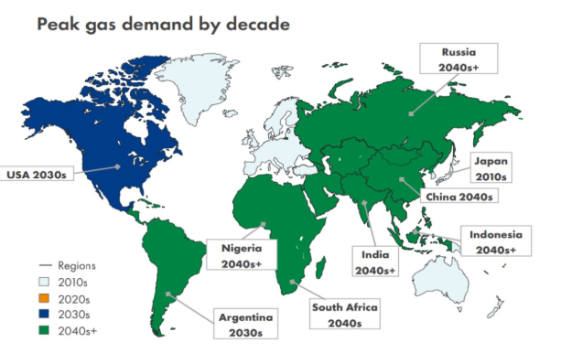
Figure 1: Sample figure text title

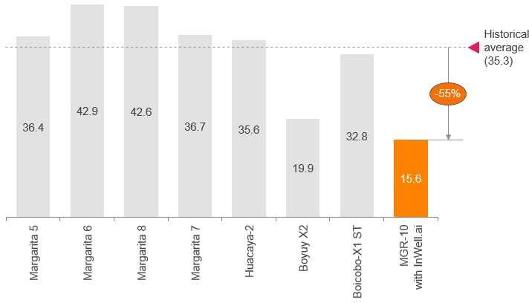
Graph/Table 1: Sample graph text title

References - References should be Arial – 9pt. Please use the reference format as below:

1. Book <Author name: last name, first name>, <Copyright date>. <Book title>. <page numbers>. <City, State of Publisher>: <Publisher name>
2. Journal article <Author name: last name, first name>, <Copyright date>. “<Article title>.” <Journal title>. <page numbers>. <City, State of Publisher>: <Publisher name>
3. Website <Author name: last name, first name>. “<Title>.” <Source>. <Date>. Available at <URL>

