Formatting Guidelines for LNG2026 Poster Summary
The template is used to format your Poster Summary and style the text.
All margins, column widths, line spaces, and text fonts are pre-set; please do not alter them.
Please start your Poster Summary on the next page and delete these instructions when completed.
Layout to include below section headers (Arial font; font size 14px):

• Abstract Title
• Presenter (Full name, job title, company)
• Co-authors (Full name, job title, company)
• Abstract
• Background/Introduction
• Main Content
• Conclusion
• References

Kindly note that we ask presenters to submit a poster summary of not more than 1000 words which can include graphs, tables and pictures. The Poster Summary provides an opportunity for you to offer additional narrative in text form to supplement the Poster itself. However, the Poster should be self-explanatory, without the need for additional clarification.

<SECTION HEADER> [e.g ABSTRACT TITLE – Arial – Bold, 14 pt.]

<Body Text> [e.g. Abstract description – Arial – 12 pt.]

<Subsection> – [Arial – 14 pt., Bold – Only Initial Letters Capitalised]

Tables/Figures/Images should be as close to the relevant text as possible.
Equations should be entered with an internal equation editor.
Captions for Tables, Figures, and Images – [Arial – 9 pt., numbered (i.e. Figure 1), centered].

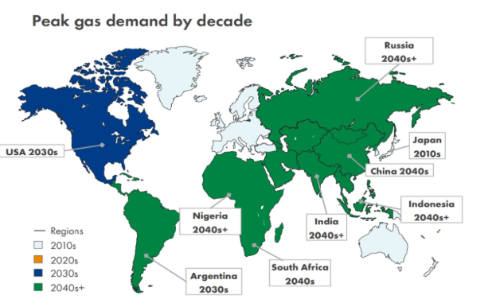
Figure 1: Sample figure text title

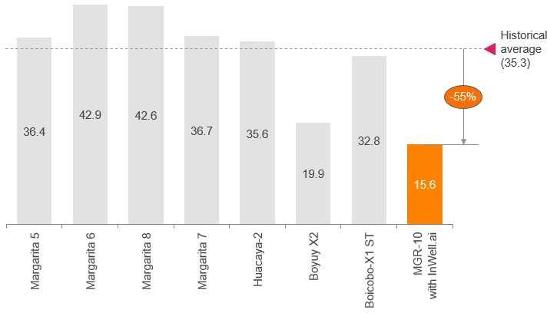
Graph/Table 1: Sample graph text title

References - References should be Arial – 9pt. Please use the reference format as below:

1. Book <Author name: last name, first name>, <Copyright date>. <Book title>. <page numbers>. <City, State of Publisher>: <Publisher name>
2. Journal article <Author name: last name, first name>, <Copyright date>. “<Article title>.” <Journal title>. <page numbers>. <City, State of Publisher>: <Publisher name>
3. Website <Author name: last name, first name>. “<Title>.” <Source>. <Date>. Available at <URL>

