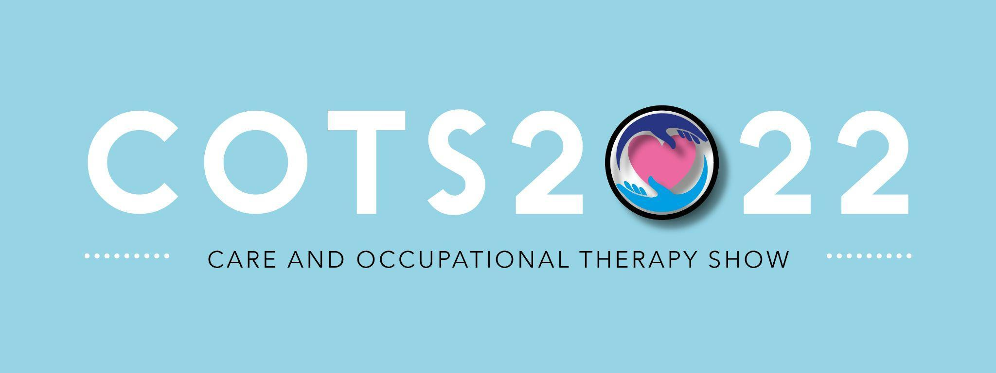

COTS22: Live Demo Information: 21st June 2022: Westpoint Arena, Exeter
Deadline: 15th April 2022.
Live Demo Presenter Name:

Company Name:

Demo Title: (max 10 words)

Live Demo Long Description: (Max 150 words, no bullet points)

Live Demo Short Description (max 70 words, no bullet points)

Please attach product images / videos when sending this form back to the organisers.
Live Demo Contact Details
(If this is different from the person we should liaise with then please add this as the secondary contact)
Presenter Contact number:

Presenter Contact Email:

Social Accounts
Twitter:
Facebook:
LinkedIn:
Other:
Secondary Contact Information (If required):
Name:

Contact Number:

Terms and Conditions
- Live demos must be educational and not a sales pitch in any form.
- Live demo forms will be reviewed by the event organiser and are subject to approval/ refusal.
- Once confirmed, it is the presenters's responsibility to fulfil to commitment above.
- If the presenter/ company is unable to make the event then it is the company's responsibility to find a replacement to represent their presenter/ company or brand.
- Live demo slots at 30 minute slots and must not overrun.
- Any presentation will need to be forwarded to the organisers 2 weeks before the event dates and also brought on a memory stick to the event.
- There will be technicians onsite who will be able to troubleshoot any onsite issues.
- For more information about your live demo slot please contact Tom Jacobson or Pearl Pearce-Smith.
tom@inspiredmotive.co.uk
pearl@inspiredmotive.co.uk

The deadline to return this form to either of the above Inspired Motive staff members
is 15th April 2022.

