Registration Process to view QR code upon confirmation of Registration Email

Step 1:
Click on the link to take you to the form to fill out further details
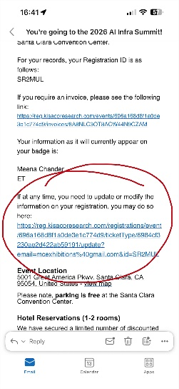

Step 2
Takes you to this form where you have to fill out more details:
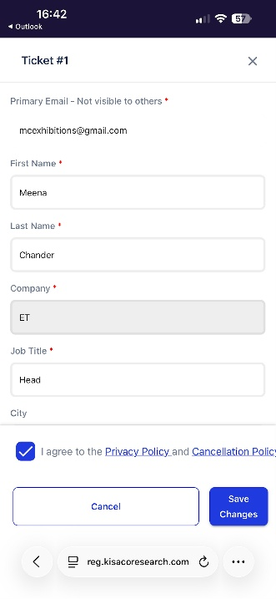
Fill out form and click Save Changes on bottom RHS.

Step 3:
This page will show with your receipt.
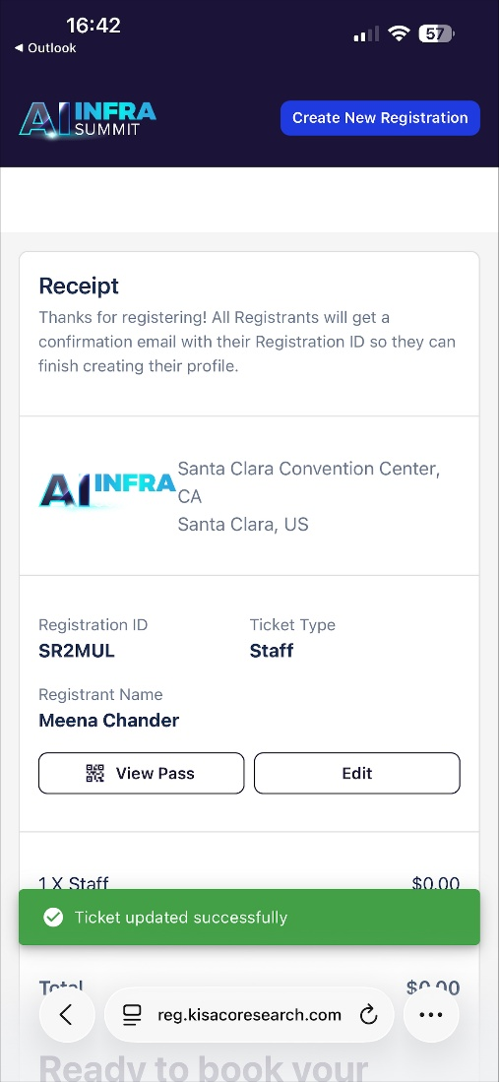

Step 4
Click on “View your pass” where the QR code will appear.
