PRESS RELEASE

23rd March 2022

MURASPEC LAUNCHES NEW MULBERRY SILK

Muraspec Wallcoverings launches its new luxurious design, MULBERRY SILK.
Luxurious because of its beauty and versatility, this silk inspired wallcovering brings style, sheen, and panache to any space. MULBERRY SILK possesses all the eye-catching qualities one would expect of a real silk, achieving a natural characteristic panelled effect once installed, just as silk.

Managing Director, Tariq Rashid commented “Mulberry Silk is a great addition to our silk embossed wallcovering range.
“With no pattern match, this design is simple to install and achieves a soft panelling effect that emulates real silk, adding depth to a space and oozing regal glamour.”

With the added benefit of durability and built-in antimicrobial protection, this luxurious wide width wallcovering will stand the test of time on looks and performance in any applications.

See all 12 elegant colourways in Muraspec’s Mulberry Silk E-Book:

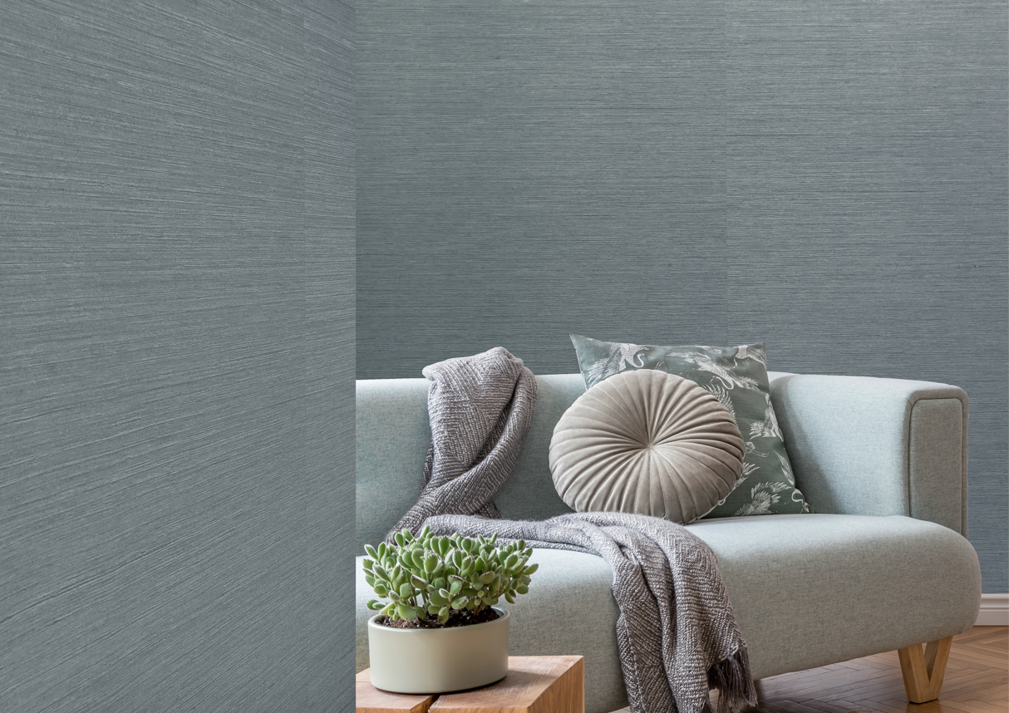

MULBERRY SILK by Muraspec

Muraspec Wallcoverings is an international leader in the commercial and bespoke wallcoverings industry.

This year we celebrate 170 years of British manufacturing excellence. We have developed a global reputation for outstanding product quality, impressive design, and exceptional production and technical support.

From our UK sales team to our dedicated global network of distribution partners, we are proud to supply a worldwide client base across the hospitality, healthcare, commercial office, retail, cruise ship and residential sectors.

Our manufacturing facility, based in Kent, UK, manufactures a wide selection of inspiring designs using our extensive range of versatile equipment, producing high quality, fire rated wallcoverings.

Our team of experienced Technical Advisors and Account Managers are always on hand, working closely to provide a comprehensive solution from inception to completion and beyond. Our customer service is second to none. As a manufacturer, we can provide flexibility on production and are proud to have the shortest lead times in the industry.

For more information, please contact us at:

Muraspec UK
03705 117 118
customerservices@muraspec.com
www.muraspec.com

- ends –

For further press information or images, please contact:

Michelle Martin
Product Marketing Manager
Muraspec Wallcoverings
Zodiac 2, Boundary Way
Hemel Hempstead
Herts., HP2 7SJ
Tel: +44 (0)1442 883164
Mob: +44 (0)7774 898947
Email: mmartin@muraspec.com
Visit: www.muraspec.com

